Results - SR - AC vs PC

Jesse Wood

Oct 1, 2018

Setup

library("unmarked")

## Loading required package: reshape

## Loading required package: lattice

## Loading required package: parallel

## Loading required package: Rcpp

library("stats")  
library(sjPlot)

## #refugeeswelcome

library(sjmisc)  
library(ggplot2)  
setwd("C:/Users/woodj/Documents/GRAD SCHOOL - CLEMSON/Project-Specific/R work/USDA-songbirds/USDA-songbirds")

# Evaluate Audio Counts (AC) vs Point Counts (PC)

#File read-in  
# as of 6/22, this one-visit breakdown has had unknowns REMOVED now (in both AC + PC)  
methodSR1 <-read.csv("17_1by1_ACPC_SR.csv") #SR by 1 visit each - Site Type SR  
summary(methodSR1)

## SiteName Type SR Sdate   
## Abercrombie_0B_E_AB: 2 AC:29 Min. : 8.00 Min. : 0.00   
## Abercrombie_1B_2 : 2 PC:29 1st Qu.:12.00 1st Qu.: 2.25   
## Blease_3B_6 : 2 Median :14.00 Median : 8.00   
## Blease_3B_9 : 2 Mean :14.24 Mean :12.83   
## Bryson_2B_9 : 2 3rd Qu.:16.00 3rd Qu.:22.75   
## Burnett_1B_5 : 2 Max. :21.00 Max. :50.00   
## (Other) :46   
## Stime Pdate Pmin Peffort Year   
## Min. :353.0 Min. :43181 Min. :12.00 Min. :1.000 A:58   
## 1st Qu.:404.0 1st Qu.:43185 1st Qu.:18.00 1st Qu.:2.000   
## Median :435.0 Median :43189 Median :24.00 Median :2.000   
## Mean :447.7 Mean :43189 Mean :25.48 Mean :3.172   
## 3rd Qu.:496.2 3rd Qu.:43193 3rd Qu.:30.00 3rd Qu.:3.000   
## Max. :589.0 Max. :43196 Max. :65.00 Max. :8.000   
## NA's :29 NA's :29 NA's :29

str(methodSR1)

## 'data.frame': 58 obs. of 9 variables:  
## $ SiteName: Factor w/ 29 levels "Abercrombie_0B_E_AB",..: 3 4 5 7 8 12 13 14 15 16 ...  
## $ Type : Factor w/ 2 levels "AC","PC": 1 1 1 1 1 1 1 1 1 1 ...  
## $ SR : int 15 14 11 10 12 16 13 17 14 11 ...  
## $ Sdate : int 3 16 31 33 23 24 30 27 10 22 ...  
## $ Stime : int 570 403 497 380 503 382 479 481 580 409 ...  
## $ Pdate : int 43181 43181 43186 43195 43196 43182 43188 43188 43188 43188 ...  
## $ Pmin : int 26 23 17 20 32 31 18 20 25 18 ...  
## $ Peffort : int 3 2 1 2 3 3 2 2 4 3 ...  
## $ Year : Factor w/ 1 level "A": 1 1 1 1 1 1 1 1 1 1 ...

#plot(methodSR1$SR ~ methodSR1$Type) #same as below  
plot(SR ~ Type, data=methodSR1)

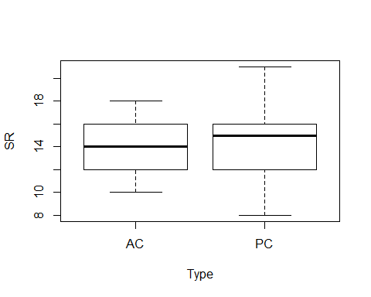

plot(SR ~ Sdate, data=methodSR1)

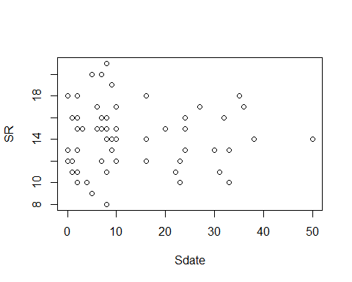

plot(SR ~ Stime, data=methodSR1)

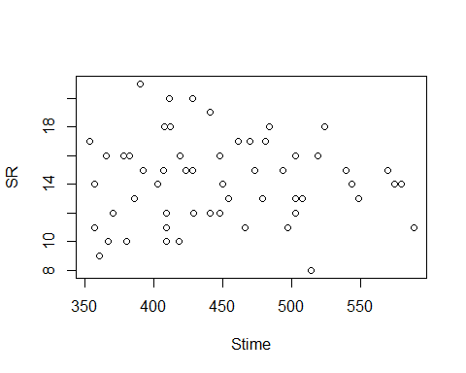

plot(SR ~ Pdate, data=methodSR1)

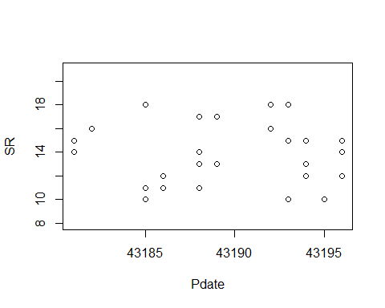

plot(SR ~ Pmin, data=methodSR1)

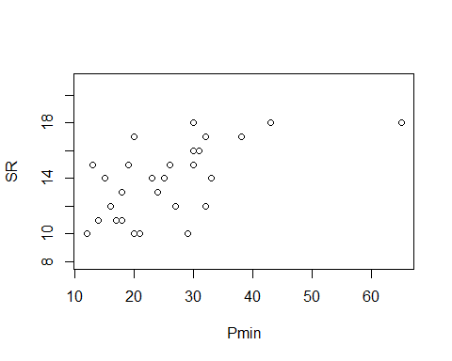

plot(SR ~ Peffort, data=methodSR1)

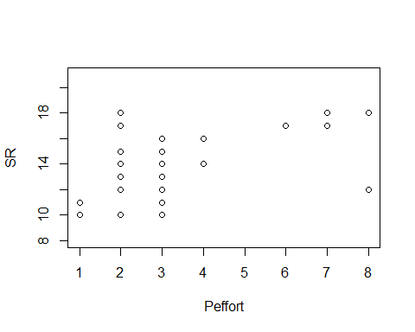

evaluation1<-lm(SR ~ Type, methodSR1) #non-significant  
summary(evaluation1)

##   
## Call:  
## lm(formula = SR ~ Type, data = methodSR1)  
##   
## Residuals:  
## Min 1Q Median 3Q Max   
## -6.6552 -2.4483 0.1724 1.3448 6.3448   
##   
## Coefficients:  
## Estimate Std. Error t value Pr(>|t|)   
## (Intercept) 13.8276 0.5418 25.52 <2e-16 ***  
## TypePC 0.8276 0.7662 1.08 0.285   
## ---  
## Signif. codes: 0 '***' 0.001 '**' 0.01 '*' 0.05 '.' 0.1 ' ' 1  
##   
## Residual standard error: 2.918 on 56 degrees of freedom  
## Multiple R-squared: 0.02041, Adjusted R-squared: 0.002915   
## F-statistic: 1.167 on 1 and 56 DF, p-value: 0.2847

confint(evaluation1, level=0.95)

## 2.5 % 97.5 %  
## (Intercept) 12.7422657 14.912907  
## TypePC -0.7072887 2.362461

anova(evaluation1)

## Analysis of Variance Table  
##   
## Response: SR  
## Df Sum Sq Mean Sq F value Pr(>F)  
## Type 1 9.93 9.9310 1.1667 0.2847  
## Residuals 56 476.69 8.5123

plot(evaluation1)

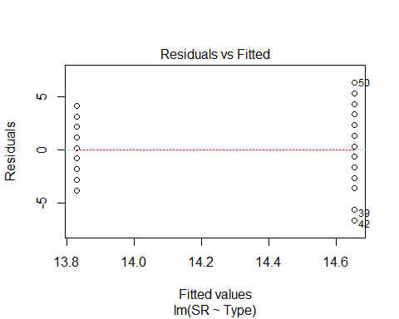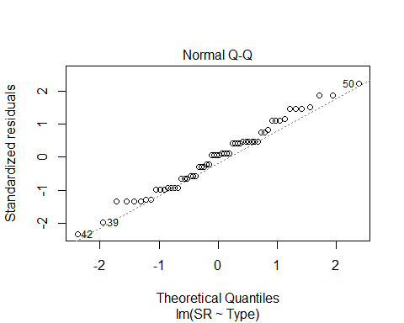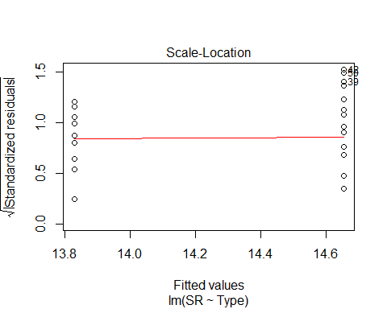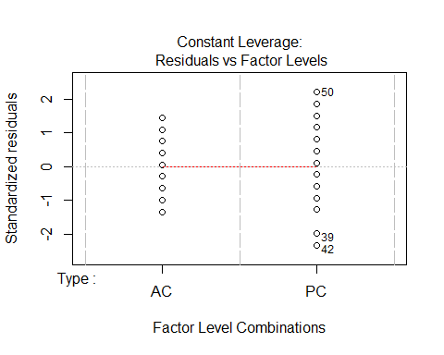

evaluation2<-lm(SR ~ Sdate, methodSR1) #non-significant  
summary(evaluation2)

##   
## Call:  
## lm(formula = SR ~ Sdate, data = methodSR1)  
##   
## Residuals:  
## Min 1Q Median 3Q Max   
## -6.2677 -2.2690 -0.0717 1.7310 6.7323   
##   
## Coefficients:  
## Estimate Std. Error t value Pr(>|t|)   
## (Intercept) 14.311221 0.562822 25.428 <2e-16 ***  
## Sdate -0.005445 0.031860 -0.171 0.865   
## ---  
## Signif. codes: 0 '***' 0.001 '**' 0.01 '*' 0.05 '.' 0.1 ' ' 1  
##   
## Residual standard error: 2.947 on 56 degrees of freedom  
## Multiple R-squared: 0.0005212, Adjusted R-squared: -0.01733   
## F-statistic: 0.0292 on 1 and 56 DF, p-value: 0.8649

confint(evaluation2, level=0.95)

## 2.5 % 97.5 %  
## (Intercept) 13.18375378 15.43868911  
## Sdate -0.06926792 0.05837855

anova(evaluation2)

## Analysis of Variance Table  
##   
## Response: SR  
## Df Sum Sq Mean Sq F value Pr(>F)  
## Sdate 1 0.25 0.2536 0.0292 0.8649  
## Residuals 56 486.37 8.6851

plot(evaluation2)

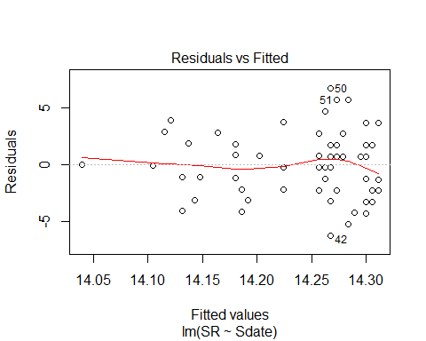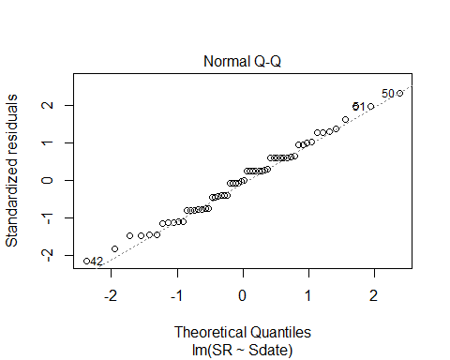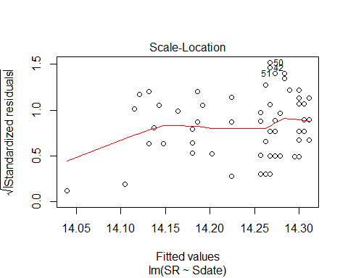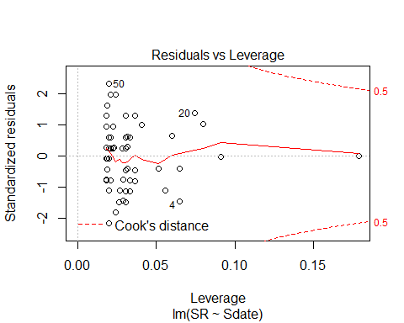

Sdate2<-methodSR1$Sdate^2  
Sdate2

## [1] 9 256 961 1089 529 576 900 729 100 484 400 1089 529 2500  
## [15] 16 576 100 576 1444 1225 100 100 1024 1296 4 256 64 4  
## [29] 256 4 4 1 49 49 1 81 64 64 25 25 49 64  
## [43] 64 4 4 81 4 4 36 64 49 81 1 0 0 36  
## [57] 0 0

evaluation2B<-lm(SR ~ Sdate2, methodSR1) #non-significant  
summary(evaluation2B)

##   
## Call:  
## lm(formula = SR ~ Sdate2, data = methodSR1)  
##   
## Residuals:  
## Min 1Q Median 3Q Max   
## -6.2788 -2.2792 0.0091 1.7206 6.7212   
##   
## Coefficients:  
## Estimate Std. Error t value Pr(>|t|)   
## (Intercept) 14.2884727 0.4593742 31.10 <2e-16 ***  
## Sdate2 -0.0001509 0.0007934 -0.19 0.85   
## ---  
## Signif. codes: 0 '***' 0.001 '**' 0.01 '*' 0.05 '.' 0.1 ' ' 1  
##   
## Residual standard error: 2.947 on 56 degrees of freedom  
## Multiple R-squared: 0.0006456, Adjusted R-squared: -0.0172   
## F-statistic: 0.03618 on 1 and 56 DF, p-value: 0.8498

confint(evaluation2B, level=0.95)

## 2.5 % 97.5 %  
## (Intercept) 13.368235525 15.208709827  
## Sdate2 -0.001740229 0.001438415

anova(evaluation2B)

## Analysis of Variance Table  
##   
## Response: SR  
## Df Sum Sq Mean Sq F value Pr(>F)  
## Sdate2 1 0.31 0.3142 0.0362 0.8498  
## Residuals 56 486.31 8.6840

plot(evaluation2B)

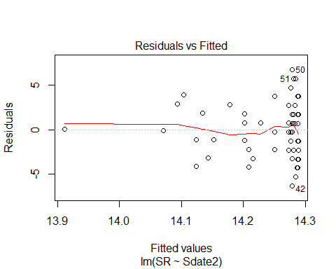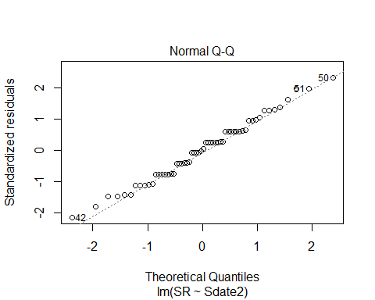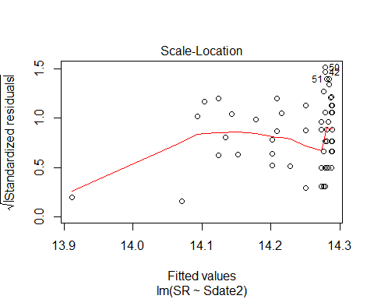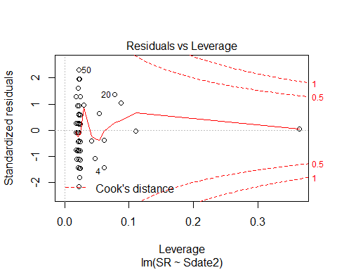

evaluation3<-lm(SR ~ Stime, methodSR1) #non-significant  
summary(evaluation3)

##   
## Call:  
## lm(formula = SR ~ Stime, data = methodSR1)  
##   
## Residuals:  
## Min 1Q Median 3Q Max   
## -6.1714 -2.2580 -0.1044 1.7512 6.6977   
##   
## Coefficients:  
## Estimate Std. Error t value Pr(>|t|)   
## (Intercept) 14.714004 2.769534 5.313 1.93e-06 ***  
## Stime -0.001056 0.006125 -0.172 0.864   
## ---  
## Signif. codes: 0 '***' 0.001 '**' 0.01 '*' 0.05 '.' 0.1 ' ' 1  
##   
## Residual standard error: 2.947 on 56 degrees of freedom  
## Multiple R-squared: 0.0005301, Adjusted R-squared: -0.01732   
## F-statistic: 0.0297 on 1 and 56 DF, p-value: 0.8638

confint(evaluation3, level=0.95)

## 2.5 % 97.5 %  
## (Intercept) 9.1659604 20.26204685  
## Stime -0.0133252 0.01121406

anova(evaluation3)

## Analysis of Variance Table  
##   
## Response: SR  
## Df Sum Sq Mean Sq F value Pr(>F)  
## Stime 1 0.26 0.258 0.0297 0.8638  
## Residuals 56 486.36 8.685

plot(evaluation3)

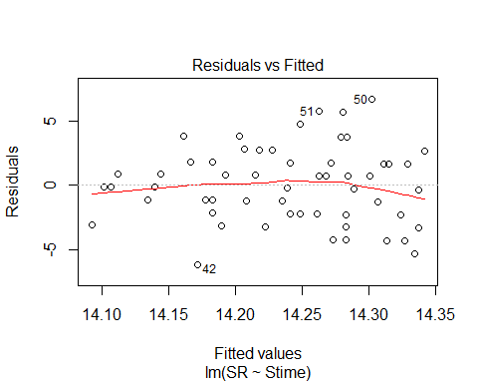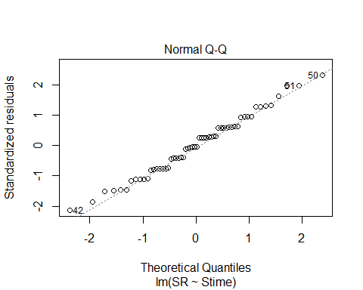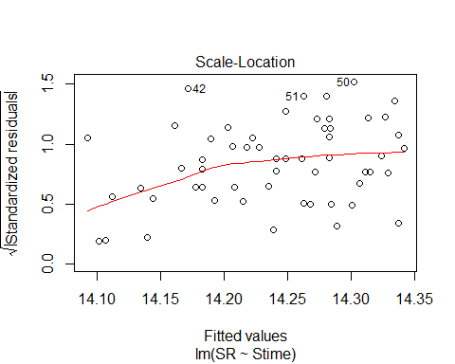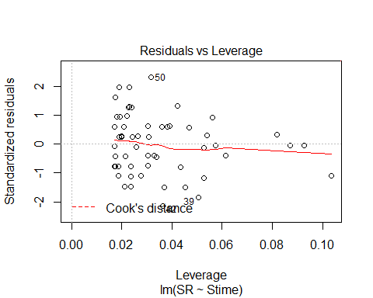

Stime2<-methodSR1$Stime^2  
evaluation3B<-lm(SR ~ Stime2, methodSR1) #non-significant  
summary(evaluation3B)

##   
## Call:  
## lm(formula = SR ~ Stime2, data = methodSR1)  
##   
## Residuals:  
## Min 1Q Median 3Q Max   
## -6.1399 -2.2716 -0.0222 1.7416 6.6697   
##   
## Coefficients:  
## Estimate Std. Error t value Pr(>|t|)   
## (Intercept) 1.459e+01 1.404e+00 10.393 1.11e-14 ***  
## Stime2 -1.699e-06 6.599e-06 -0.257 0.798   
## ---  
## Signif. codes: 0 '***' 0.001 '**' 0.01 '*' 0.05 '.' 0.1 ' ' 1  
##   
## Residual standard error: 2.946 on 56 degrees of freedom  
## Multiple R-squared: 0.001182, Adjusted R-squared: -0.01665   
## F-statistic: 0.06624 on 1 and 56 DF, p-value: 0.7978

confint(evaluation3B, level=0.95)

## 2.5 % 97.5 %  
## (Intercept) 1.177670e+01 1.740065e+01  
## Stime2 -1.491892e-05 1.152180e-05

anova(evaluation3B)

## Analysis of Variance Table  
##   
## Response: SR  
## Df Sum Sq Mean Sq F value Pr(>F)  
## Stime2 1 0.57 0.5750 0.0662 0.7978  
## Residuals 56 486.05 8.6794

plot(evaluation3B)

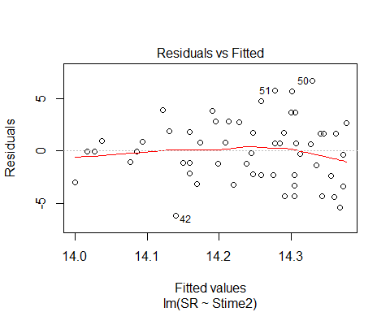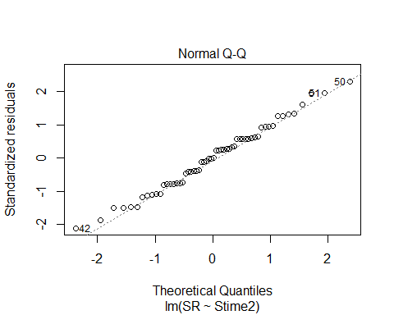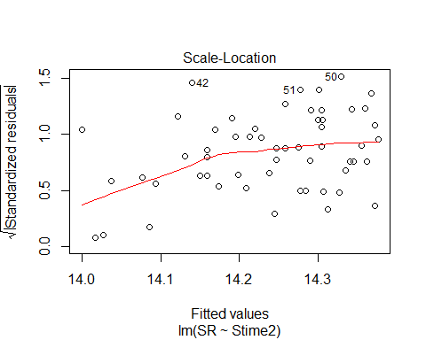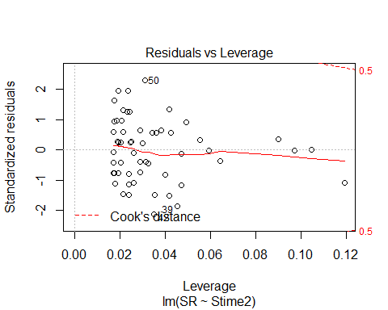

evaluation4<-lm(SR ~ Pdate, methodSR1) #non-significant  
summary(evaluation4)

##   
## Call:  
## lm(formula = SR ~ Pdate, data = methodSR1)  
##   
## Residuals:  
## Min 1Q Median 3Q Max   
## -3.8595 -1.8649 0.1784 2.1568 4.1946   
##   
## Coefficients:  
## Estimate Std. Error t value Pr(>|t|)  
## (Intercept) -2.196e+02 4.516e+03 -0.049 0.962  
## Pdate 5.405e-03 1.046e-01 0.052 0.959  
##   
## Residual standard error: 2.667 on 27 degrees of freedom  
## (29 observations deleted due to missingness)  
## Multiple R-squared: 9.895e-05, Adjusted R-squared: -0.03693   
## F-statistic: 0.002672 on 1 and 27 DF, p-value: 0.9592

confint(evaluation4, level=0.95)

## 2.5 % 97.5 %  
## (Intercept) -9486.472261 9047.2182069  
## Pdate -0.209159 0.2199698

anova(evaluation4)

## Analysis of Variance Table  
##   
## Response: SR  
## Df Sum Sq Mean Sq F value Pr(>F)  
## Pdate 1 0.019 0.0190 0.0027 0.9592  
## Residuals 27 192.119 7.1155

plot(evaluation4)

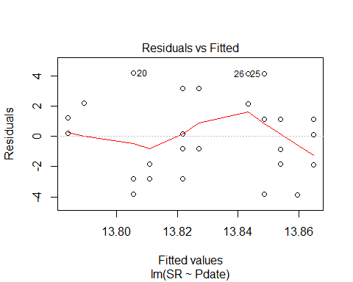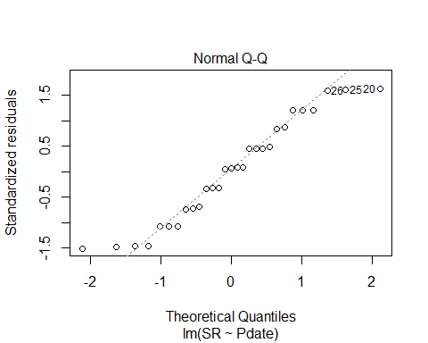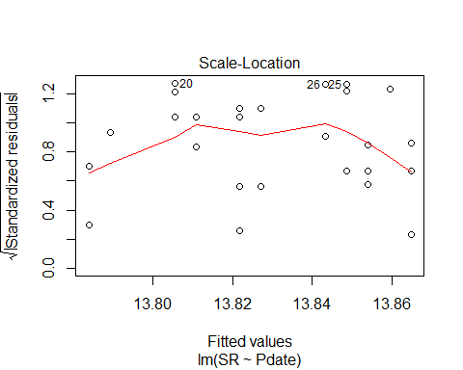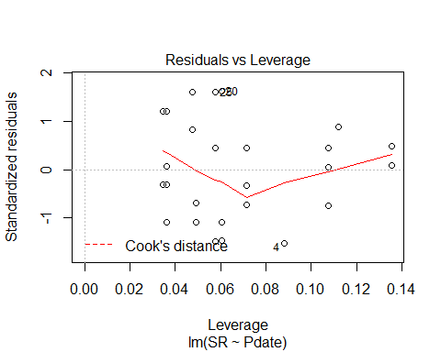

Pdate2<-(methodSR1$Pdate)^2  
evaluation4B<-lm(SR ~ Pdate2, methodSR1) #non-significant  
summary(evaluation4B)

##   
## Call:  
## lm(formula = SR ~ Pdate2, data = methodSR1)  
##   
## Residuals:  
## Min 1Q Median 3Q Max   
## -3.8595 -1.8649 0.1784 2.1568 4.1946   
##   
## Coefficients:  
## Estimate Std. Error t value Pr(>|t|)  
## (Intercept) -1.029e+02 2.258e+03 -0.046 0.964  
## Pdate2 6.257e-08 1.211e-06 0.052 0.959  
##   
## Residual standard error: 2.667 on 27 degrees of freedom  
## (29 observations deleted due to missingness)  
## Multiple R-squared: 9.891e-05, Adjusted R-squared: -0.03693   
## F-statistic: 0.002671 on 1 and 27 DF, p-value: 0.9592

confint(evaluation4B, level=0.95)

## 2.5 % 97.5 %  
## (Intercept) -4.736346e+03 4.530587e+03  
## Pdate2 -2.421467e-06 2.546602e-06

anova(evaluation4B)

## Analysis of Variance Table  
##   
## Response: SR  
## Df Sum Sq Mean Sq F value Pr(>F)  
## Pdate2 1 0.019 0.0190 0.0027 0.9592  
## Residuals 27 192.119 7.1155

plot(evaluation4B)

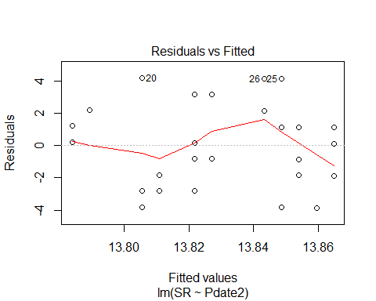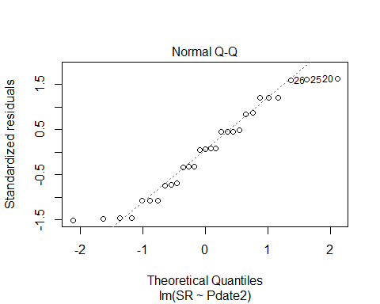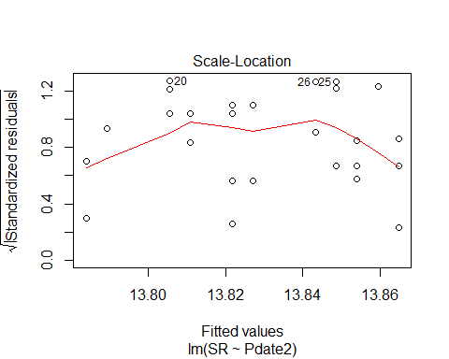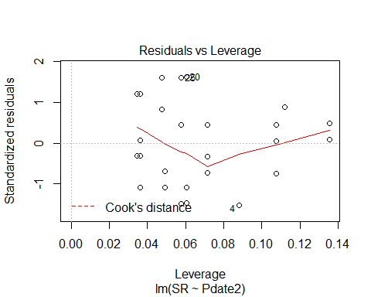

Pdate3<-(methodSR1$Pdate)^3  
evaluation4C<-lm(SR ~ Pdate + Pdate2 + Pdate3, methodSR1) #non-significant  
summary(evaluation4C)

##   
## Call:  
## lm(formula = SR ~ Pdate + Pdate2 + Pdate3, data = methodSR1)  
##   
## Residuals:  
## Min 1Q Median 3Q Max   
## -3.8595 -1.8649 0.1784 2.1568 4.1946   
##   
## Coefficients: (2 not defined because of singularities)  
## Estimate Std. Error t value Pr(>|t|)  
## (Intercept) -2.196e+02 4.516e+03 -0.049 0.962  
## Pdate 5.405e-03 1.046e-01 0.052 0.959  
## Pdate2 NA NA NA NA  
## Pdate3 NA NA NA NA  
##   
## Residual standard error: 2.667 on 27 degrees of freedom  
## (29 observations deleted due to missingness)  
## Multiple R-squared: 9.895e-05, Adjusted R-squared: -0.03693   
## F-statistic: 0.002672 on 1 and 27 DF, p-value: 0.9592

confint(evaluation4C, level=0.95)

## 2.5 % 97.5 %  
## (Intercept) -9486.472261 9047.2182069  
## Pdate -0.209159 0.2199698  
## Pdate2 NA NA  
## Pdate3 NA NA

anova(evaluation4C)

## Analysis of Variance Table  
##   
## Response: SR  
## Df Sum Sq Mean Sq F value Pr(>F)  
## Pdate 1 0.019 0.0190 0.0027 0.9592  
## Residuals 27 192.119 7.1155

plot(evaluation4C)

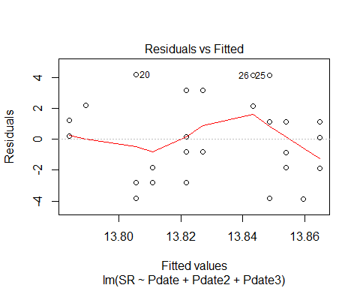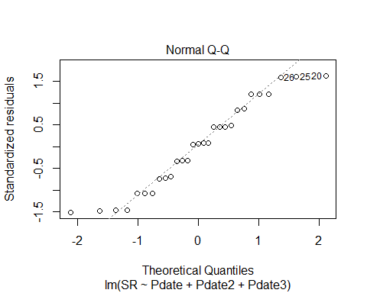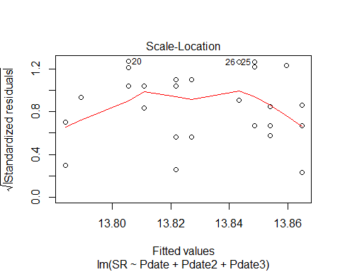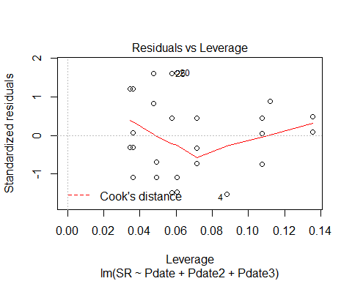

evaluation5<-lm(SR ~ Pmin, methodSR1) #significant + linear relationship   
summary(evaluation5)

##   
## Call:  
## lm(formula = SR ~ Pmin, data = methodSR1)  
##   
## Residuals:  
## Min 1Q Median 3Q Max   
## -4.3312 -1.6130 0.2438 1.5256 3.9575   
##   
## Coefficients:  
## Estimate Std. Error t value Pr(>|t|)   
## (Intercept) 10.17878 1.02969 9.885 1.82e-10 ***  
## Pmin 0.14319 0.03726 3.843 0.00067 ***  
## ---  
## Signif. codes: 0 '***' 0.001 '**' 0.01 '*' 0.05 '.' 0.1 ' ' 1  
##   
## Residual standard error: 2.145 on 27 degrees of freedom  
## (29 observations deleted due to missingness)  
## Multiple R-squared: 0.3535, Adjusted R-squared: 0.3296   
## F-statistic: 14.77 on 1 and 27 DF, p-value: 0.00067

confint(evaluation5, level=0.95)

## 2.5 % 97.5 %  
## (Intercept) 8.06603845 12.2915237  
## Pmin 0.06673188 0.2196425

anova(evaluation5)

## Analysis of Variance Table  
##   
## Response: SR  
## Df Sum Sq Mean Sq F value Pr(>F)   
## Pmin 1 67.93 67.93 14.766 0.00067 ***  
## Residuals 27 124.21 4.60   
## ---  
## Signif. codes: 0 '***' 0.001 '**' 0.01 '*' 0.05 '.' 0.1 ' ' 1

plot(evaluation5)

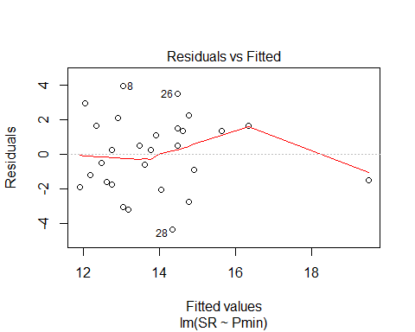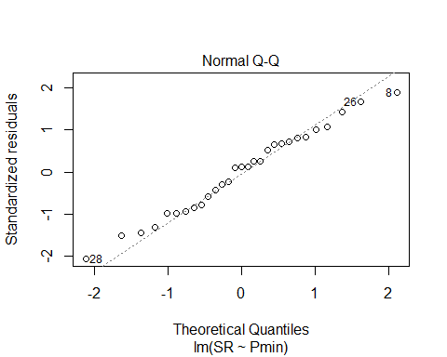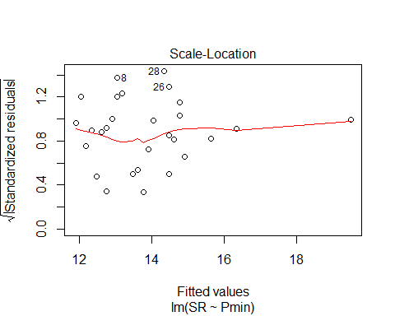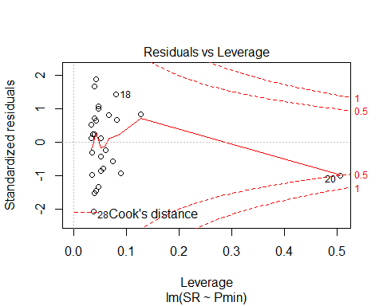

evaluation6<-lm(SR ~ Peffort, methodSR1) #significant + linear relationship  
summary(evaluation6)

##   
## Call:  
## lm(formula = SR ~ Peffort, data = methodSR1)  
##   
## Residuals:  
## Min 1Q Median 3Q Max   
## -4.8147 -1.4834 0.2791 1.6603 4.8979   
##   
## Coefficients:  
## Estimate Std. Error t value Pr(>|t|)   
## (Intercept) 11.8646 0.8140 14.576 2.57e-14 ***  
## Peffort 0.6188 0.2170 2.851 0.00825 **   
## ---  
## Signif. codes: 0 '***' 0.001 '**' 0.01 '*' 0.05 '.' 0.1 ' ' 1  
##   
## Residual standard error: 2.339 on 27 degrees of freedom  
## (29 observations deleted due to missingness)  
## Multiple R-squared: 0.2314, Adjusted R-squared: 0.203   
## F-statistic: 8.13 on 1 and 27 DF, p-value: 0.008245

confint(evaluation6, level=0.95)

## 2.5 % 97.5 %  
## (Intercept) 10.1944675 13.534749  
## Peffort 0.1734964 1.064033

anova(evaluation6)

## Analysis of Variance Table  
##   
## Response: SR  
## Df Sum Sq Mean Sq F value Pr(>F)   
## Peffort 1 44.466 44.466 8.13 0.008245 **  
## Residuals 27 147.672 5.469   
## ---  
## Signif. codes: 0 '***' 0.001 '**' 0.01 '*' 0.05 '.' 0.1 ' ' 1

plot(evaluation6)

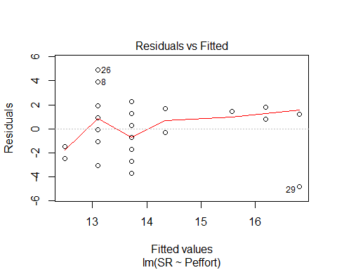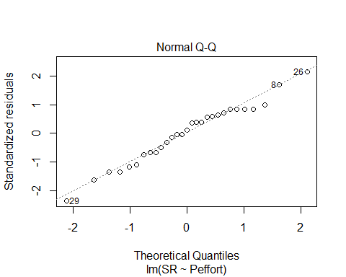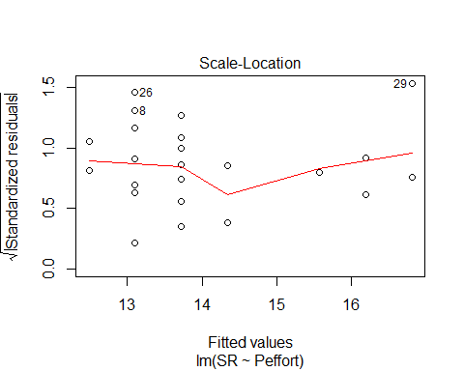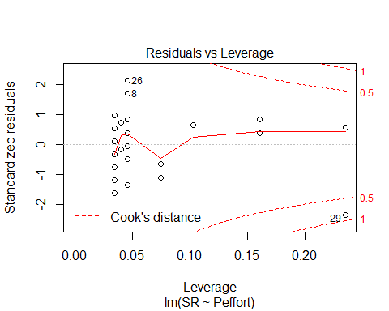

Peffort2<-(methodSR1$Peffort)^2  
evaluation6B<-lm(SR ~ Peffort2, methodSR1) #significant + linear relationship  
summary(evaluation6B)

##   
## Call:  
## lm(formula = SR ~ Peffort2, data = methodSR1)  
##   
## Residuals:  
## Min 1Q Median 3Q Max   
## -4.8789 -2.0289 0.4822 1.7877 4.7877   
##   
## Coefficients:  
## Estimate Std. Error t value Pr(>|t|)   
## (Intercept) 12.96782 0.56083 23.122 <2e-16 ***  
## Peffort2 0.06111 0.02421 2.524 0.0178 *   
## ---  
## Signif. codes: 0 '***' 0.001 '**' 0.01 '*' 0.05 '.' 0.1 ' ' 1  
##   
## Residual standard error: 2.399 on 27 degrees of freedom  
## (29 observations deleted due to missingness)  
## Multiple R-squared: 0.1909, Adjusted R-squared: 0.161   
## F-statistic: 6.372 on 1 and 27 DF, p-value: 0.01778

confint(evaluation6B, level=0.95)

## 2.5 % 97.5 %  
## (Intercept) 11.81708282 14.1185560  
## Peffort2 0.01143857 0.1107832

anova(evaluation6B)

## Analysis of Variance Table  
##   
## Response: SR  
## Df Sum Sq Mean Sq F value Pr(>F)   
## Peffort2 1 36.688 36.688 6.3722 0.01778 *  
## Residuals 27 155.450 5.757   
## ---  
## Signif. codes: 0 '***' 0.001 '**' 0.01 '*' 0.05 '.' 0.1 ' ' 1

plot(evaluation6B)

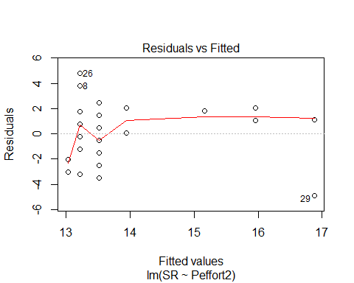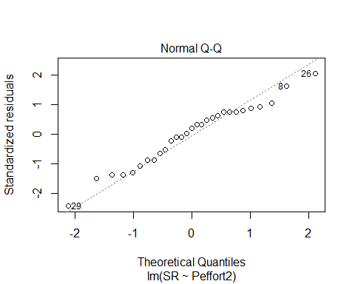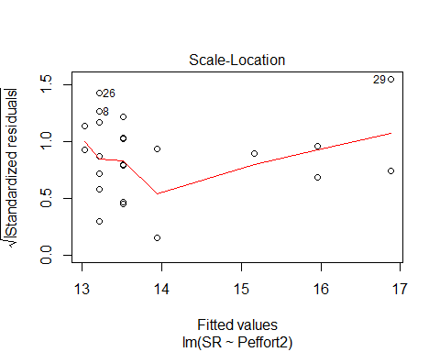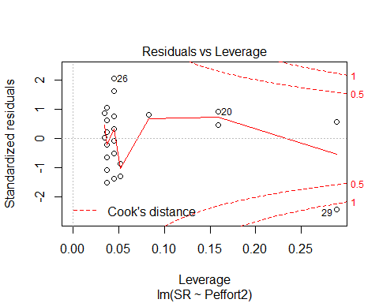

Peffort3<-(methodSR1$Peffort)^3  
evaluation6C<-lm(SR ~ Peffort3, methodSR1) #significant + linear relationship  
summary(evaluation6C)

##   
## Call:  
## lm(formula = SR ~ Peffort3, data = methodSR1)  
##   
## Residuals:  
## Min 1Q Median 3Q Max   
## -4.8269 -2.2729 0.5463 1.6784 4.6784   
##   
## Coefficients:  
## Estimate Std. Error t value Pr(>|t|)   
## (Intercept) 13.265910 0.517922 25.614 <2e-16 ***  
## Peffort3 0.006955 0.003079 2.259 0.0322 *   
## ---  
## Signif. codes: 0 '***' 0.001 '**' 0.01 '*' 0.05 '.' 0.1 ' ' 1  
##   
## Residual standard error: 2.447 on 27 degrees of freedom  
## (29 observations deleted due to missingness)  
## Multiple R-squared: 0.1589, Adjusted R-squared: 0.1277   
## F-statistic: 5.101 on 1 and 27 DF, p-value: 0.0322

confint(evaluation6C, level=0.95)

## 2.5 % 97.5 %  
## (Intercept) 1.220322e+01 14.32859766  
## Peffort3 6.364656e-04 0.01327352

anova(evaluation6C)

## Analysis of Variance Table  
##   
## Response: SR  
## Df Sum Sq Mean Sq F value Pr(>F)   
## Peffort3 1 30.531 30.5310 5.1009 0.0322 *  
## Residuals 27 161.607 5.9854   
## ---  
## Signif. codes: 0 '***' 0.001 '**' 0.01 '*' 0.05 '.' 0.1 ' ' 1

plot(evaluation6C)

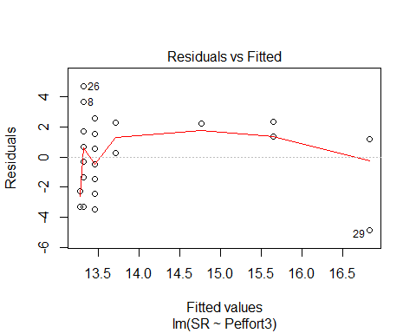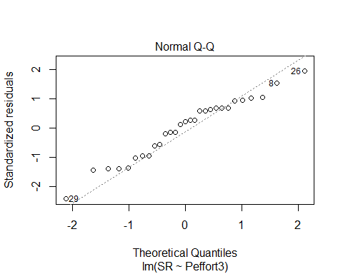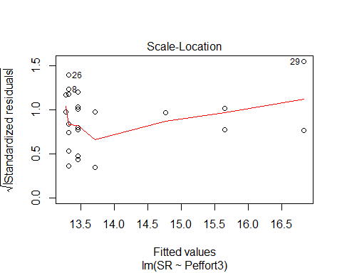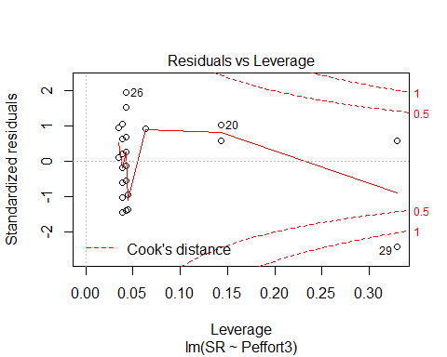

# Visit 2

#File read-in  
# as of 6/22, this one-visit breakdown has had unknowns REMOVED now (in both AC + PC)  
methodSR2 <-read.csv("17_2by2_ACPC_SR.csv") #SR by count #2 each - Site Type SR  
#summary(methodSR2)  
str(methodSR2)

## 'data.frame': 58 obs. of 9 variables:  
## $ SiteName: Factor w/ 29 levels "Abercrombie_0B_E_AB",..: 3 4 5 7 8 12 13 14 15 16 ...  
## $ Type : Factor w/ 2 levels "AC","PC": 1 1 1 1 1 1 1 1 1 1 ...  
## $ SR : int 17 15 12 9 9 16 13 11 17 13 ...  
## $ Sdate : int 2 17 28 36 22 25 35 28 9 22 ...  
## $ Stime : int 426 353 553 355 354 558 386 425 521 514 ...  
## $ Pdate : int 43201 43201 43203 43209 43210 43202 43205 43205 43206 43205 ...  
## $ Pmin : int 39 25 37 14 15 15 18 22 15 21 ...  
## $ Peffort : int 4 3 7 1 1 2 2 2 2 2 ...  
## $ Year : Factor w/ 1 level "A": 1 1 1 1 1 1 1 1 1 1 ...

plot(methodSR2$SR ~ methodSR2$Type) #more equalized

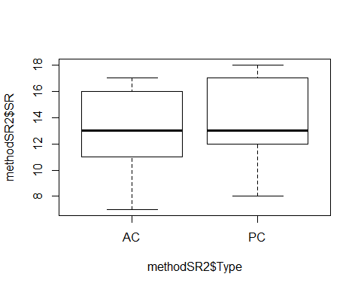

#plot(SR ~ Type, data=methodSR) #same as above

evaluation7<-lm(SR ~ Type, methodSR2) #non-sig  
summary(evaluation7)

##   
## Call:  
## lm(formula = SR ~ Type, data = methodSR2)  
##   
## Residuals:  
## Min 1Q Median 3Q Max   
## -6.3793 -1.9655 -0.3793 3.0345 4.0345   
##   
## Coefficients:  
## Estimate Std. Error t value Pr(>|t|)   
## (Intercept) 13.3793 0.5435 24.615 <2e-16 ***  
## TypePC 0.5862 0.7687 0.763 0.449   
## ---  
## Signif. codes: 0 '***' 0.001 '**' 0.01 '*' 0.05 '.' 0.1 ' ' 1  
##   
## Residual standard error: 2.927 on 56 degrees of freedom  
## Multiple R-squared: 0.01028, Adjusted R-squared: -0.007395   
## F-statistic: 0.5816 on 1 and 56 DF, p-value: 0.4489

confint(evaluation7, level=0.95)

## 2.5 % 97.5 %  
## (Intercept) 12.2904627 14.46816  
## TypePC -0.9536563 2.12607

anova(evaluation7)

## Analysis of Variance Table  
##   
## Response: SR  
## Df Sum Sq Mean Sq F value Pr(>F)  
## Type 1 4.98 4.9828 0.5816 0.4489  
## Residuals 56 479.79 8.5677

evaluation8<-lm(SR ~ Sdate, methodSR2) #non-signficant  
summary(evaluation8)

##   
## Call:  
## lm(formula = SR ~ Sdate, data = methodSR2)  
##   
## Residuals:  
## Min 1Q Median 3Q Max   
## -5.9232 -1.8455 -0.4475 2.6715 4.5720   
##   
## Coefficients:  
## Estimate Std. Error t value Pr(>|t|)   
## (Intercept) 12.84556 0.95397 13.465 <2e-16 ***  
## Sdate 0.03883 0.04103 0.947 0.348   
## ---  
## Signif. codes: 0 '***' 0.001 '**' 0.01 '*' 0.05 '.' 0.1 ' ' 1  
##   
## Residual standard error: 2.919 on 56 degrees of freedom  
## Multiple R-squared: 0.01575, Adjusted R-squared: -0.00183   
## F-statistic: 0.8959 on 1 and 56 DF, p-value: 0.348

confint(evaluation8, level=0.95)

## 2.5 % 97.5 %  
## (Intercept) 10.93452241 14.7565916  
## Sdate -0.04335454 0.1210188

anova(evaluation8)

## Analysis of Variance Table  
##   
## Response: SR  
## Df Sum Sq Mean Sq F value Pr(>F)  
## Sdate 1 7.63 7.6332 0.8959 0.348  
## Residuals 56 477.14 8.5204

evaluation9<-lm(SR ~ Stime, methodSR2) #non-signficant  
summary(evaluation9)

##   
## Call:  
## lm(formula = SR ~ Stime, data = methodSR2)  
##   
## Residuals:  
## Min 1Q Median 3Q Max   
## -6.9175 -1.6896 -0.5347 3.1973 4.4687   
##   
## Coefficients:  
## Estimate Std. Error t value Pr(>|t|)   
## (Intercept) 12.911893 2.660799 4.853 1.01e-05 ***  
## Stime 0.001740 0.006022 0.289 0.774   
## ---  
## Signif. codes: 0 '***' 0.001 '**' 0.01 '*' 0.05 '.' 0.1 ' ' 1  
##   
## Residual standard error: 2.94 on 56 degrees of freedom  
## Multiple R-squared: 0.001488, Adjusted R-squared: -0.01634   
## F-statistic: 0.08345 on 1 and 56 DF, p-value: 0.7737

confint(evaluation9, level=0.95)

## 2.5 % 97.5 %  
## (Intercept) 7.58167139 18.24211500  
## Stime -0.01032466 0.01380421

anova(evaluation9)

## Analysis of Variance Table  
##   
## Response: SR  
## Df Sum Sq Mean Sq F value Pr(>F)  
## Stime 1 0.72 0.7213 0.0835 0.7737  
## Residuals 56 484.05 8.6438

evaluation10<-lm(SR ~ Pdate, methodSR2) #non-signficant  
summary(evaluation10)

##   
## Call:  
## lm(formula = SR ~ Pdate, data = methodSR2)  
##   
## Residuals:  
## Min 1Q Median 3Q Max   
## -5.7685 -2.2651 -0.0929 2.9071 4.3970   
##   
## Coefficients:  
## Estimate Std. Error t value Pr(>|t|)  
## (Intercept) -7139.1104 8308.4341 -0.859 0.398  
## Pdate 0.1655 0.1923 0.861 0.397  
##   
## Residual standard error: 3.078 on 27 degrees of freedom  
## (29 observations deleted due to missingness)  
## Multiple R-squared: 0.02671, Adjusted R-squared: -0.009333   
## F-statistic: 0.7411 on 1 and 27 DF, p-value: 0.3969

confint(evaluation10, level=0.95)

## 2.5 % 97.5 %  
## (Intercept) -24186.608951 9908.3882241  
## Pdate -0.229021 0.5601111

anova(evaluation10)

## Analysis of Variance Table  
##   
## Response: SR  
## Df Sum Sq Mean Sq F value Pr(>F)  
## Pdate 1 7.021 7.0214 0.7411 0.3969  
## Residuals 27 255.806 9.4743

evaluation11<-lm(SR ~ Pmin, methodSR2) #non-signficant  
summary(evaluation11)

##   
## Call:  
## lm(formula = SR ~ Pmin, data = methodSR2)  
##   
## Residuals:  
## Min 1Q Median 3Q Max   
## -5.968 -2.264 -0.190 3.033 4.181   
##   
## Coefficients:  
## Estimate Std. Error t value Pr(>|t|)   
## (Intercept) 11.85476 1.64894 7.189 9.88e-08 ***  
## Pmin 0.07418 0.07530 0.985 0.333   
## ---  
## Signif. codes: 0 '***' 0.001 '**' 0.01 '*' 0.05 '.' 0.1 ' ' 1  
##   
## Residual standard error: 3.065 on 27 degrees of freedom  
## (29 observations deleted due to missingness)  
## Multiple R-squared: 0.0347, Adjusted R-squared: -0.001056   
## F-statistic: 0.9705 on 1 and 27 DF, p-value: 0.3333

confint(evaluation11, level=0.95)

## 2.5 % 97.5 %  
## (Intercept) 8.47142147 15.2380962  
## Pmin -0.08032403 0.2286864

anova(evaluation11)

## Analysis of Variance Table  
##   
## Response: SR  
## Df Sum Sq Mean Sq F value Pr(>F)  
## Pmin 1 9.119 9.1192 0.9705 0.3333  
## Residuals 27 253.708 9.3966

evaluation12<-lm(SR ~ Peffort, methodSR2) #signficant + linear relationship!  
summary(evaluation12)

##   
## Call:  
## lm(formula = SR ~ Peffort, data = methodSR2)  
##   
## Residuals:  
## Min 1Q Median 3Q Max   
## -5.9344 -2.1874 -0.1874 2.8126 4.0656   
##   
## Coefficients:  
## Estimate Std. Error t value Pr(>|t|)   
## (Intercept) 12.6814 0.9932 12.769 5.92e-13 ***  
## Peffort 0.2530 0.2944 0.859 0.398   
## ---  
## Signif. codes: 0 '***' 0.001 '**' 0.01 '*' 0.05 '.' 0.1 ' ' 1  
##   
## Residual standard error: 3.078 on 27 degrees of freedom  
## (29 observations deleted due to missingness)  
## Multiple R-squared: 0.02662, Adjusted R-squared: -0.00943   
## F-statistic: 0.7384 on 1 and 27 DF, p-value: 0.3977

confint(evaluation12, level=0.95)

## 2.5 % 97.5 %  
## (Intercept) 10.6435791 14.7191969  
## Peffort -0.3510985 0.8570922

anova(evaluation12)

## Analysis of Variance Table  
##   
## Response: SR  
## Df Sum Sq Mean Sq F value Pr(>F)  
## Peffort 1 6.997 6.9967 0.7384 0.3977  
## Residuals 27 255.831 9.4752

# Visit 3

#File read-in  
# as of 6/22, this one-visit breakdown has had unknowns REMOVED now (in both AC + PC)  
methodSR3 <-read.csv("17_3by3_ACPC_SR.csv") #SR by count #3 each - Site Type SR  
#summary(methodSR3)  
str(methodSR3)

## 'data.frame': 58 obs. of 9 variables:  
## $ SiteName: Factor w/ 29 levels "Abercrombie_0B_E_AB",..: 3 4 5 7 8 12 13 14 15 16 ...  
## $ Type : Factor w/ 2 levels "AC","PC": 1 1 1 1 1 1 1 1 1 1 ...  
## $ SR : int 10 16 11 16 16 16 14 14 15 14 ...  
## $ Sdate : int 15 18 47 33 22 33 34 29 10 20 ...  
## $ Stime : int 363 500 380 513 559 507 526 359 395 566 ...  
## $ Pdate : int 43214 43214 43216 43219 43220 43215 43216 43216 43217 43216 ...  
## $ Pmin : int 18 15 14 27 12 26 14 19 24 19 ...  
## $ Peffort : int 1 2 2 7 2 8 2 4 5 5 ...  
## $ Year : Factor w/ 1 level "A": 1 1 1 1 1 1 1 1 1 1 ...

plot(methodSR3$SR ~ methodSR3$Type) #

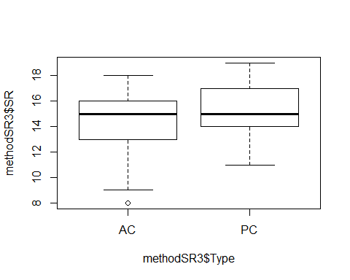

#plot(SR ~ Type, data=methodSR) #same as above

evaluation13<-lm(SR ~ Type, methodSR3) #non-significant  
summary(evaluation13)

##   
## Call:  
## lm(formula = SR ~ Type, data = methodSR3)  
##   
## Residuals:  
## Min 1Q Median 3Q Max   
## -6.4828 -1.1724 0.5172 1.5172 3.8276   
##   
## Coefficients:  
## Estimate Std. Error t value Pr(>|t|)   
## (Intercept) 14.4828 0.4449 32.556 <2e-16 ***  
## TypePC 0.6897 0.6291 1.096 0.278   
## ---  
## Signif. codes: 0 '***' 0.001 '**' 0.01 '*' 0.05 '.' 0.1 ' ' 1  
##   
## Residual standard error: 2.396 on 56 degrees of freedom  
## Multiple R-squared: 0.02101, Adjusted R-squared: 0.003526   
## F-statistic: 1.202 on 1 and 56 DF, p-value: 0.2777

confint(evaluation13, level=0.95)

## 2.5 % 97.5 %  
## (Intercept) 13.5916122 15.373905  
## TypePC -0.5706162 1.949927

anova(evaluation13)

## Analysis of Variance Table  
##   
## Response: SR  
## Df Sum Sq Mean Sq F value Pr(>F)  
## Type 1 6.90 6.8966 1.2017 0.2777  
## Residuals 56 321.38 5.7389

evaluation14<-lm(SR ~ Sdate, methodSR3) #non-significant  
summary(evaluation14)

##   
## Call:  
## lm(formula = SR ~ Sdate, data = methodSR3)  
##   
## Residuals:  
## Min 1Q Median 3Q Max   
## -6.9003 -0.8524 0.1678 1.1720 4.1465   
##   
## Coefficients:  
## Estimate Std. Error t value Pr(>|t|)   
## (Intercept) 14.981252 0.390418 38.372 <2e-16 ***  
## Sdate -0.004258 0.006329 -0.673 0.504   
## ---  
## Signif. codes: 0 '***' 0.001 '**' 0.01 '*' 0.05 '.' 0.1 ' ' 1  
##   
## Residual standard error: 2.411 on 56 degrees of freedom  
## Multiple R-squared: 0.008018, Adjusted R-squared: -0.009696   
## F-statistic: 0.4527 on 1 and 56 DF, p-value: 0.5038

confint(evaluation14, level=0.95)

## 2.5 % 97.5 %  
## (Intercept) 14.19915199 15.763352555  
## Sdate -0.01693734 0.008420727

anova(evaluation14)

## Analysis of Variance Table  
##   
## Response: SR  
## Df Sum Sq Mean Sq F value Pr(>F)  
## Sdate 1 2.63 2.6322 0.4527 0.5038  
## Residuals 56 325.64 5.8151

evaluation15<-lm(SR ~ Stime, methodSR3) #significant +!  
summary(evaluation15)

##   
## Call:  
## lm(formula = SR ~ Stime, data = methodSR3)  
##   
## Residuals:  
## Min 1Q Median 3Q Max   
## -5.9696 -1.2562 0.0823 1.4125 4.6254   
##   
## Coefficients:  
## Estimate Std. Error t value Pr(>|t|)   
## (Intercept) 10.23114 2.21645 4.616 2.33e-05 ***  
## Stime 0.01039 0.00496 2.094 0.0408 *   
## ---  
## Signif. codes: 0 '***' 0.001 '**' 0.01 '*' 0.05 '.' 0.1 ' ' 1  
##   
## Residual standard error: 2.332 on 56 degrees of freedom  
## Multiple R-squared: 0.07261, Adjusted R-squared: 0.05605   
## F-statistic: 4.384 on 1 and 56 DF, p-value: 0.04081

confint(evaluation15, level=0.95)

## 2.5 % 97.5 %  
## (Intercept) 5.7910620421 14.6712080  
## Stime 0.0004494594 0.0203198

anova(evaluation15)

## Analysis of Variance Table  
##   
## Response: SR  
## Df Sum Sq Mean Sq F value Pr(>F)   
## Stime 1 23.835 23.8349 4.3843 0.04081 *  
## Residuals 56 304.441 5.4364   
## ---  
## Signif. codes: 0 '***' 0.001 '**' 0.01 '*' 0.05 '.' 0.1 ' ' 1

plot(SR ~ Stime, methodSR3)

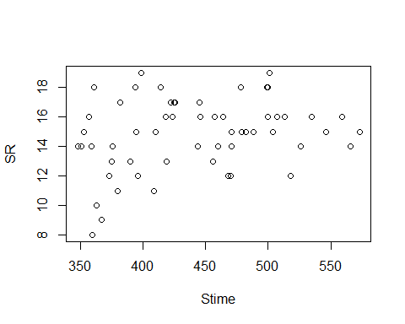

plot(evaluation15)

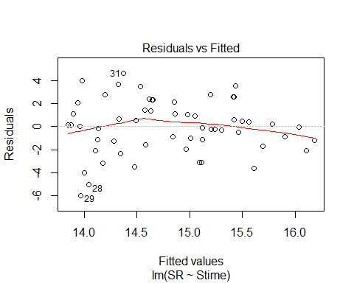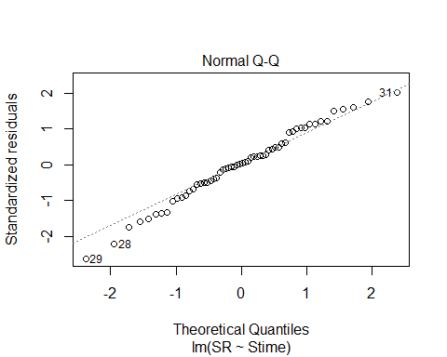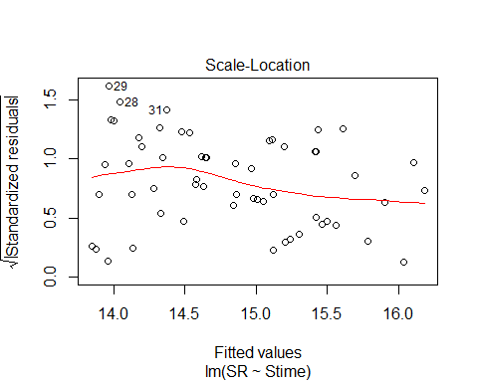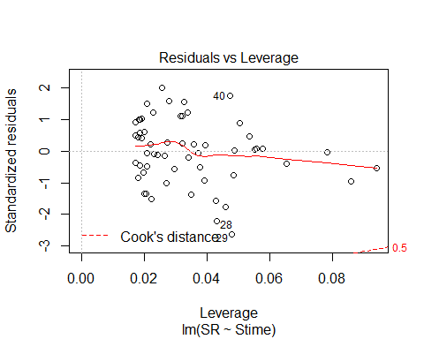

evaluation16<-lm(SR ~ Pdate, methodSR3) #significant +!  
summary(evaluation16)

##   
## Call:  
## lm(formula = SR ~ Pdate, data = methodSR3)  
##   
## Residuals:  
## Min 1Q Median 3Q Max   
## -5.8546 -0.8906 0.1454 0.8684 3.6634   
##   
## Coefficients:  
## Estimate Std. Error t value Pr(>|t|)   
## (Intercept) -3.279e+04 9.885e+03 -3.317 0.00261 **  
## Pdate 7.590e-01 2.287e-01 3.318 0.00260 **  
## ---  
## Signif. codes: 0 '***' 0.001 '**' 0.01 '*' 0.05 '.' 0.1 ' ' 1  
##   
## Residual standard error: 2.171 on 27 degrees of freedom  
## (29 observations deleted due to missingness)  
## Multiple R-squared: 0.2897, Adjusted R-squared: 0.2634   
## F-statistic: 11.01 on 1 and 27 DF, p-value: 0.002597

confint(evaluation16, level=0.95)

## 2.5 % 97.5 %  
## (Intercept) -5.306816e+04 -12505.154898  
## Pdate 2.896936e-01 1.228287

anova(evaluation16)

## Analysis of Variance Table  
##   
## Response: SR  
## Df Sum Sq Mean Sq F value Pr(>F)   
## Pdate 1 51.925 51.925 11.012 0.002597 **  
## Residuals 27 127.316 4.715   
## ---  
## Signif. codes: 0 '***' 0.001 '**' 0.01 '*' 0.05 '.' 0.1 ' ' 1

plot(SR ~ Pdate, methodSR3)

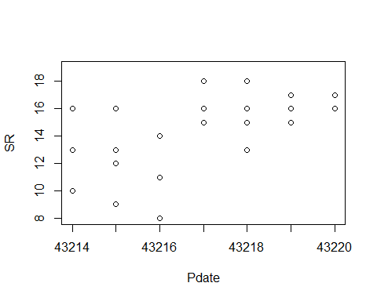

plot(evaluation16)

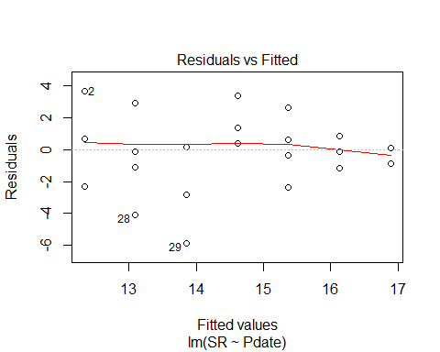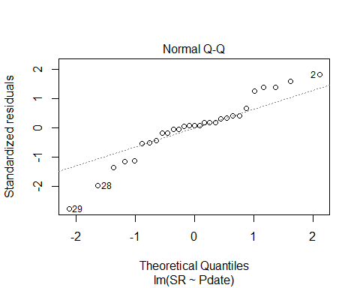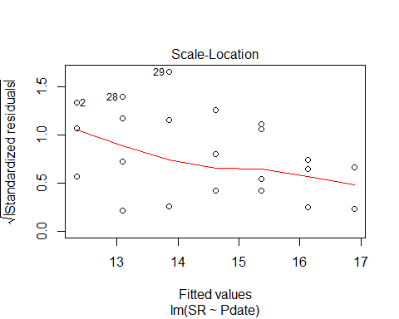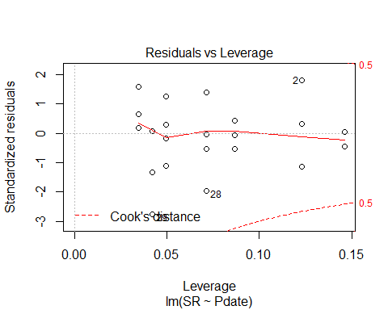

evaluation17<-lm(SR ~ Pmin, methodSR3) #non-significant  
summary(evaluation17)

##   
## Call:  
## lm(formula = SR ~ Pmin, data = methodSR3)  
##   
## Residuals:  
## Min 1Q Median 3Q Max   
## -6.3405 -1.4081 0.5581 1.5919 3.6257   
##   
## Coefficients:  
## Estimate Std. Error t value Pr(>|t|)   
## (Intercept) 13.93455 1.81783 7.666 3.03e-08 ***  
## Pmin 0.03383 0.10822 0.313 0.757   
## ---  
## Signif. codes: 0 '***' 0.001 '**' 0.01 '*' 0.05 '.' 0.1 ' ' 1  
##   
## Residual standard error: 2.572 on 27 degrees of freedom  
## (29 observations deleted due to missingness)  
## Multiple R-squared: 0.003605, Adjusted R-squared: -0.0333   
## F-statistic: 0.09769 on 1 and 27 DF, p-value: 0.757

confint(evaluation17, level=0.95)

## 2.5 % 97.5 %  
## (Intercept) 10.2046756 17.6644171  
## Pmin -0.1882304 0.2558821

anova(evaluation17)

## Analysis of Variance Table  
##   
## Response: SR  
## Df Sum Sq Mean Sq F value Pr(>F)  
## Pmin 1 0.646 0.6462 0.0977 0.757  
## Residuals 27 178.595 6.6146

evaluation18<-lm(SR ~ Peffort, methodSR3) #close but not sig  
summary(evaluation18)

##   
## Call:  
## lm(formula = SR ~ Peffort, data = methodSR3)  
##   
## Residuals:  
## Min 1Q Median 3Q Max   
## -5.9905 -1.0479 0.1591 1.7451 4.0095   
##   
## Coefficients:  
## Estimate Std. Error t value Pr(>|t|)   
## (Intercept) 13.7262 0.8335 16.467 1.32e-15 ***  
## Peffort 0.2643 0.2410 1.097 0.282   
## ---  
## Signif. codes: 0 '***' 0.001 '**' 0.01 '*' 0.05 '.' 0.1 ' ' 1  
##   
## Residual standard error: 2.521 on 27 degrees of freedom  
## (29 observations deleted due to missingness)  
## Multiple R-squared: 0.04267, Adjusted R-squared: 0.007209   
## F-statistic: 1.203 on 1 and 27 DF, p-value: 0.2823

confint(evaluation18, level=0.95)

## 2.5 % 97.5 %  
## (Intercept) 12.0159150 15.4365110  
## Peffort -0.2300962 0.7587666

anova(evaluation18)

## Analysis of Variance Table  
##   
## Response: SR  
## Df Sum Sq Mean Sq F value Pr(>F)  
## Peffort 1 7.647 7.6475 1.2033 0.2823  
## Residuals 27 171.594 6.3553

# 3 visits pooled 2017 - redone with only 3 PC visits this time (not 4)

#File read-in  
# UNKNS NOT INCLUDED IN THIS!  
methodOSR <-read.csv("17_all3_ACPC_SR.csv") #SR by 3 counts pooled SR with unkns extracted  
#summary(methodOSR)  
str(methodOSR)

## 'data.frame': 58 obs. of 3 variables:  
## $ SiteName: Factor w/ 29 levels "Abercrombie_0B_E_AB",..: 3 4 5 7 8 12 13 14 15 16 ...  
## $ Type : Factor w/ 2 levels "AC","PC": 1 1 1 1 1 1 1 1 1 1 ...  
## $ SR : int 23 22 18 24 23 25 23 26 24 21 ...

plot(methodOSR$SR ~ methodOSR$Type)

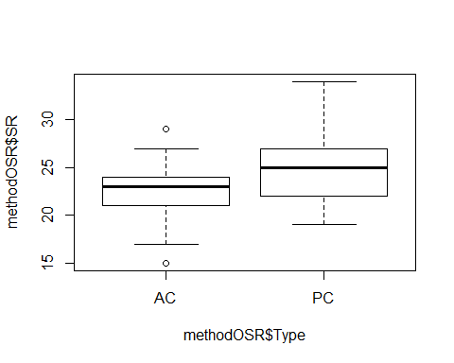

evaluationOSR<-lm(SR ~ Type, methodOSR)  
summary(evaluationOSR)

##   
## Call:  
## lm(formula = SR ~ Type, data = methodOSR)  
##   
## Residuals:  
## Min 1Q Median 3Q Max   
## -7.5517 -2.2069 0.1207 1.7069 8.7931   
##   
## Coefficients:  
## Estimate Std. Error t value Pr(>|t|)   
## (Intercept) 22.552 0.664 33.965 < 2e-16 ***  
## TypePC 2.655 0.939 2.828 0.00649 **   
## ---  
## Signif. codes: 0 '***' 0.001 '**' 0.01 '*' 0.05 '.' 0.1 ' ' 1  
##   
## Residual standard error: 3.576 on 56 degrees of freedom  
## Multiple R-squared: 0.1249, Adjusted R-squared: 0.1093   
## F-statistic: 7.996 on 1 and 56 DF, p-value: 0.006492

confint(evaluationOSR, level=0.95)

## 2.5 % 97.5 %  
## (Intercept) 21.2216504 23.881798  
## TypePC 0.7741641 4.536181

anova(evaluationOSR)

## Analysis of Variance Table  
##   
## Response: SR  
## Df Sum Sq Mean Sq F value Pr(>F)   
## Type 1 102.22 102.224 7.996 0.006492 **  
## Residuals 56 715.93 12.784   
## ---  
## Signif. codes: 0 '***' 0.001 '**' 0.01 '*' 0.05 '.' 0.1 ' ' 1

#### 2018 on its own

#File read-in  
# updated 8/27 - unknowns REMOVED (in both AC + PC)  
methodSR1 <-read.csv("18_1by1_ACPC_SR.csv") #SR by 1 visit each - Site Type SR  
summary(methodSR1)

## SiteName Type SR Sdate   
## Abercrombie_0B_E_AB: 2 AC:30 Min. : 9.00 Min. : 4.00   
## Abercrombie_1B_2 : 2 PC:30 1st Qu.:14.00 1st Qu.: 7.75   
## Battlewood_1B_8 : 2 Median :16.50 Median :11.00   
## Blease_3B_6 : 2 Mean :16.47 Mean :16.18   
## Blease_3B_9 : 2 3rd Qu.:19.00 3rd Qu.:24.25   
## Bryson_2B_9 : 2 Max. :23.00 Max. :41.00   
## (Other) :48   
## Stime Pdate Pmin Peffort Year   
## Min. :352.0 Min. :43314 Min. :12.00 Min. :1.000 B:60   
## 1st Qu.:390.2 1st Qu.:43315 1st Qu.:13.00 1st Qu.:1.000   
## Median :446.0 Median :43318 Median :13.00 Median :2.000   
## Mean :447.4 Mean :43318 Mean :14.23 Mean :1.667   
## 3rd Qu.:501.2 3rd Qu.:43320 3rd Qu.:15.75 3rd Qu.:2.000   
## Max. :568.0 Max. :43325 Max. :25.00 Max. :3.000   
## NA's :30 NA's :30 NA's :30

str(methodSR1)

## 'data.frame': 60 obs. of 9 variables:  
## $ SiteName: Factor w/ 30 levels "Abercrombie_0B_E_AB",..: 3 4 5 6 7 8 9 10 14 15 ...  
## $ Type : Factor w/ 2 levels "AC","PC": 1 1 1 1 1 1 1 1 1 1 ...  
## $ SR : int 16 15 12 12 14 10 15 11 12 15 ...  
## $ Sdate : int 41 20 32 6 6 34 29 36 35 24 ...  
## $ Stime : int 511 499 354 407 485 391 509 364 400 352 ...  
## $ Pdate : int 43325 43317 43320 43314 43314 43320 43318 43325 43325 43317 ...  
## $ Pmin : int 12 15 16 13 16 12 13 12 12 13 ...  
## $ Peffort : int 3 2 2 1 2 1 1 1 1 1 ...  
## $ Year : Factor w/ 1 level "B": 1 1 1 1 1 1 1 1 1 1 ...

#plot(methodSR1$SR ~ methodSR1$Type) #same as below  
plot(SR ~ Type, data=methodSR1)

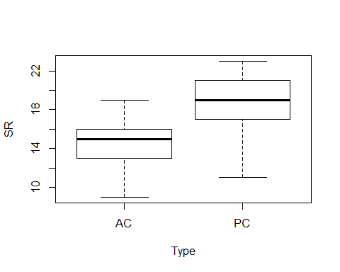

plot(SR ~ Sdate, data=methodSR1)

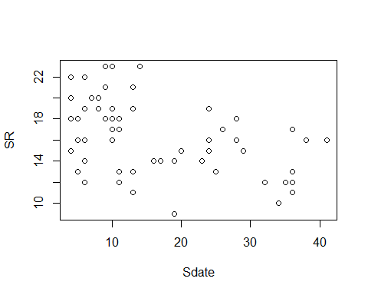

plot(SR ~ Stime, data=methodSR1)

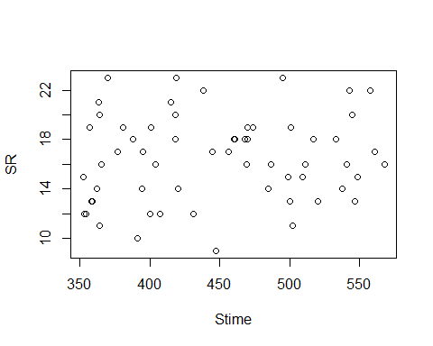

plot(SR ~ Pdate, data=methodSR1)

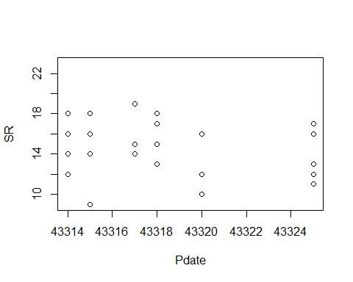

plot(SR ~ Pmin, data=methodSR1)

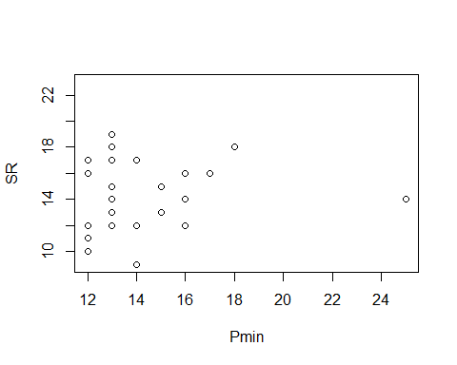

plot(SR ~ Peffort, data=methodSR1)

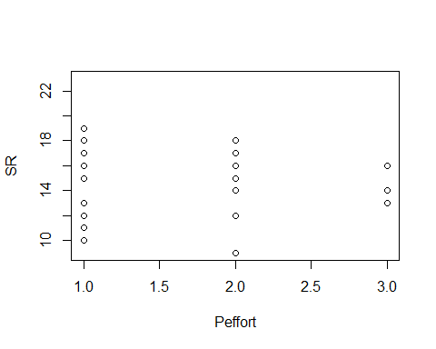

evaluation1<-lm(SR ~ Type, methodSR1) #sig  
summary(evaluation1)

##   
## Call:  
## lm(formula = SR ~ Type, data = methodSR1)  
##   
## Residuals:  
## Min 1Q Median 3Q Max   
## -7.3000 -1.6333 0.3667 1.8667 4.7000   
##   
## Coefficients:  
## Estimate Std. Error t value Pr(>|t|)   
## (Intercept) 14.6333 0.5431 26.943 < 2e-16 ***  
## TypePC 3.6667 0.7681 4.774 1.27e-05 ***  
## ---  
## Signif. codes: 0 '***' 0.001 '**' 0.01 '*' 0.05 '.' 0.1 ' ' 1  
##   
## Residual standard error: 2.975 on 58 degrees of freedom  
## Multiple R-squared: 0.2821, Adjusted R-squared: 0.2697   
## F-statistic: 22.79 on 1 and 58 DF, p-value: 1.266e-05

confint(evaluation1, level=0.95)

## 2.5 % 97.5 %  
## (Intercept) 13.546158 15.720509  
## TypePC 2.129168 5.204165

anova(evaluation1)

## Analysis of Variance Table  
##   
## Response: SR  
## Df Sum Sq Mean Sq F value Pr(>F)   
## Type 1 201.67 201.667 22.789 1.266e-05 ***  
## Residuals 58 513.27 8.849   
## ---  
## Signif. codes: 0 '***' 0.001 '**' 0.01 '*' 0.05 '.' 0.1 ' ' 1

test1<-lm(SR ~ Sdate, methodSR1)  
summary(test1)

##   
## Call:  
## lm(formula = SR ~ Sdate, data = methodSR1)  
##   
## Residuals:  
## Min 1Q Median 3Q Max   
## -7.0580 -2.1099 0.1518 2.1039 6.2166   
##   
## Coefficients:  
## Estimate Std. Error t value Pr(>|t|)   
## (Intercept) 18.81459 0.72158 26.074 < 2e-16 ***  
## Sdate -0.14508 0.03699 -3.922 0.000235 ***  
## ---  
## Signif. codes: 0 '***' 0.001 '**' 0.01 '*' 0.05 '.' 0.1 ' ' 1  
##   
## Residual standard error: 3.121 on 58 degrees of freedom  
## Multiple R-squared: 0.2097, Adjusted R-squared: 0.196   
## F-statistic: 15.39 on 1 and 58 DF, p-value: 0.0002346

confint(test1, level=0.95)

## 2.5 % 97.5 %  
## (Intercept) 17.3702023 20.25898280  
## Sdate -0.2191218 -0.07104411

anova(test1)

## Analysis of Variance Table  
##   
## Response: SR  
## Df Sum Sq Mean Sq F value Pr(>F)   
## Sdate 1 149.89 149.890 15.386 0.0002346 ***  
## Residuals 58 565.04 9.742   
## ---  
## Signif. codes: 0 '***' 0.001 '**' 0.01 '*' 0.05 '.' 0.1 ' ' 1

test2<-glm(SR ~ Sdate, family=gaussian, data=methodSR1)  
summary(test2)

##   
## Call:  
## glm(formula = SR ~ Sdate, family = gaussian, data = methodSR1)  
##   
## Deviance Residuals:   
## Min 1Q Median 3Q Max   
## -7.0580 -2.1099 0.1518 2.1039 6.2166   
##   
## Coefficients:  
## Estimate Std. Error t value Pr(>|t|)   
## (Intercept) 18.81459 0.72158 26.074 < 2e-16 ***  
## Sdate -0.14508 0.03699 -3.922 0.000235 ***  
## ---  
## Signif. codes: 0 '***' 0.001 '**' 0.01 '*' 0.05 '.' 0.1 ' ' 1  
##   
## (Dispersion parameter for gaussian family taken to be 9.742126)  
##   
## Null deviance: 714.93 on 59 degrees of freedom  
## Residual deviance: 565.04 on 58 degrees of freedom  
## AIC: 310.83  
##   
## Number of Fisher Scoring iterations: 2

confint(test2, level=0.95)

## Waiting for profiling to be done...

## 2.5 % 97.5 %  
## (Intercept) 17.4003306 20.22885449  
## Sdate -0.2175774 -0.07258847

anova(test2)

## Analysis of Deviance Table  
##   
## Model: gaussian, link: identity  
##   
## Response: SR  
##   
## Terms added sequentially (first to last)  
##   
##   
## Df Deviance Resid. Df Resid. Dev  
## NULL 59 714.93  
## Sdate 1 149.89 58 565.04

test3<-glm(SR ~ Sdate, data=methodSR1, family=poisson())  
summary(test3)

##   
## Call:  
## glm(formula = SR ~ Sdate, family = poisson(), data = methodSR1)  
##   
## Deviance Residuals:   
## Min 1Q Median 3Q Max   
## -1.90179 -0.52659 0.03766 0.51143 1.45272   
##   
## Coefficients:  
## Estimate Std. Error z value Pr(>|z|)   
## (Intercept) 2.944738 0.055949 52.632 < 2e-16 ***  
## Sdate -0.009161 0.003040 -3.013 0.00259 **   
## ---  
## Signif. codes: 0 '***' 0.001 '**' 0.01 '*' 0.05 '.' 0.1 ' ' 1  
##   
## (Dispersion parameter for poisson family taken to be 1)  
##   
## Null deviance: 44.140 on 59 degrees of freedom  
## Residual deviance: 34.803 on 58 degrees of freedom  
## AIC: 316.4  
##   
## Number of Fisher Scoring iterations: 4

confint(test3, level=0.95)

## Waiting for profiling to be done...

## 2.5 % 97.5 %  
## (Intercept) 2.83410938 3.053459430  
## Sdate -0.01517763 -0.003256257

anova(test3)

## Analysis of Deviance Table  
##   
## Model: poisson, link: log  
##   
## Response: SR  
##   
## Terms added sequentially (first to last)  
##   
##   
## Df Deviance Resid. Df Resid. Dev  
## NULL 59 44.140  
## Sdate 1 9.3374 58 34.803

plot(test3)

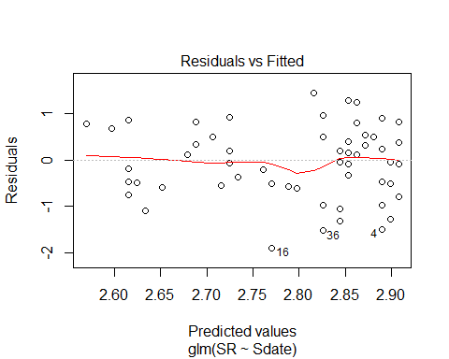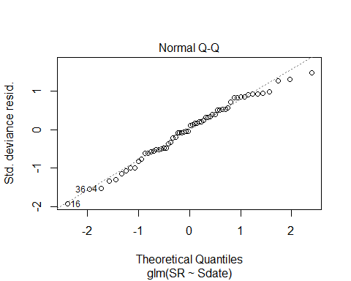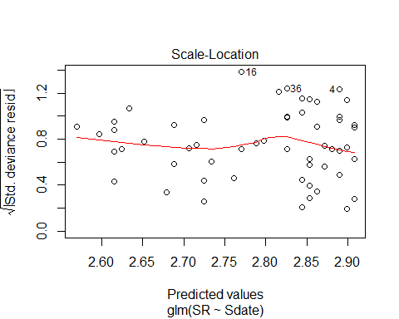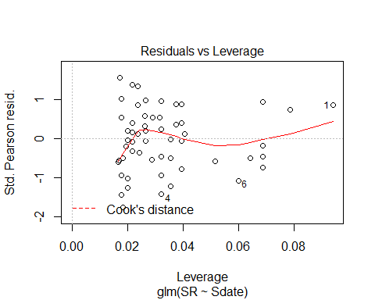

plot(test2)

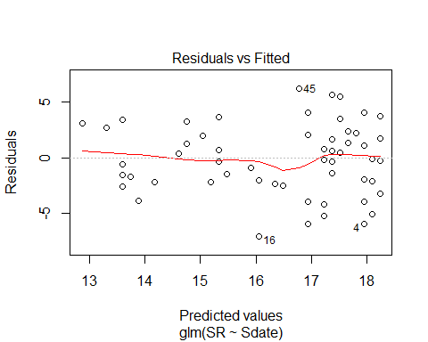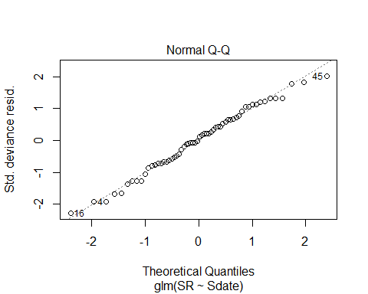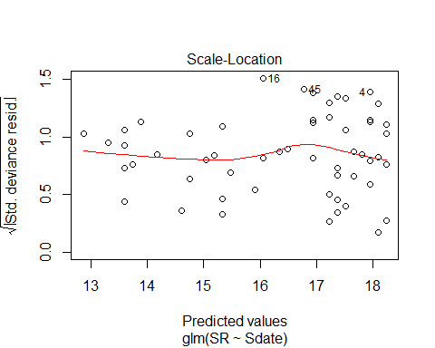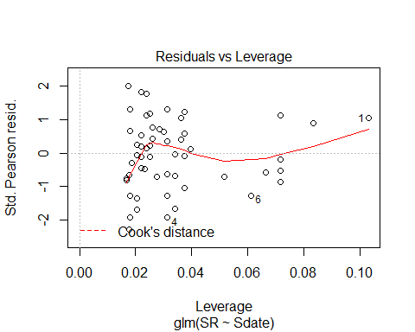

#test2<-glm(SR ~ Sdate, family=gaussian, data=methodSR1)  
#test3<-glm(SR ~ Sdate, data=methodSR1, family=poisson())  
#AIC(test2,test3)  
  
#dtest <- fitList(test1, test2, test3)  
#dtest1 <- modSel(dtest)  
#dtest1

evaluation2<-lm(SR ~ Sdate, methodSR1) #sig  
summary(evaluation2)

##   
## Call:  
## lm(formula = SR ~ Sdate, data = methodSR1)  
##   
## Residuals:  
## Min 1Q Median 3Q Max   
## -7.0580 -2.1099 0.1518 2.1039 6.2166   
##   
## Coefficients:  
## Estimate Std. Error t value Pr(>|t|)   
## (Intercept) 18.81459 0.72158 26.074 < 2e-16 ***  
## Sdate -0.14508 0.03699 -3.922 0.000235 ***  
## ---  
## Signif. codes: 0 '***' 0.001 '**' 0.01 '*' 0.05 '.' 0.1 ' ' 1  
##   
## Residual standard error: 3.121 on 58 degrees of freedom  
## Multiple R-squared: 0.2097, Adjusted R-squared: 0.196   
## F-statistic: 15.39 on 1 and 58 DF, p-value: 0.0002346

confint(evaluation2, level=0.95)

## 2.5 % 97.5 %  
## (Intercept) 17.3702023 20.25898280  
## Sdate -0.2191218 -0.07104411

anova(evaluation2)

## Analysis of Variance Table  
##   
## Response: SR  
## Df Sum Sq Mean Sq F value Pr(>F)   
## Sdate 1 149.89 149.890 15.386 0.0002346 ***  
## Residuals 58 565.04 9.742   
## ---  
## Signif. codes: 0 '***' 0.001 '**' 0.01 '*' 0.05 '.' 0.1 ' ' 1

plot(SR ~ Sdate, methodSR1)



plot(evaluation2)

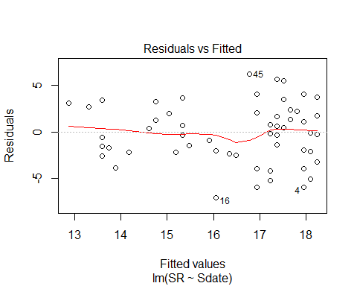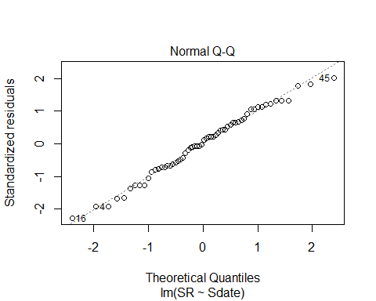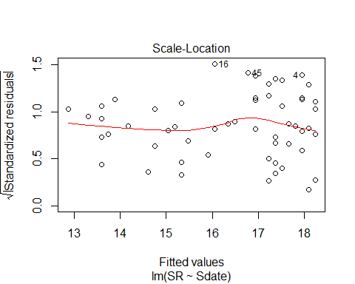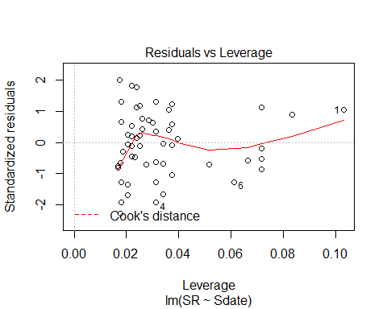

#testing a quadratic for real this time # not this variable, though!  
Sdate2BB<-(methodSR1$Sdate)^2  
Sdate2BB

## [1] 1681 400 1024 36 36 1156 841 1296 1225 576 256 784 36 1296  
## [15] 784 361 100 576 1296 529 576 121 16 361 289 625 1296 676  
## [29] 676 1444 49 36 36 25 25 169 169 121 16 25 169 169  
## [43] 16 16 196 81 81 64 64 64 121 121 16 81 36 100  
## [57] 100 100 100 100

evaluation2BB<-lm(SR ~ Sdate + Sdate2BB, methodSR1)  
summary(evaluation2BB)

##   
## Call:  
## lm(formula = SR ~ Sdate + Sdate2BB, data = methodSR1)  
##   
## Residuals:  
## Min 1Q Median 3Q Max   
## -6.7303 -2.0592 0.2385 2.2195 6.4527   
##   
## Coefficients:  
## Estimate Std. Error t value Pr(>|t|)   
## (Intercept) 19.487707 1.355595 14.376 <2e-16 ***  
## Sdate -0.244383 0.172961 -1.413 0.163   
## Sdate2BB 0.002454 0.004174 0.588 0.559   
## ---  
## Signif. codes: 0 '***' 0.001 '**' 0.01 '*' 0.05 '.' 0.1 ' ' 1  
##   
## Residual standard error: 3.139 on 57 degrees of freedom  
## Multiple R-squared: 0.2144, Adjusted R-squared: 0.1869   
## F-statistic: 7.779 on 2 and 57 DF, p-value: 0.00103

confint(evaluation2BB, level=0.95)

## 2.5 % 97.5 %  
## (Intercept) 16.773175467 22.20223913  
## Sdate -0.590731416 0.10196580  
## Sdate2BB -0.005904627 0.01081229

anova(evaluation2BB)

## Analysis of Variance Table  
##   
## Response: SR  
## Df Sum Sq Mean Sq F value Pr(>F)   
## Sdate 1 149.89 149.890 15.2122 0.0002559 ***  
## Sdate2BB 1 3.41 3.405 0.3456 0.5589393   
## Residuals 57 561.64 9.853   
## ---  
## Signif. codes: 0 '***' 0.001 '**' 0.01 '*' 0.05 '.' 0.1 ' ' 1

evaluation3<-lm(SR ~ Stime, methodSR1) #non-sig  
summary(evaluation3)

##   
## Call:  
## lm(formula = SR ~ Stime, data = methodSR1)  
##   
## Residuals:  
## Min 1Q Median 3Q Max   
## -7.4640 -2.7507 -0.0579 2.3835 6.9877   
##   
## Coefficients:  
## Estimate Std. Error t value Pr(>|t|)   
## (Intercept) 13.841924 3.056757 4.528 3.01e-05 ***  
## Stime 0.005866 0.006757 0.868 0.389   
## ---  
## Signif. codes: 0 '***' 0.001 '**' 0.01 '*' 0.05 '.' 0.1 ' ' 1  
##   
## Residual standard error: 3.488 on 58 degrees of freedom  
## Multiple R-squared: 0.01283, Adjusted R-squared: -0.004193   
## F-statistic: 0.7537 on 1 and 58 DF, p-value: 0.3889

confint(evaluation3, level=0.95)

## 2.5 % 97.5 %  
## (Intercept) 7.723160887 19.96068762  
## Stime -0.007659522 0.01939153

anova(evaluation3)

## Analysis of Variance Table  
##   
## Response: SR  
## Df Sum Sq Mean Sq F value Pr(>F)  
## Stime 1 9.17 9.1709 0.7537 0.3889  
## Residuals 58 705.76 12.1683

evaluation4<-lm(SR ~ Pdate, methodSR1) #non-sig  
summary(evaluation4)

##   
## Call:  
## lm(formula = SR ~ Pdate, data = methodSR1)  
##   
## Residuals:  
## Min 1Q Median 3Q Max   
## -6.0524 -1.5377 0.2123 2.1056 4.2123   
##   
## Coefficients:  
## Estimate Std. Error t value Pr(>|t|)  
## (Intercept) 5747.6507 5471.2258 1.051 0.302  
## Pdate -0.1323 0.1263 -1.048 0.304  
##   
## Residual standard error: 2.508 on 28 degrees of freedom  
## (30 observations deleted due to missingness)  
## Multiple R-squared: 0.03773, Adjusted R-squared: 0.003367   
## F-statistic: 1.098 on 1 and 28 DF, p-value: 0.3037

confint(evaluation4, level=0.95)

## 2.5 % 97.5 %  
## (Intercept) -5459.6472033 1.695495e+04  
## Pdate -0.3910672 1.263738e-01

anova(evaluation4)

## Analysis of Variance Table  
##   
## Response: SR  
## Df Sum Sq Mean Sq F value Pr(>F)  
## Pdate 1 6.904 6.9041 1.098 0.3037  
## Residuals 28 176.063 6.2879

evaluation5<-lm(SR ~ Pmin, methodSR1) #non-sig  
summary(evaluation5)

##   
## Call:  
## lm(formula = SR ~ Pmin, data = methodSR1)  
##   
## Residuals:  
## Min 1Q Median 3Q Max   
## -5.6238 -1.6442 0.3762 1.4580 4.4171   
##   
## Coefficients:  
## Estimate Std. Error t value Pr(>|t|)   
## (Intercept) 14.05095 2.55504 5.499 7.1e-06 ***  
## Pmin 0.04092 0.17650 0.232 0.818   
## ---  
## Signif. codes: 0 '***' 0.001 '**' 0.01 '*' 0.05 '.' 0.1 ' ' 1  
##   
## Residual standard error: 2.554 on 28 degrees of freedom  
## (30 observations deleted due to missingness)  
## Multiple R-squared: 0.001916, Adjusted R-squared: -0.03373   
## F-statistic: 0.05374 on 1 and 28 DF, p-value: 0.8184

confint(evaluation5, level=0.95)

## 2.5 % 97.5 %  
## (Intercept) 8.8171827 19.2847119  
## Pmin -0.3206202 0.4024543

anova(evaluation5)

## Analysis of Variance Table  
##   
## Response: SR  
## Df Sum Sq Mean Sq F value Pr(>F)  
## Pmin 1 0.351 0.3505 0.0537 0.8184  
## Residuals 28 182.616 6.5220

evaluation6<-lm(SR ~ Peffort, methodSR1) #non-sig  
summary(evaluation6)

##   
## Call:  
## lm(formula = SR ~ Peffort, data = methodSR1)  
##   
## Residuals:  
## Min 1Q Median 3Q Max   
## -5.5895 -1.6553 0.2789 1.5092 4.2789   
##   
## Coefficients:  
## Estimate Std. Error t value Pr(>|t|)   
## (Intercept) 14.8526 1.2841 11.567 3.53e-12 ***  
## Peffort -0.1316 0.7178 -0.183 0.856   
## ---  
## Signif. codes: 0 '***' 0.001 '**' 0.01 '*' 0.05 '.' 0.1 ' ' 1  
##   
## Residual standard error: 2.555 on 28 degrees of freedom  
## (30 observations deleted due to missingness)  
## Multiple R-squared: 0.001199, Adjusted R-squared: -0.03447   
## F-statistic: 0.0336 on 1 and 28 DF, p-value: 0.8559

confint(evaluation6, level=0.95)

## 2.5 % 97.5 %  
## (Intercept) 12.222323 17.482940  
## Peffort -1.601966 1.338808

anova(evaluation6)

## Analysis of Variance Table  
##   
## Response: SR  
## Df Sum Sq Mean Sq F value Pr(>F)  
## Peffort 1 0.219 0.2193 0.0336 0.8559  
## Residuals 28 182.747 6.5267

plot(evaluation6)

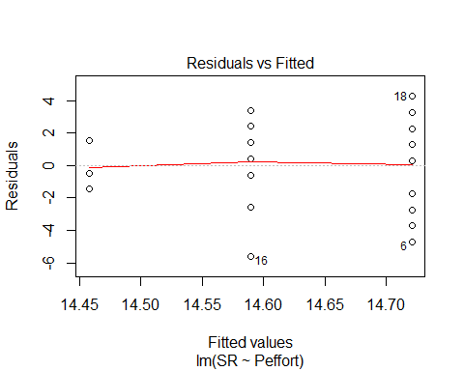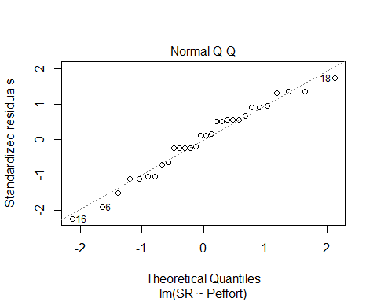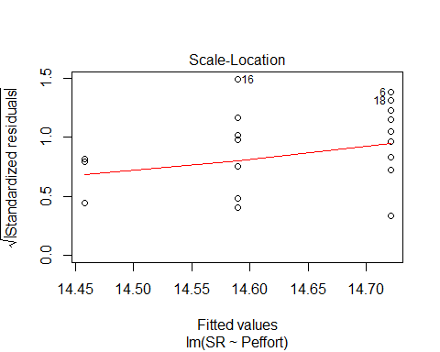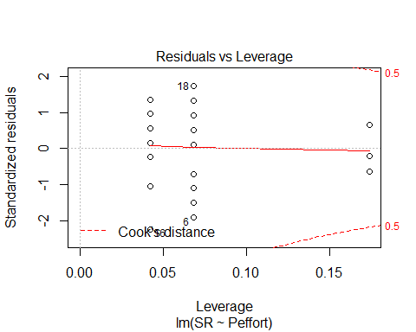

# Visit 2

methodSR2 <-read.csv("18_2by2_ACPC_SR.csv") #SR by count #2 each - Site Type SR  
#summary(methodSR2)  
str(methodSR2)

## 'data.frame': 60 obs. of 9 variables:  
## $ SiteName: Factor w/ 30 levels "Abercrombie_0B_E_AB",..: 3 4 5 6 7 8 9 10 14 15 ...  
## $ Type : Factor w/ 2 levels "AC","PC": 1 1 1 1 1 1 1 1 1 1 ...  
## $ SR : int 19 15 17 7 15 12 16 13 11 21 ...  
## $ Sdate : int 42 21 31 7 7 35 28 35 34 24 ...  
## $ Stime : int 444 443 556 355 508 410 424 478 556 464 ...  
## $ Pdate : int 43332 43328 43330 43326 43326 43330 43329 43332 43332 43328 ...  
## $ Pmin : int 12 11 14 13 12 13 12 12 12 13 ...  
## $ Peffort : int 2 1 3 2 1 2 2 2 2 1 ...  
## $ Year : Factor w/ 1 level "B": 1 1 1 1 1 1 1 1 1 1 ...

plot(methodSR2$SR ~ methodSR2$Type)

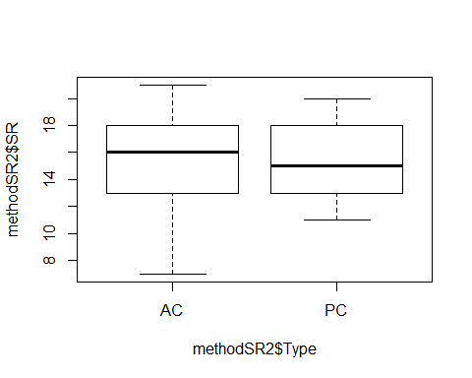

plot(methodSR2$SR ~ methodSR2$Stime)

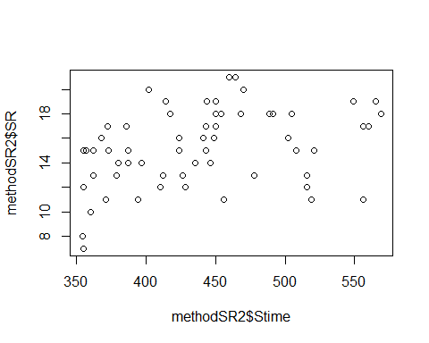

#plot(SR ~ Type, data=methodSR) #same as above

evaluation7<-lm(SR ~ Type, methodSR2) #non-sig  
summary(evaluation7)

##   
## Call:  
## lm(formula = SR ~ Type, data = methodSR2)  
##   
## Residuals:  
## Min 1Q Median 3Q Max   
## -8.3000 -2.1667 -0.1667 2.7000 5.7000   
##   
## Coefficients:  
## Estimate Std. Error t value Pr(>|t|)   
## (Intercept) 15.3000 0.5786 26.444 <2e-16 ***  
## TypePC -0.1333 0.8182 -0.163 0.871   
## ---  
## Signif. codes: 0 '***' 0.001 '**' 0.01 '*' 0.05 '.' 0.1 ' ' 1  
##   
## Residual standard error: 3.169 on 58 degrees of freedom  
## Multiple R-squared: 0.0004576, Adjusted R-squared: -0.01678   
## F-statistic: 0.02655 on 1 and 58 DF, p-value: 0.8711

confint(evaluation7, level=0.95)

## 2.5 % 97.5 %  
## (Intercept) 14.141853 16.458147  
## TypePC -1.771201 1.504534

anova(evaluation7)

## Analysis of Variance Table  
##   
## Response: SR  
## Df Sum Sq Mean Sq F value Pr(>F)  
## Type 1 0.27 0.2667 0.0266 0.8711  
## Residuals 58 582.47 10.0425

evaluation8<-lm(SR ~ Sdate, methodSR2) #non-sig  
summary(evaluation8)

##   
## Call:  
## lm(formula = SR ~ Sdate, data = methodSR2)  
##   
## Residuals:  
## Min 1Q Median 3Q Max   
## -7.5949 -2.1157 0.0001 2.7300 5.7493   
##   
## Coefficients:  
## Estimate Std. Error t value Pr(>|t|)   
## (Intercept) 14.32480 1.30616 10.967 9.08e-16 ***  
## Sdate 0.03858 0.05270 0.732 0.467   
## ---  
## Signif. codes: 0 '***' 0.001 '**' 0.01 '*' 0.05 '.' 0.1 ' ' 1  
##   
## Residual standard error: 3.155 on 58 degrees of freedom  
## Multiple R-squared: 0.009156, Adjusted R-squared: -0.007928   
## F-statistic: 0.536 on 1 and 58 DF, p-value: 0.4671

confint(evaluation8, level=0.95)

## 2.5 % 97.5 %  
## (Intercept) 11.71023625 16.9393586  
## Sdate -0.06690602 0.1440641

anova(evaluation8)

## Analysis of Variance Table  
##   
## Response: SR  
## Df Sum Sq Mean Sq F value Pr(>F)  
## Sdate 1 5.34 5.3355 0.536 0.4671  
## Residuals 58 577.40 9.9551

evaluation9<-lm(SR ~ Stime, methodSR2) #sig  
summary(evaluation9)

##   
## Call:  
## lm(formula = SR ~ Stime, data = methodSR2)  
##   
## Residuals:  
## Min 1Q Median 3Q Max   
## -6.7335 -1.7328 0.2862 1.8914 5.4427   
##   
## Coefficients:  
## Estimate Std. Error t value Pr(>|t|)   
## (Intercept) 7.510847 2.748974 2.732 0.00832 **  
## Stime 0.017529 0.006179 2.837 0.00626 **  
## ---  
## Signif. codes: 0 '***' 0.001 '**' 0.01 '*' 0.05 '.' 0.1 ' ' 1  
##   
## Residual standard error: 2.97 on 58 degrees of freedom  
## Multiple R-squared: 0.1219, Adjusted R-squared: 0.1067   
## F-statistic: 8.048 on 1 and 58 DF, p-value: 0.006264

confint(evaluation9, level=0.95)

## 2.5 % 97.5 %  
## (Intercept) 2.008176770 13.0135171  
## Stime 0.005160665 0.0298964

anova(evaluation9)

## Analysis of Variance Table  
##   
## Response: SR  
## Df Sum Sq Mean Sq F value Pr(>F)   
## Stime 1 71.01 71.009 8.0484 0.006264 **  
## Residuals 58 511.72 8.823   
## ---  
## Signif. codes: 0 '***' 0.001 '**' 0.01 '*' 0.05 '.' 0.1 ' ' 1

plot(SR ~ Stime, methodSR2)

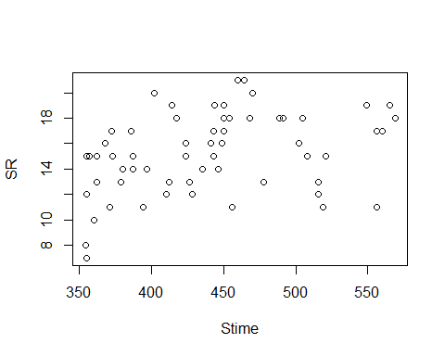

plot(evaluation9)

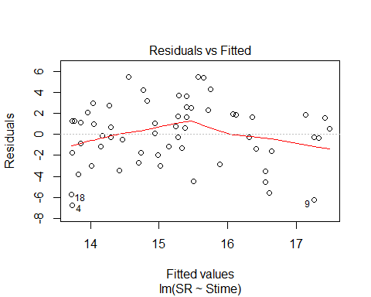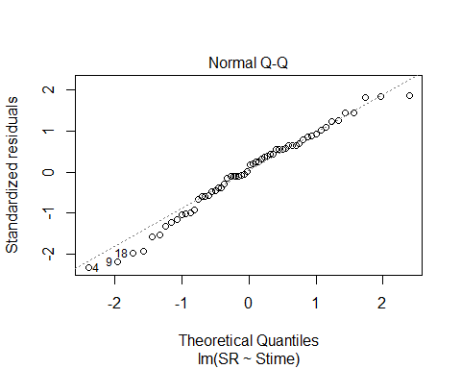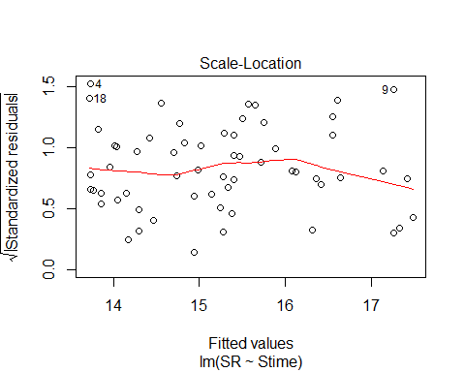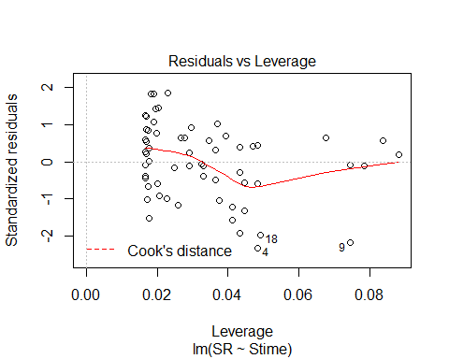

#testing a quadratic for real this time # is or is not better for this variable, though!  
Stime2C<-(methodSR2$Stime)^2  
Stime2C

## [1] 197136 196249 309136 126025 258064 168100 179776 228484 309136 215296  
## [11] 219024 126025 189225 155236 252004 266256 323761 125316 157609 173889  
## [21] 129600 149769 301401 313600 319225 148996 196249 194481 202500 211600  
## [31] 271441 131044 143641 201601 198916 144400 131044 179776 137641 127449  
## [41] 181476 202500 138384 171396 202500 269361 241081 207936 169744 135424  
## [51] 266256 183184 255025 149769 239121 126025 139129 161604 206116 220900

evaluation2C<-lm(SR ~ Stime + Stime2C, methodSR2)  
summary(evaluation2C)

##   
## Call:  
## lm(formula = SR ~ Stime + Stime2C, data = methodSR2)  
##   
## Residuals:  
## Min 1Q Median 3Q Max   
## -5.5438 -2.2132 0.2455 2.4263 5.1385   
##   
## Coefficients:  
## Estimate Std. Error t value Pr(>|t|)   
## (Intercept) -3.701e+01 1.916e+01 -1.932 0.0584 .  
## Stime 2.178e-01 8.557e-02 2.546 0.0136 *  
## Stime2C -2.209e-04 9.414e-05 -2.346 0.0225 *  
## ---  
## Signif. codes: 0 '***' 0.001 '**' 0.01 '*' 0.05 '.' 0.1 ' ' 1  
##   
## Residual standard error: 2.861 on 57 degrees of freedom  
## Multiple R-squared: 0.1992, Adjusted R-squared: 0.1711   
## F-statistic: 7.09 on 2 and 57 DF, p-value: 0.00178

confint(evaluation2C, level=0.95)

## 2.5 % 97.5 %  
## (Intercept) -75.368375679 1.352740e+00  
## Stime 0.046477621 3.891849e-01  
## Stime2C -0.000409423 -3.238411e-05

anova(evaluation2C)

## Analysis of Variance Table  
##   
## Response: SR  
## Df Sum Sq Mean Sq F value Pr(>F)   
## Stime 1 71.01 71.009 8.6736 0.004667 **  
## Stime2C 1 45.08 45.075 5.5058 0.022453 *   
## Residuals 57 466.65 8.187   
## ---  
## Signif. codes: 0 '***' 0.001 '**' 0.01 '*' 0.05 '.' 0.1 ' ' 1

plot(evaluation2C)

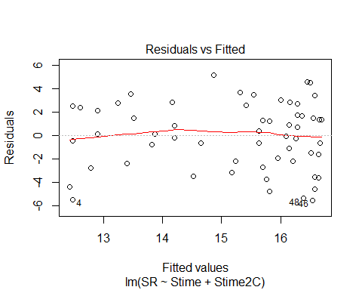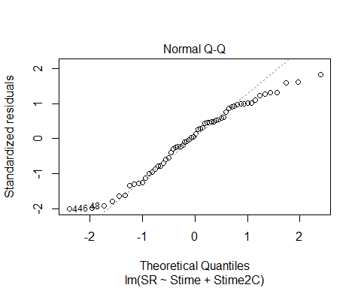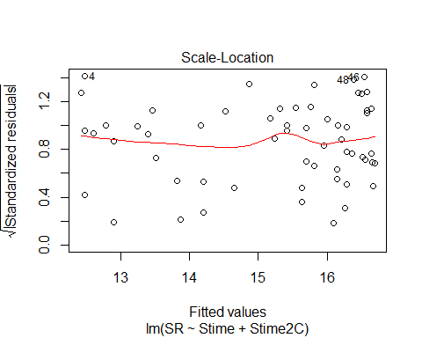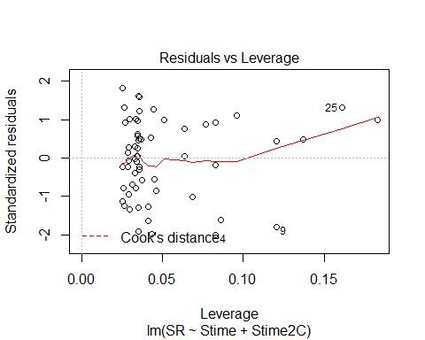

AIC(evaluation9,evaluation2C)

## df AIC  
## evaluation9 3 304.8791  
## evaluation2C 4 301.3466

evaluation10<-lm(SR ~ Pdate, methodSR2) #non-sig  
summary(evaluation10)

##   
## Call:  
## lm(formula = SR ~ Pdate, data = methodSR2)  
##   
## Residuals:  
## Min 1Q Median 3Q Max   
## -8.4371 -1.9557 0.7171 2.6014 5.7686   
##   
## Coefficients:  
## Estimate Std. Error t value Pr(>|t|)  
## (Intercept) 2.244e+03 1.450e+04 0.155 0.878  
## Pdate -5.143e-02 3.347e-01 -0.154 0.879  
##   
## Residual standard error: 3.615 on 28 degrees of freedom  
## (30 observations deleted due to missingness)  
## Multiple R-squared: 0.0008424, Adjusted R-squared: -0.03484   
## F-statistic: 0.02361 on 1 and 28 DF, p-value: 0.879

confint(evaluation10, level=0.95)

## 2.5 % 97.5 %  
## (Intercept) -2.746445e+04 3.195172e+04  
## Pdate -7.370736e-01 6.342165e-01

anova(evaluation10)

## Analysis of Variance Table  
##   
## Response: SR  
## Df Sum Sq Mean Sq F value Pr(>F)  
## Pdate 1 0.31 0.3086 0.0236 0.879  
## Residuals 28 365.99 13.0711

evaluation11<-lm(SR ~ Pmin, methodSR2) #non-sig  
summary(evaluation11)

##   
## Call:  
## lm(formula = SR ~ Pmin, data = methodSR2)  
##   
## Residuals:  
## Min 1Q Median 3Q Max   
## -8.4461 -1.9526 0.7843 2.5539 5.5539   
##   
## Coefficients:  
## Estimate Std. Error t value Pr(>|t|)  
## (Intercept) 9.1166 7.7832 1.171 0.251  
## Pmin 0.4869 0.6107 0.797 0.432  
##   
## Residual standard error: 3.577 on 28 degrees of freedom  
## (30 observations deleted due to missingness)  
## Multiple R-squared: 0.0222, Adjusted R-squared: -0.01272   
## F-statistic: 0.6356 on 1 and 28 DF, p-value: 0.432

confint(evaluation11, level=0.95)

## 2.5 % 97.5 %  
## (Intercept) -6.8264478 25.059684  
## Pmin -0.7640531 1.737814

anova(evaluation11)

## Analysis of Variance Table  
##   
## Response: SR  
## Df Sum Sq Mean Sq F value Pr(>F)  
## Pmin 1 8.13 8.1309 0.6356 0.432  
## Residuals 28 358.17 12.7918

evaluation12<-lm(SR ~ Peffort, methodSR2) #non-sig  
summary(evaluation12)

##   
## Call:  
## lm(formula = SR ~ Peffort, data = methodSR2)  
##   
## Residuals:  
## Min 1Q Median 3Q Max   
## -8.2865 -2.0365 0.6882 2.6629 5.7135   
##   
## Coefficients:  
## Estimate Std. Error t value Pr(>|t|)   
## (Intercept) 15.38764 1.93596 7.948 1.17e-08 ***  
## Peffort -0.05056 1.04992 -0.048 0.962   
## ---  
## Signif. codes: 0 '***' 0.001 '**' 0.01 '*' 0.05 '.' 0.1 ' ' 1  
##   
## Residual standard error: 3.617 on 28 degrees of freedom  
## (30 observations deleted due to missingness)  
## Multiple R-squared: 8.282e-05, Adjusted R-squared: -0.03563   
## F-statistic: 0.002319 on 1 and 28 DF, p-value: 0.9619

confint(evaluation12, level=0.95)

## 2.5 % 97.5 %  
## (Intercept) 11.42200 19.353276  
## Peffort -2.20123 2.100106

anova(evaluation12)

## Analysis of Variance Table  
##   
## Response: SR  
## Df Sum Sq Mean Sq F value Pr(>F)  
## Peffort 1 0.03 0.0303 0.0023 0.9619  
## Residuals 28 366.27 13.0811

# Visit 3

#File read-in  
methodSR3 <-read.csv("18_3by3_ACPC_SR.csv") #SR by count #3 each - Site Type SR  
#summary(methodSR3)  
str(methodSR3)

## 'data.frame': 60 obs. of 9 variables:  
## $ SiteName: Factor w/ 30 levels "Abercrombie_0B_E_AB",..: 3 4 5 6 7 8 9 10 14 15 ...  
## $ Type : Factor w/ 2 levels "AC","PC": 1 1 1 1 1 1 1 1 1 1 ...  
## $ SR : int 18 15 13 13 9 14 14 15 15 15 ...  
## $ Sdate : int 41 22 33 5 8 35 28 34 36 23 ...  
## $ Stime : int 388 398 380 474 350 530 354 518 505 506 ...  
## $ Pdate : int 43338 43335 43338 43333 43333 43338 43336 43338 43338 43335 ...  
## $ Pmin : int 12 11 11 11 11 11 12 12 12 12 ...  
## $ Peffort : int 1 1 1 2 2 1 1 1 2 2 ...  
## $ Year : Factor w/ 1 level "B": 1 1 1 1 1 1 1 1 1 1 ...

plot(methodSR3$SR ~ methodSR3$Type) #

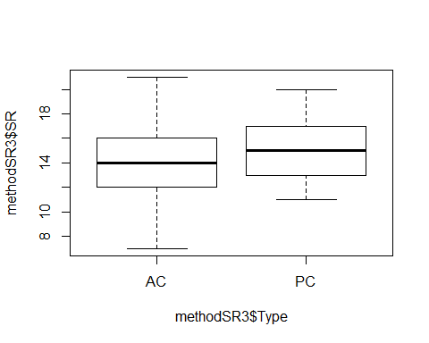

#plot(SR ~ Type, data=methodSR) #same as above

evaluation13<-lm(SR ~ Type, methodSR3) #non-sig  
summary(evaluation13)

##   
## Call:  
## lm(formula = SR ~ Type, data = methodSR3)  
##   
## Residuals:  
## Min 1Q Median 3Q Max   
## -7.0667 -2.1167 -0.0667 1.7333 6.9333   
##   
## Coefficients:  
## Estimate Std. Error t value Pr(>|t|)   
## (Intercept) 14.0667 0.5284 26.624 <2e-16 ***  
## TypePC 1.2000 0.7472 1.606 0.114   
## ---  
## Signif. codes: 0 '***' 0.001 '**' 0.01 '*' 0.05 '.' 0.1 ' ' 1  
##   
## Residual standard error: 2.894 on 58 degrees of freedom  
## Multiple R-squared: 0.04258, Adjusted R-squared: 0.02607   
## F-statistic: 2.579 on 1 and 58 DF, p-value: 0.1137

confint(evaluation13, level=0.95)

## 2.5 % 97.5 %  
## (Intercept) 13.0090529 15.124280  
## TypePC -0.2956918 2.695692

anova(evaluation13)

## Analysis of Variance Table  
##   
## Response: SR  
## Df Sum Sq Mean Sq F value Pr(>F)  
## Type 1 21.60 21.6000 2.5792 0.1137  
## Residuals 58 485.73 8.3747

evaluation14<-lm(SR ~ Sdate, methodSR3) #non-sig  
summary(evaluation14)

##   
## Call:  
## lm(formula = SR ~ Sdate, data = methodSR3)  
##   
## Residuals:  
## Min 1Q Median 3Q Max   
## -6.9959 -1.8663 0.0009 1.7214 6.4140   
##   
## Coefficients:  
## Estimate Std. Error t value Pr(>|t|)   
## (Intercept) 12.87480 1.22815 10.483 5.25e-15 ***  
## Sdate 0.05901 0.03852 1.532 0.131   
## ---  
## Signif. codes: 0 '***' 0.001 '**' 0.01 '*' 0.05 '.' 0.1 ' ' 1  
##   
## Residual standard error: 2.899 on 58 degrees of freedom  
## Multiple R-squared: 0.03889, Adjusted R-squared: 0.02232   
## F-statistic: 2.347 on 1 and 58 DF, p-value: 0.131

confint(evaluation14, level=0.95)

## 2.5 % 97.5 %  
## (Intercept) 10.41638692 15.3332160  
## Sdate -0.01809819 0.1361135

anova(evaluation14)

## Analysis of Variance Table  
##   
## Response: SR  
## Df Sum Sq Mean Sq F value Pr(>F)  
## Sdate 1 19.73 19.728 2.3466 0.131  
## Residuals 58 487.61 8.407

evaluation15<-lm(SR ~ Stime, methodSR3) #sig  
summary(evaluation15)

##   
## Call:  
## lm(formula = SR ~ Stime, data = methodSR3)  
##   
## Residuals:  
## Min 1Q Median 3Q Max   
## -6.4454 -1.2949 0.1177 1.5057 5.8216   
##   
## Coefficients:  
## Estimate Std. Error t value Pr(>|t|)   
## (Intercept) 6.78697 2.30296 2.947 0.00461 **  
## Stime 0.01824 0.00527 3.461 0.00102 **  
## ---  
## Signif. codes: 0 '***' 0.001 '**' 0.01 '*' 0.05 '.' 0.1 ' ' 1  
##   
## Residual standard error: 2.693 on 58 degrees of freedom  
## Multiple R-squared: 0.1712, Adjusted R-squared: 0.1569   
## F-statistic: 11.98 on 1 and 58 DF, p-value: 0.001016

confint(evaluation15, level=0.95)

## 2.5 % 97.5 %  
## (Intercept) 2.177087358 11.39684514  
## Stime 0.007692176 0.02879214

anova(evaluation15)

## Analysis of Variance Table  
##   
## Response: SR  
## Df Sum Sq Mean Sq F value Pr(>F)   
## Stime 1 86.85 86.851 11.98 0.001016 **  
## Residuals 58 420.48 7.250   
## ---  
## Signif. codes: 0 '***' 0.001 '**' 0.01 '*' 0.05 '.' 0.1 ' ' 1

plot(SR ~ Stime, methodSR3)

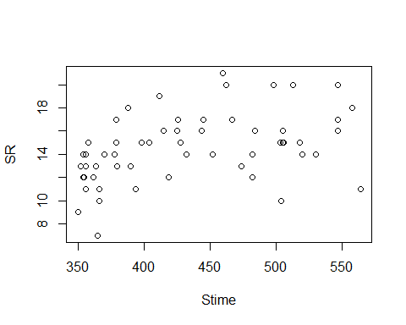

plot(evaluation15)

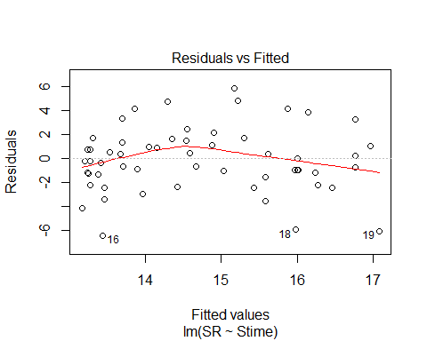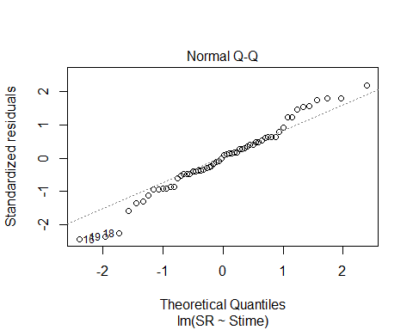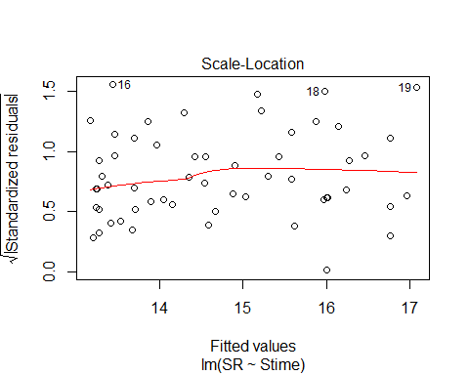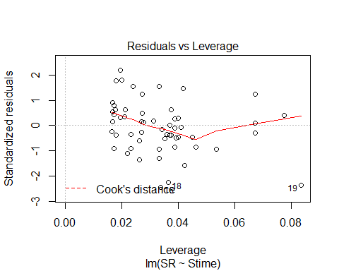

evaluation16<-lm(SR ~ Pdate, methodSR3) #non-sig  
summary(evaluation16)

##   
## Call:  
## lm(formula = SR ~ Pdate, data = methodSR3)  
##   
## Residuals:  
## Min 1Q Median 3Q Max   
## -6.838 -1.931 0.300 1.466 6.888   
##   
## Coefficients:  
## Estimate Std. Error t value Pr(>|t|)  
## (Intercept) -5944.5875 13312.5461 -0.447 0.659  
## Pdate 0.1375 0.3072 0.448 0.658  
##   
## Residual standard error: 3.173 on 28 degrees of freedom  
## (30 observations deleted due to missingness)  
## Multiple R-squared: 0.007104, Adjusted R-squared: -0.02836   
## F-statistic: 0.2003 on 1 and 28 DF, p-value: 0.6579

confint(evaluation16, level=0.95)

## 2.5 % 97.5 %  
## (Intercept) -3.321410e+04 2.132493e+04  
## Pdate -4.917626e-01 7.667626e-01

anova(evaluation16)

## Analysis of Variance Table  
##   
## Response: SR  
## Df Sum Sq Mean Sq F value Pr(>F)  
## Pdate 1 2.017 2.0167 0.2003 0.6579  
## Residuals 28 281.850 10.0661

evaluation17<-lm(SR ~ Pmin, methodSR3) #non-sig  
summary(evaluation17)

##   
## Call:  
## lm(formula = SR ~ Pmin, data = methodSR3)  
##   
## Residuals:  
## Min 1Q Median 3Q Max   
## -7.48 -1.92 0.52 1.52 6.52   
##   
## Coefficients:  
## Estimate Std. Error t value Pr(>|t|)  
## (Intercept) -0.4000 8.6964 -0.046 0.964  
## Pmin 1.2400 0.7439 1.667 0.107  
##   
## Residual standard error: 3.037 on 28 degrees of freedom  
## (30 observations deleted due to missingness)  
## Multiple R-squared: 0.09028, Adjusted R-squared: 0.05779   
## F-statistic: 2.779 on 1 and 28 DF, p-value: 0.1067

confint(evaluation17, level=0.95)

## 2.5 % 97.5 %  
## (Intercept) -18.2137744 17.413774  
## Pmin -0.2837883 2.763788

anova(evaluation17)

## Analysis of Variance Table  
##   
## Response: SR  
## Df Sum Sq Mean Sq F value Pr(>F)  
## Pmin 1 25.627 25.6267 2.7786 0.1067  
## Residuals 28 258.240 9.2229

evaluation18<-lm(SR ~ Peffort, methodSR3) #very close to sig (p.0591)  
summary(evaluation18)

##   
## Call:  
## lm(formula = SR ~ Peffort, data = methodSR3)  
##   
## Residuals:  
## Min 1Q Median 3Q Max   
## -6.1761 -1.8574 -0.0845 0.9155 5.9155   
##   
## Coefficients:  
## Estimate Std. Error t value Pr(>|t|)   
## (Intercept) 11.268 1.523 7.396 4.7e-08 ***  
## Peffort 1.909 0.970 1.968 0.0591 .   
## ---  
## Signif. codes: 0 '***' 0.001 '**' 0.01 '*' 0.05 '.' 0.1 ' ' 1  
##   
## Residual standard error: 2.984 on 28 degrees of freedom  
## (30 observations deleted due to missingness)  
## Multiple R-squared: 0.1215, Adjusted R-squared: 0.09009   
## F-statistic: 3.871 on 1 and 28 DF, p-value: 0.0591

confint(evaluation18, level=0.95)

## 2.5 % 97.5 %  
## (Intercept) 8.14705565 14.38816  
## Peffort -0.07844884 3.89535

anova(evaluation18)

## Analysis of Variance Table  
##   
## Response: SR  
## Df Sum Sq Mean Sq F value Pr(>F)   
## Peffort 1 34.479 34.479 3.8712 0.0591 .  
## Residuals 28 249.387 8.907   
## ---  
## Signif. codes: 0 '***' 0.001 '**' 0.01 '*' 0.05 '.' 0.1 ' ' 1

plot(SR ~ Peffort, methodSR3)

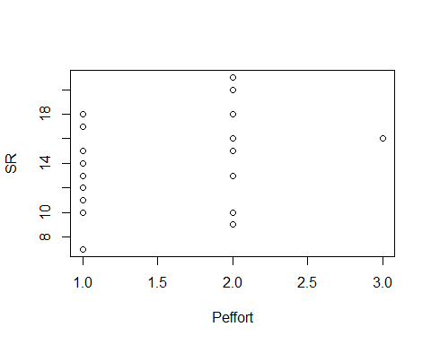

plot(evaluation18)

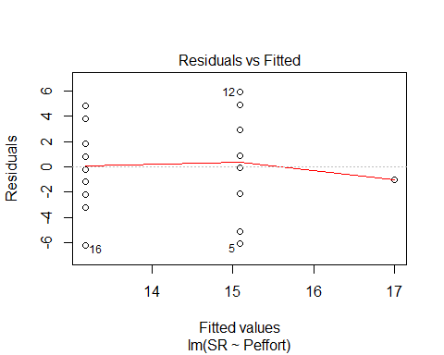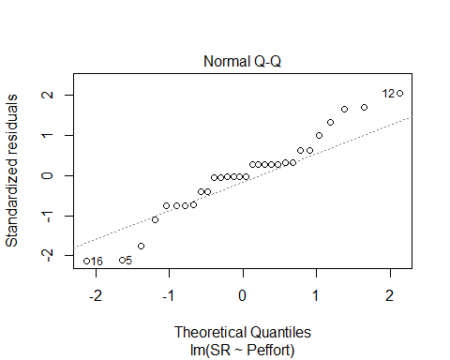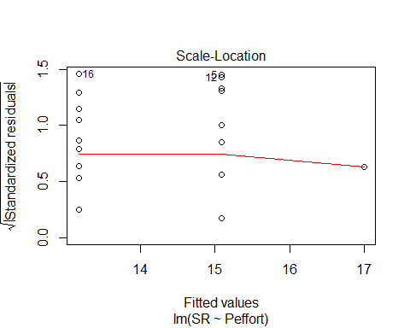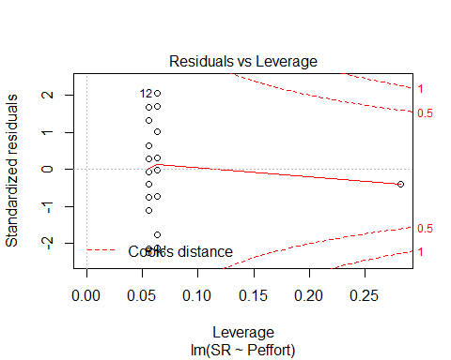

# 3 visits pooled, 2018 alone

#File read-in  
# UNKNS removed  
methodOSR <-read.csv("18_all3_ACPC_SR.csv") #SR by 3 counts pooled SR with unkns extracted  
#summary(methodOSR)  
str(methodOSR)

## 'data.frame': 60 obs. of 4 variables:  
## $ SiteName: Factor w/ 30 levels "Abercrombie_0B_E_AB",..: 3 4 5 6 7 8 9 10 14 15 ...  
## $ Type : Factor w/ 2 levels "AC","PC": 1 1 1 1 1 1 1 1 1 1 ...  
## $ SR : int 26 19 23 18 21 21 23 22 20 29 ...  
## $ Year : Factor w/ 1 level "B": 1 1 1 1 1 1 1 1 1 1 ...

plot(methodOSR$SR ~ methodOSR$Type)

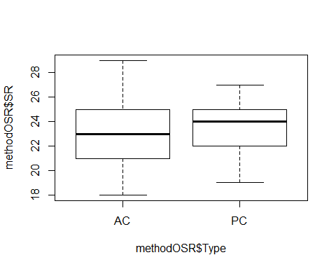

tapply(methodOSR$SR, methodOSR$Type,mean)

## AC PC   
## 22.83333 23.66667

evaluationOSR<-lm(SR ~ Type, methodOSR) #non-sig  
summary(evaluationOSR)

##   
## Call:  
## lm(formula = SR ~ Type, data = methodOSR)  
##   
## Residuals:  
## Min 1Q Median 3Q Max   
## -4.8333 -1.8333 0.1667 1.5417 6.1667   
##   
## Coefficients:  
## Estimate Std. Error t value Pr(>|t|)   
## (Intercept) 22.8333 0.4490 50.850 <2e-16 ***  
## TypePC 0.8333 0.6350 1.312 0.195   
## ---  
## Signif. codes: 0 '***' 0.001 '**' 0.01 '*' 0.05 '.' 0.1 ' ' 1  
##   
## Residual standard error: 2.459 on 58 degrees of freedom  
## Multiple R-squared: 0.02884, Adjusted R-squared: 0.01209   
## F-statistic: 1.722 on 1 and 58 DF, p-value: 0.1946

confint(evaluationOSR, level=0.95)

## 2.5 % 97.5 %  
## (Intercept) 21.9345012 23.732165  
## TypePC -0.4378072 2.104474

anova(evaluationOSR)

## Analysis of Variance Table  
##   
## Response: SR  
## Df Sum Sq Mean Sq F value Pr(>F)  
## Type 1 10.42 10.4167 1.7221 0.1946  
## Residuals 58 350.83 6.0489

#### 2017+2018 together

# don’t forget to do min, max, mean, etc. and test if significant effect of years - do separately if so. pool if not.

#File read-in  
# UNKNS removed  
methodOOSR <-read.csv("17_18_all3_ACPC_SR.csv") #SR by 3 counts pooled SR with unkns extracted for BOTH years - Year column A or B  
summary(methodOOSR)

## SiteName Type SR Year   
## Abercrombie_0B_E_AB: 4 AC:59 Min. :15.00 A:58   
## Abercrombie_1B_2 : 4 PC:59 1st Qu.:21.25 B:60   
## Blease_3B_6 : 4 Median :23.00   
## Blease_3B_9 : 4 Mean :23.56   
## Bryson_2B_9 : 4 3rd Qu.:25.00   
## Burnett_1B_5 : 4 Max. :34.00   
## (Other) :94

str(methodOOSR)

## 'data.frame': 118 obs. of 4 variables:  
## $ SiteName: Factor w/ 32 levels "Abercrombie_0B_E_AB",..: 4 5 6 8 9 15 16 17 18 19 ...  
## $ Type : Factor w/ 2 levels "AC","PC": 1 1 1 1 1 1 1 1 1 1 ...  
## $ SR : int 23 22 18 24 23 25 23 26 24 21 ...  
## $ Year : Factor w/ 2 levels "A","B": 1 1 1 1 1 1 1 1 1 1 ...

plot(methodOOSR$SR ~ methodOOSR$Type)

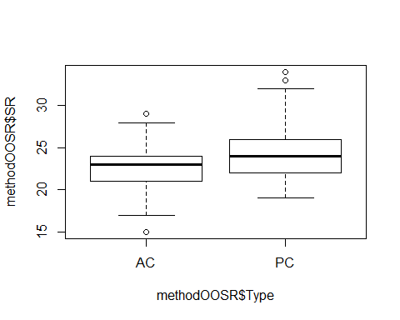

summary(methodOOSR$SR)

## Min. 1st Qu. Median Mean 3rd Qu. Max.   
## 15.00 21.25 23.00 23.56 25.00 34.00

#library(psych)  
mean(methodOOSR$SR)

## [1] 23.55932

#tapply(methodOOSR$SR, methodOOSR$Type)

evaluationOOSR<-lm(SR ~ Type, methodOOSR) #sig - PC +   
summary(evaluationOOSR)

##   
## Call:  
## lm(formula = SR ~ Type, data = methodOOSR)  
##   
## Residuals:  
## Min 1Q Median 3Q Max   
## -7.6949 -1.6949 -0.0593 1.5763 9.5763   
##   
## Coefficients:  
## Estimate Std. Error t value Pr(>|t|)   
## (Intercept) 22.6949 0.4014 56.534 < 2e-16 ***  
## TypePC 1.7288 0.5677 3.045 0.00288 **   
## ---  
## Signif. codes: 0 '***' 0.001 '**' 0.01 '*' 0.05 '.' 0.1 ' ' 1  
##   
## Residual standard error: 3.083 on 116 degrees of freedom  
## Multiple R-squared: 0.07402, Adjusted R-squared: 0.06604   
## F-statistic: 9.273 on 1 and 116 DF, p-value: 0.002878

confint(evaluationOOSR, level=0.95)

## 2.5 % 97.5 %  
## (Intercept) 21.8998211 23.490009  
## TypePC 0.6043807 2.853246

anova(evaluationOOSR)

## Analysis of Variance Table  
##   
## Response: SR  
## Df Sum Sq Mean Sq F value Pr(>F)   
## Type 1 88.17 88.169 9.2733 0.002878 **  
## Residuals 116 1102.92 9.508   
## ---  
## Signif. codes: 0 '***' 0.001 '**' 0.01 '*' 0.05 '.' 0.1 ' ' 1

Evaluated effect of year on SR results and no significant difference, so it is ok to pool for the rest of the Ch 2 results!

yearevalOOSR<-lm(SR ~ Year, methodOOSR)  
summary(yearevalOOSR)

##   
## Call:  
## lm(formula = SR ~ Year, data = methodOOSR)  
##   
## Residuals:  
## Min 1Q Median 3Q Max   
## -8.879 -2.157 -0.250 1.750 10.121   
##   
## Coefficients:  
## Estimate Std. Error t value Pr(>|t|)   
## (Intercept) 23.8793 0.4187 57.034 <2e-16 ***  
## YearB -0.6293 0.5872 -1.072 0.286   
## ---  
## Signif. codes: 0 '***' 0.001 '**' 0.01 '*' 0.05 '.' 0.1 ' ' 1  
##   
## Residual standard error: 3.189 on 116 degrees of freedom  
## Multiple R-squared: 0.009806, Adjusted R-squared: 0.00127   
## F-statistic: 1.149 on 1 and 116 DF, p-value: 0.286

confint(yearevalOOSR, level=0.95)

## 2.5 % 97.5 %  
## (Intercept) 23.050050 24.7085709  
## YearB -1.792248 0.5336272

anova(yearevalOOSR)

## Analysis of Variance Table  
##   
## Response: SR  
## Df Sum Sq Mean Sq F value Pr(>F)  
## Year 1 11.68 11.680 1.1487 0.286  
## Residuals 116 1179.41 10.167

plot(yearevalOOSR)

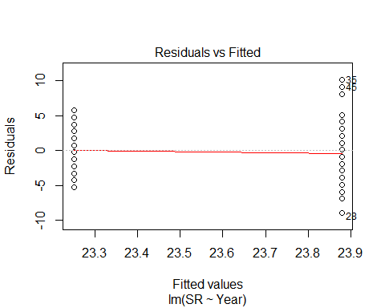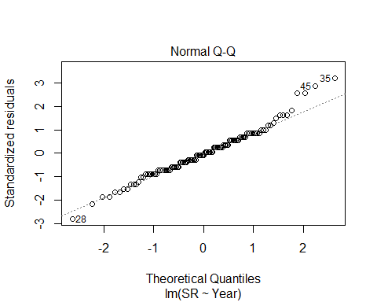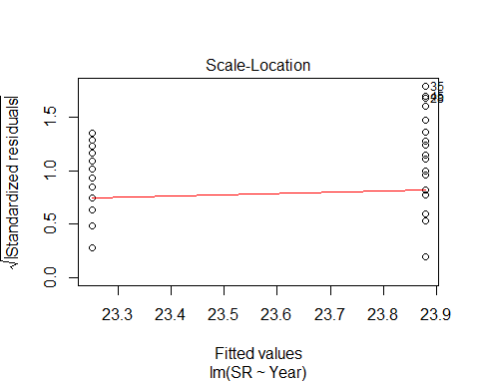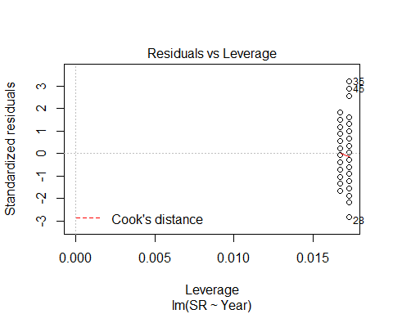

No sig interaction w/ both (Year * Type nor Year + Type)

yearintevalOOSR<-lm(SR ~ Year * Type, methodOOSR)  
summary(yearintevalOOSR)

##   
## Call:  
## lm(formula = SR ~ Year * Type, data = methodOOSR)  
##   
## Residuals:  
## Min 1Q Median 3Q Max   
## -7.5517 -2.1135 0.1667 1.7069 8.7931   
##   
## Coefficients:  
## Estimate Std. Error t value Pr(>|t|)   
## (Intercept) 22.5517 0.5680 39.701 < 2e-16 ***  
## YearB 0.2816 0.7966 0.354 0.72436   
## TypePC 2.6552 0.8033 3.305 0.00127 **   
## YearB:TypePC -1.8218 1.1266 -1.617 0.10861   
## ---  
## Signif. codes: 0 '***' 0.001 '**' 0.01 '*' 0.05 '.' 0.1 ' ' 1  
##   
## Residual standard error: 3.059 on 114 degrees of freedom  
## Multiple R-squared: 0.1044, Adjusted R-squared: 0.08081   
## F-statistic: 4.429 on 3 and 114 DF, p-value: 0.005532

confint(yearintevalOOSR, level=0.95)

## 2.5 % 97.5 %  
## (Intercept) 21.426431 23.6770171  
## YearB -1.296478 1.8596964  
## TypePC 1.063768 4.2465770  
## YearB:TypePC -4.053591 0.4099132

anova(yearintevalOOSR)

## Analysis of Variance Table  
##   
## Response: SR  
## Df Sum Sq Mean Sq F value Pr(>F)   
## Year 1 11.68 11.680 1.2481 0.26626   
## Type 1 88.17 88.169 9.4223 0.00268 **  
## Year:Type 1 24.47 24.471 2.6151 0.10861   
## Residuals 114 1066.76 9.358   
## ---  
## Signif. codes: 0 '***' 0.001 '**' 0.01 '*' 0.05 '.' 0.1 ' ' 1

## back to individual visits, but years pooled together (17+18):

# visit 1 _ method only

methodYSR1 <-read.csv("17_18_1by1_ACPC_SR.csv") #SR by count #1 each - Site Type SR  
#summary(methodYSR1)  
str(methodYSR1)

## 'data.frame': 118 obs. of 9 variables:  
## $ SiteName: Factor w/ 32 levels "Abercrombie_0B_E_AB",..: 4 5 6 8 9 15 16 17 18 19 ...  
## $ Type : Factor w/ 2 levels "AC","PC": 1 1 1 1 1 1 1 1 1 1 ...  
## $ SR : int 15 14 11 10 12 16 13 17 14 11 ...  
## $ Sdate : int 3 16 31 33 23 24 30 27 10 22 ...  
## $ Stime : int 570 403 497 380 503 382 479 481 580 409 ...  
## $ Pdate : int 43181 43181 43186 43195 43196 43182 43188 43188 43188 43188 ...  
## $ Pmin : int 26 23 17 20 32 31 18 20 25 18 ...  
## $ Peffort : int 3 2 1 2 3 3 2 2 4 3 ...  
## $ Year : Factor w/ 2 levels "A","B": 1 1 1 1 1 1 1 1 1 1 ...

plot(methodYSR1$SR ~ methodYSR1$Type)

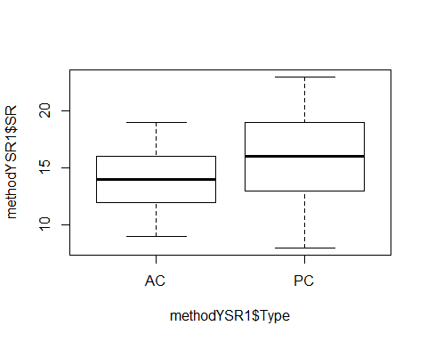

evaluationYVM1<-lm(SR ~ Type, methodYSR1) #sig! p.0002  
summary(evaluationYVM1)

##   
## Call:  
## lm(formula = SR ~ Type, data = methodYSR1)  
##   
## Residuals:  
## Min 1Q Median 3Q Max   
## -8.5085 -2.2373 -0.2373 2.4915 6.4915   
##   
## Coefficients:  
## Estimate Std. Error t value Pr(>|t|)   
## (Intercept) 14.2373 0.4179 34.066 < 2e-16 ***  
## TypePC 2.2712 0.5910 3.843 0.000199 ***  
## ---  
## Signif. codes: 0 '***' 0.001 '**' 0.01 '*' 0.05 '.' 0.1 ' ' 1  
##   
## Residual standard error: 3.21 on 116 degrees of freedom  
## Multiple R-squared: 0.1129, Adjusted R-squared: 0.1053   
## F-statistic: 14.77 on 1 and 116 DF, p-value: 0.0001991

confint(evaluationYVM1, level=0.95)

## 2.5 % 97.5 %  
## (Intercept) 13.409521 15.065056  
## TypePC 1.100546 3.441827

anova(evaluationYVM1)

## Analysis of Variance Table  
##   
## Response: SR  
## Df Sum Sq Mean Sq F value Pr(>F)   
## Type 1 152.17 152.169 14.766 0.0001991 ***  
## Residuals 116 1195.42 10.305   
## ---  
## Signif. codes: 0 '***' 0.001 '**' 0.01 '*' 0.05 '.' 0.1 ' ' 1

plot(evaluationYVM1)

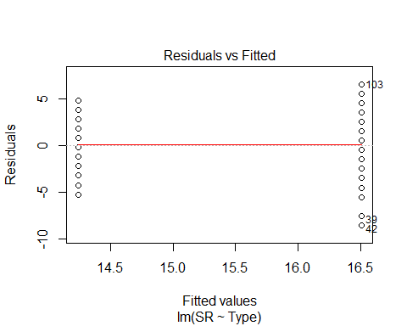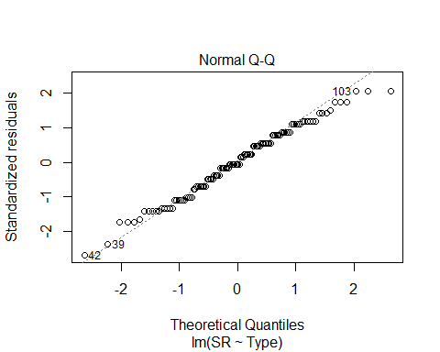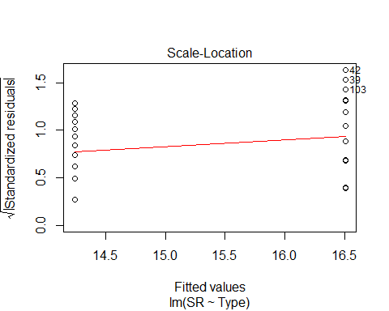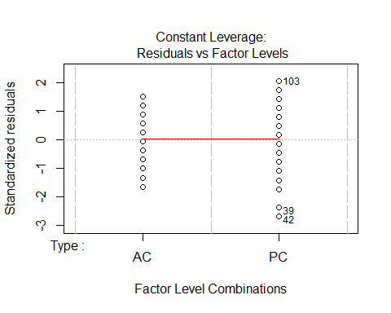

# visit 2 _ method only

methodYSR2 <-read.csv("17_18_2by2_ACPC_SR.csv") #SR by count #2 each - Site Type SR  
#summary(methodYSR2)  
str(methodYSR2)

## 'data.frame': 118 obs. of 9 variables:  
## $ SiteName: Factor w/ 32 levels "Abercrombie_0B_E_AB",..: 4 5 6 8 9 15 16 17 18 19 ...  
## $ Type : Factor w/ 2 levels "AC","PC": 1 1 1 1 1 1 1 1 1 1 ...  
## $ SR : int 17 15 12 9 9 16 13 11 17 13 ...  
## $ Sdate : int 2 17 28 36 22 25 35 28 9 22 ...  
## $ Stime : int 426 353 553 355 354 558 386 425 521 514 ...  
## $ Pdate : int 43201 43201 43203 43209 43210 43202 43205 43205 43206 43205 ...  
## $ Pmin : int 39 25 37 14 15 15 18 22 15 21 ...  
## $ Peffort : int 4 3 7 1 1 2 2 2 2 2 ...  
## $ Year : Factor w/ 2 levels "A","B": 1 1 1 1 1 1 1 1 1 1 ...

plot(methodYSR2$SR ~ methodYSR2$Type)

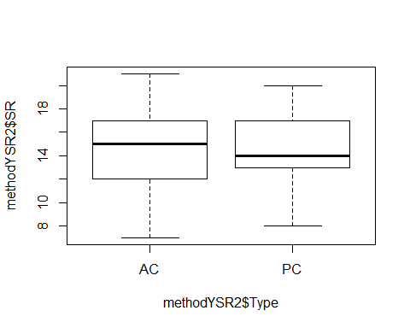

#plot(SR ~ Type, data=methodSR) #same as above

evaluationYVM2<-lm(SR ~ Type, methodYSR2) #non-sig  
summary(evaluationYVM2)

##   
## Call:  
## lm(formula = SR ~ Type, data = methodYSR2)  
##   
## Residuals:  
## Min 1Q Median 3Q Max   
## -7.3559 -2.3559 0.0339 2.6441 6.6441   
##   
## Coefficients:  
## Estimate Std. Error t value Pr(>|t|)   
## (Intercept) 14.3559 0.4078 35.207 <2e-16 ***  
## TypePC 0.2203 0.5767 0.382 0.703   
## ---  
## Signif. codes: 0 '***' 0.001 '**' 0.01 '*' 0.05 '.' 0.1 ' ' 1  
##   
## Residual standard error: 3.132 on 116 degrees of freedom  
## Multiple R-squared: 0.001257, Adjusted R-squared: -0.007353   
## F-statistic: 0.146 on 1 and 116 DF, p-value: 0.7031

confint(evaluationYVM2, level=0.95)

## 2.5 % 97.5 %  
## (Intercept) 13.5483148 15.163550  
## TypePC -0.9218045 1.362482

anova(evaluationYVM2)

## Analysis of Variance Table  
##   
## Response: SR  
## Df Sum Sq Mean Sq F value Pr(>F)  
## Type 1 1.43 1.4322 0.146 0.7031  
## Residuals 116 1137.93 9.8098

# visit 3 _ method only

methodYSR3 <-read.csv("17_18_3by3_ACPC_SR.csv") #SR by count #3 each - Site Type SR  
#summary(methodYSR3)  
str(methodYSR3)

## 'data.frame': 118 obs. of 9 variables:  
## $ SiteName: Factor w/ 32 levels "Abercrombie_0B_E_AB",..: 4 5 6 8 9 15 16 17 18 19 ...  
## $ Type : Factor w/ 2 levels "AC","PC": 1 1 1 1 1 1 1 1 1 1 ...  
## $ SR : int 10 16 11 16 16 16 14 14 15 14 ...  
## $ Sdate : int 15 18 47 33 22 33 34 29 10 20 ...  
## $ Stime : int 363 500 380 513 559 507 526 359 395 566 ...  
## $ Pdate : int 43214 43214 43216 43219 43220 43215 43216 43216 43217 43216 ...  
## $ Pmin : int 18 15 14 27 12 26 14 19 24 19 ...  
## $ Peffort : int 1 2 2 7 2 8 2 4 5 5 ...  
## $ Year : Factor w/ 2 levels "A","B": 1 1 1 1 1 1 1 1 1 1 ...

plot(methodYSR3$SR ~ methodYSR3$Type)

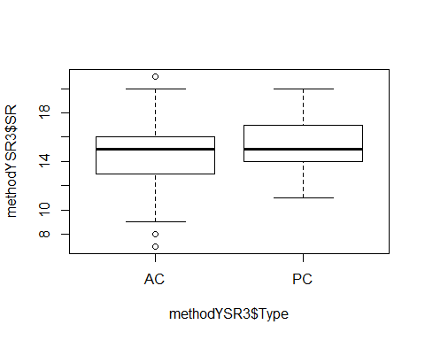

#plot(SR ~ Type, data=methodSR) #same as above

evaluationYVM3<-lm(SR ~ Type, methodYSR3) #marginally, p 0.0535  
summary(evaluationYVM3)

##   
## Call:  
## lm(formula = SR ~ Type, data = methodYSR3)  
##   
## Residuals:  
## Min 1Q Median 3Q Max   
## -7.2712 -1.2712 -0.2203 1.7288 6.7288   
##   
## Coefficients:  
## Estimate Std. Error t value Pr(>|t|)   
## (Intercept) 14.2712 0.3440 41.488 <2e-16 ***  
## TypePC 0.9492 0.4865 1.951 0.0535 .   
## ---  
## Signif. codes: 0 '***' 0.001 '**' 0.01 '*' 0.05 '.' 0.1 ' ' 1  
##   
## Residual standard error: 2.642 on 116 degrees of freedom  
## Multiple R-squared: 0.03178, Adjusted R-squared: 0.02343   
## F-statistic: 3.807 on 1 and 116 DF, p-value: 0.05345

confint(evaluationYVM3, level=0.95)

## 2.5 % 97.5 %  
## (Intercept) 13.58989105 14.95248  
## TypePC -0.01434464 1.91265

anova(evaluationYVM3)

## Analysis of Variance Table  
##   
## Response: SR  
## Df Sum Sq Mean Sq F value Pr(>F)   
## Type 1 26.58 26.576 3.8069 0.05345 .  
## Residuals 116 809.80 6.981   
## ---  
## Signif. codes: 0 '***' 0.001 '**' 0.01 '*' 0.05 '.' 0.1 ' ' 1

#### 2017+2018 COMBINED, SOLO VISITS - ALL VARIABLES

# visit 1 - all variables

#File read-in  
# updated 9/12 - unknowns REMOVED (in both AC + PC)  
methodYSR1 <-read.csv("17_18_1by1_ACPC_SR.csv") #SR by count #1 each - Site Type SR  
#summary(methodYSR1)  
str(methodYSR1)

## 'data.frame': 118 obs. of 9 variables:  
## $ SiteName: Factor w/ 32 levels "Abercrombie_0B_E_AB",..: 4 5 6 8 9 15 16 17 18 19 ...  
## $ Type : Factor w/ 2 levels "AC","PC": 1 1 1 1 1 1 1 1 1 1 ...  
## $ SR : int 15 14 11 10 12 16 13 17 14 11 ...  
## $ Sdate : int 3 16 31 33 23 24 30 27 10 22 ...  
## $ Stime : int 570 403 497 380 503 382 479 481 580 409 ...  
## $ Pdate : int 43181 43181 43186 43195 43196 43182 43188 43188 43188 43188 ...  
## $ Pmin : int 26 23 17 20 32 31 18 20 25 18 ...  
## $ Peffort : int 3 2 1 2 3 3 2 2 4 3 ...  
## $ Year : Factor w/ 2 levels "A","B": 1 1 1 1 1 1 1 1 1 1 ...

#testing distribution - ran thru all variables here - gaussian is best for ALL  
test2<-glm(SR ~ Sdate, family=gaussian(), data=methodYSR1)  
test3<-glm(SR ~ Sdate, family=poisson(), data=methodYSR1)  
AIC(test2,test3)

## df AIC  
## test2 3 624.1343  
## test3 2 626.7957

#plot(methodYSR1$SR ~ methodYSR1$Type) #same as below  
plot(SR ~ Type, data=methodYSR1)

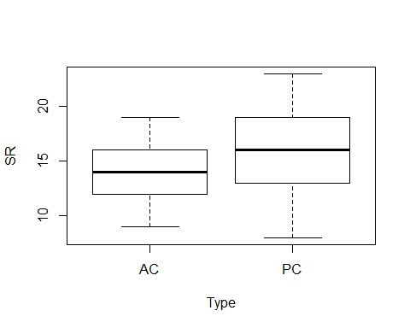

plot(SR ~ Sdate, data=methodYSR1)

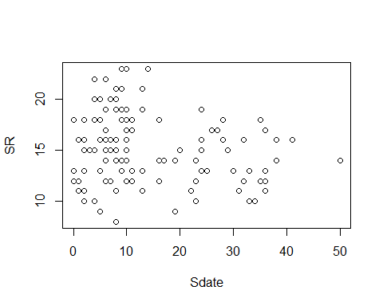

plot(SR ~ Stime, data=methodYSR1)

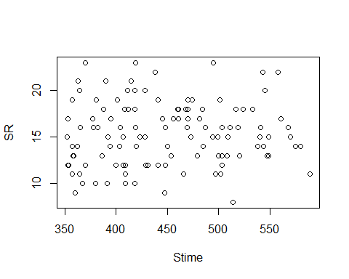

plot(SR ~ Pdate, data=methodYSR1)

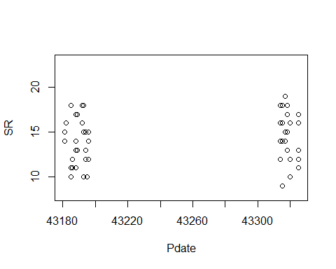

plot(SR ~ Pmin, data=methodYSR1) #?

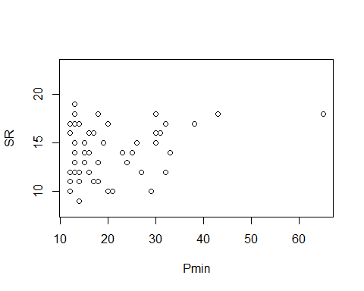

plot(SR ~ Peffort, data=methodYSR1)

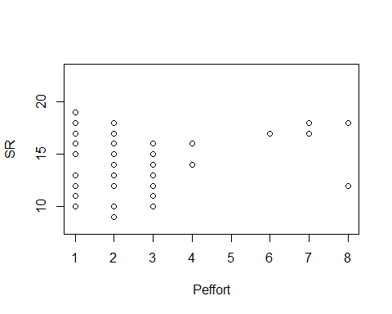

evaluationYV1A<-lm(SR ~ Year, methodYSR1) #year 2018 significantly more +  
summary(evaluationYV1A)

##   
## Call:  
## lm(formula = SR ~ Year, data = methodYSR1)  
##   
## Residuals:  
## Min 1Q Median 3Q Max   
## -7.4667 -2.4103 -0.2414 1.7586 6.7586   
##   
## Coefficients:  
## Estimate Std. Error t value Pr(>|t|)   
## (Intercept) 14.2414 0.4226 33.699 < 2e-16 ***  
## YearB 2.2253 0.5926 3.755 0.000273 ***  
## ---  
## Signif. codes: 0 '***' 0.001 '**' 0.01 '*' 0.05 '.' 0.1 ' ' 1  
##   
## Residual standard error: 3.218 on 116 degrees of freedom  
## Multiple R-squared: 0.1084, Adjusted R-squared: 0.1007   
## F-statistic: 14.1 on 1 and 116 DF, p-value: 0.0002727

confint(evaluationYV1A, level=0.95)

## 2.5 % 97.5 %  
## (Intercept) 13.404368 15.078390  
## YearB 1.051481 3.399094

anova(evaluationYV1A)

## Analysis of Variance Table  
##   
## Response: SR  
## Df Sum Sq Mean Sq F value Pr(>F)   
## Year 1 146.04 146.039 14.099 0.0002727 ***  
## Residuals 116 1201.55 10.358   
## ---  
## Signif. codes: 0 '***' 0.001 '**' 0.01 '*' 0.05 '.' 0.1 ' ' 1

evaluationYV1<-lm(SR ~ Type+Year, methodYSR1) #sig  
summary(evaluationYV1)

##   
## Call:  
## lm(formula = SR ~ Type + Year, data = methodYSR1)  
##   
## Residuals:  
## Min 1Q Median 3Q Max   
## -7.3770 -2.2748 0.3977 1.8942 5.6230   
##   
## Coefficients:  
## Estimate Std. Error t value Pr(>|t|)   
## (Intercept) 13.1058 0.4844 27.055 < 2e-16 ***  
## TypePC 2.2712 0.5562 4.084 8.23e-05 ***  
## YearB 2.2253 0.5562 4.001 0.000112 ***  
## ---  
## Signif. codes: 0 '***' 0.001 '**' 0.01 '*' 0.05 '.' 0.1 ' ' 1  
##   
## Residual standard error: 3.021 on 115 degrees of freedom  
## Multiple R-squared: 0.2213, Adjusted R-squared: 0.2077   
## F-statistic: 16.34 on 2 and 115 DF, p-value: 5.677e-07

confint(evaluationYV1, level=0.95)

## 2.5 % 97.5 %  
## (Intercept) 12.146248 14.065324  
## TypePC 1.169521 3.372852  
## YearB 1.123464 3.327111

anova(evaluationYV1)

## Analysis of Variance Table  
##   
## Response: SR  
## Df Sum Sq Mean Sq F value Pr(>F)   
## Type 1 152.17 152.169 16.676 8.226e-05 ***  
## Year 1 146.04 146.039 16.004 0.0001122 ***  
## Residuals 115 1049.38 9.125   
## ---  
## Signif. codes: 0 '***' 0.001 '**' 0.01 '*' 0.05 '.' 0.1 ' ' 1

evaluationYV1B<-lm(SR ~ Type*Year, methodYSR1) #interaction is sig too  
summary(evaluationYV1B)

##   
## Call:  
## lm(formula = SR ~ Type * Year, data = methodYSR1)  
##   
## Residuals:  
## Min 1Q Median 3Q Max   
## -7.3000 -1.8276 0.3448 1.7000 6.3448   
##   
## Coefficients:  
## Estimate Std. Error t value Pr(>|t|)   
## (Intercept) 13.8276 0.5472 25.269 <2e-16 ***  
## TypePC 0.8276 0.7739 1.069 0.2871   
## YearB 0.8057 0.7674 1.050 0.2960   
## TypePC:YearB 2.8391 1.0853 2.616 0.0101 *   
## ---  
## Signif. codes: 0 '***' 0.001 '**' 0.01 '*' 0.05 '.' 0.1 ' ' 1  
##   
## Residual standard error: 2.947 on 114 degrees of freedom  
## Multiple R-squared: 0.2654, Adjusted R-squared: 0.2461   
## F-statistic: 13.73 on 3 and 114 DF, p-value: 1.048e-07

confint(evaluationYV1B, level=0.95)

## 2.5 % 97.5 %  
## (Intercept) 12.7435610 14.911611  
## TypePC -0.7054569 2.360629  
## YearB -0.7144670 2.325961  
## TypePC:YearB 0.6891731 4.988988

anova(evaluationYV1B)

## Analysis of Variance Table  
##   
## Response: SR  
## Df Sum Sq Mean Sq F value Pr(>F)   
## Type 1 152.17 152.169 17.5233 5.610e-05 ***  
## Year 1 146.04 146.039 16.8174 7.747e-05 ***  
## Type:Year 1 59.43 59.428 6.8436 0.0101 *   
## Residuals 114 989.96 8.684   
## ---  
## Signif. codes: 0 '***' 0.001 '**' 0.01 '*' 0.05 '.' 0.1 ' ' 1

AIC(evaluationYV1,evaluationYV1B) #technically, interaction model is best

## df AIC  
## evaluationYV1 4 600.7319  
## evaluationYV1B 5 595.8527

plot(evaluationYV1B)

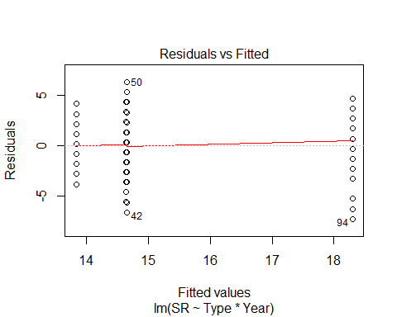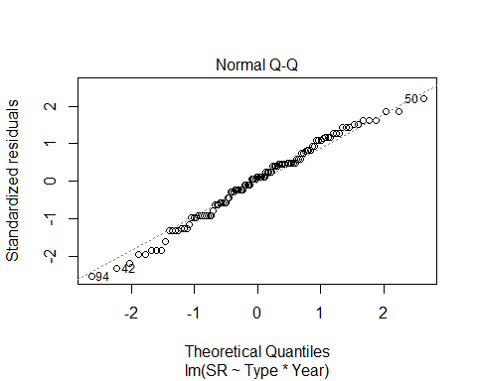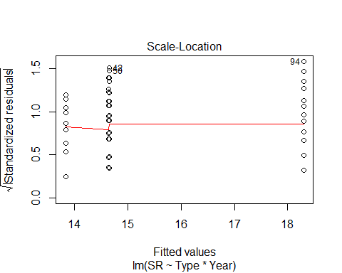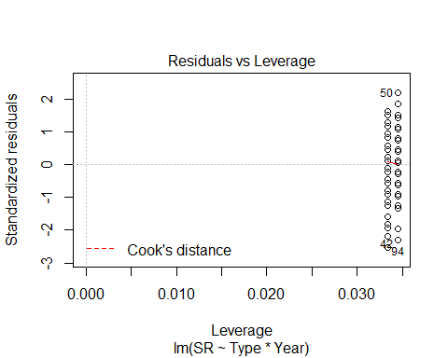

evaluationYV2<-lm(SR ~ Sdate+Year, methodYSR1) #sig - date, + year  
summary(evaluationYV2)

##   
## Call:  
## lm(formula = SR ~ Sdate + Year, data = methodYSR1)  
##   
## Residuals:  
## Min 1Q Median 3Q Max   
## -7.2727 -2.4297 0.2324 2.0730 6.4261   
##   
## Coefficients:  
## Estimate Std. Error t value Pr(>|t|)   
## (Intercept) 15.12484 0.52141 29.007 < 2e-16 ***  
## Sdate -0.06887 0.02500 -2.754 0.00684 **   
## YearB 2.45640 0.58258 4.216 4.97e-05 ***  
## ---  
## Signif. codes: 0 '***' 0.001 '**' 0.01 '*' 0.05 '.' 0.1 ' ' 1  
##   
## Residual standard error: 3.131 on 115 degrees of freedom  
## Multiple R-squared: 0.1636, Adjusted R-squared: 0.149   
## F-statistic: 11.24 on 2 and 115 DF, p-value: 3.469e-05

confint(evaluationYV2, level=0.95)

## 2.5 % 97.5 %  
## (Intercept) 14.0920180 16.15765605  
## Sdate -0.1184004 -0.01934297  
## YearB 1.3024304 3.61037638

anova(evaluationYV2)

## Analysis of Variance Table  
##   
## Response: SR  
## Df Sum Sq Mean Sq F value Pr(>F)   
## Sdate 1 46.14 46.143 4.7077 0.03209 *   
## Year 1 174.26 174.258 17.7784 4.968e-05 ***  
## Residuals 115 1127.19 9.802   
## ---  
## Signif. codes: 0 '***' 0.001 '**' 0.01 '*' 0.05 '.' 0.1 ' ' 1

evaluationYV2B<-lm(SR ~ Sdate*Year, methodYSR1) #interaction term sig but not date   
summary(evaluationYV2B)

##   
## Call:  
## lm(formula = SR ~ Sdate * Year, data = methodYSR1)  
##   
## Residuals:  
## Min 1Q Median 3Q Max   
## -7.0580 -2.2150 -0.0641 1.9339 6.7323   
##   
## Coefficients:  
## Estimate Std. Error t value Pr(>|t|)   
## (Intercept) 14.311221 0.579985 24.675 < 2e-16 ***  
## Sdate -0.005445 0.032832 -0.166 0.86858   
## YearB 4.503371 0.910661 4.945 2.64e-06 ***  
## Sdate:YearB -0.139638 0.048714 -2.866 0.00494 **   
## ---  
## Signif. codes: 0 '***' 0.001 '**' 0.01 '*' 0.05 '.' 0.1 ' ' 1  
##   
## Residual standard error: 3.037 on 114 degrees of freedom  
## Multiple R-squared: 0.2198, Adjusted R-squared: 0.1993   
## F-statistic: 10.7 on 3 and 114 DF, p-value: 2.973e-06

confint(evaluationYV2B, level=0.95)

## 2.5 % 97.5 %  
## (Intercept) 13.16227607 15.46016683  
## Sdate -0.07048372 0.05959435  
## YearB 2.69935897 6.30738325  
## Sdate:YearB -0.23614091 -0.04313564

anova(evaluationYV2B)

## Analysis of Variance Table  
##   
## Response: SR  
## Df Sum Sq Mean Sq F value Pr(>F)   
## Sdate 1 46.14 46.143 5.0031 0.027247 *   
## Year 1 174.26 174.258 18.8941 3.017e-05 ***  
## Sdate:Year 1 75.78 75.782 8.2167 0.004945 **   
## Residuals 114 1051.41 9.223   
## ---  
## Signif. codes: 0 '***' 0.001 '**' 0.01 '*' 0.05 '.' 0.1 ' ' 1

AIC(evaluationYV2,evaluationYV2B) #interaction model better

## df AIC  
## evaluationYV2 4 609.1719  
## evaluationYV2B 5 602.9595

plot(SR ~ Sdate, methodYSR1)



plot(evaluationYV2)

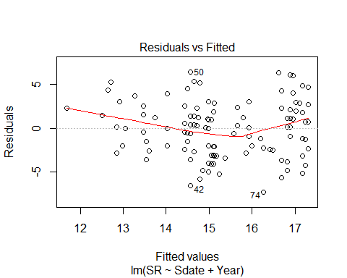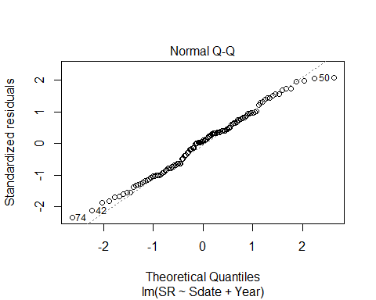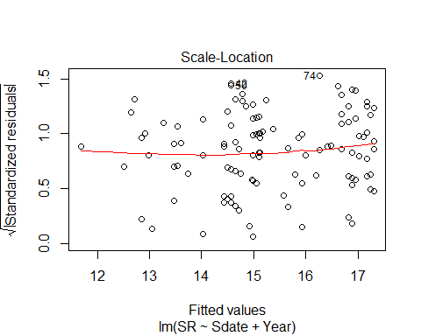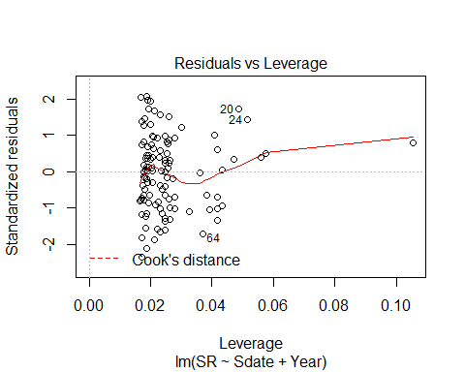

plot(evaluationYV2B)

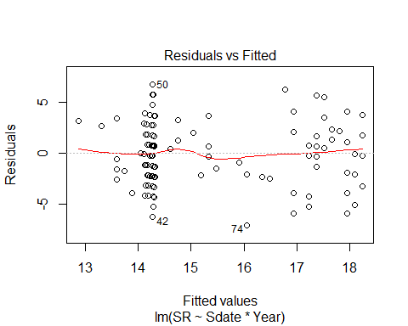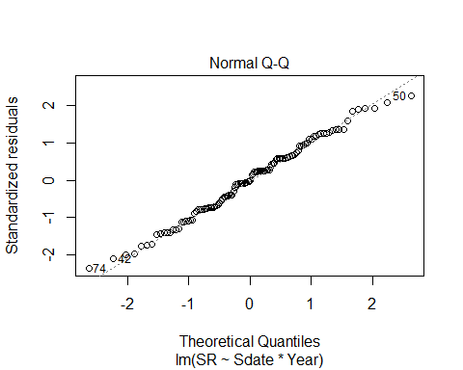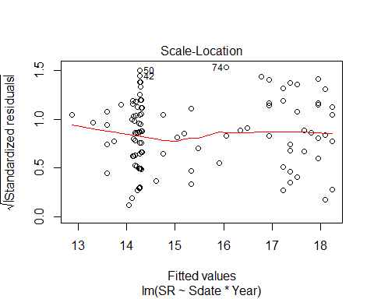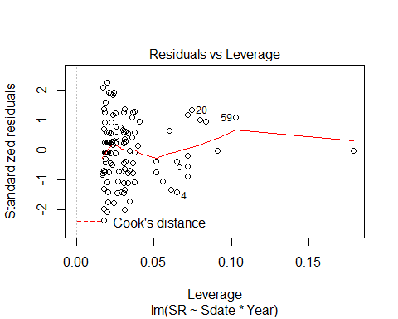 ^tested for quadratic effect for date (even though doesnt look) and it definitely wasn’t better.

#year is missing from this!!! not the actual top model  
evaluationYVa2<-lm(SR ~ Sdate, methodYSR1)  
plot(SR ~ Sdate, methodYSR1, pch=16, axes=F, xlab="", ylab="")  
axis(1,cex.axis=0.8)  
mtext(text="Survey Date", side = 1, line = 3)  
axis(2,las=1)  
mtext(text="Species Richness by Site", side = 2, line = 3)  
box(bty="l")  
x<-seq(min(methodYSR1$Sdate), max(methodYSR1$Sdate),l=1000)  
points(x, predict(evaluationYVa2, data.frame(Sdate=x)),type="l")

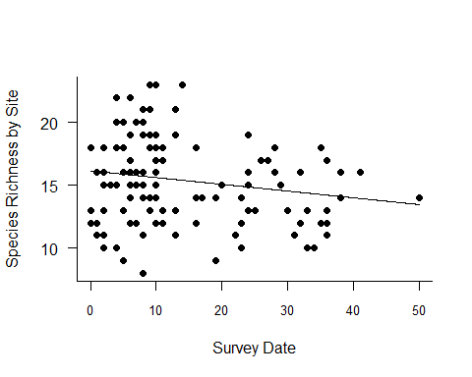

evaluationYV2B<-lm(SR ~ Sdate * Year, methodYSR1)  
plot_model(evaluationYV2B, type="pred", terms=c("Sdate","Year"))

## Argument `include.non.labelled` is deprecated. Please use `non.labelled` instead.

## Argument `include.values` is deprecated. Please use `values` instead.

## Argument `include.non.labelled` is deprecated. Please use `non.labelled` instead.

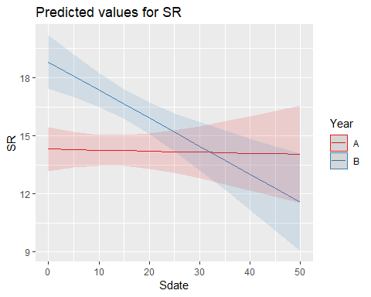

evaluationYV3<-lm(SR ~ Stime+Year, methodYSR1) #year effect but time non-sig  
summary(evaluationYV3)

##   
## Call:  
## lm(formula = SR ~ Stime + Year, data = methodYSR1)  
##   
## Residuals:  
## Min 1Q Median 3Q Max   
## -7.465 -2.304 -0.062 1.969 6.912   
##   
## Coefficients:  
## Estimate Std. Error t value Pr(>|t|)   
## (Intercept) 13.055552 2.091204 6.243 7.42e-09 ***  
## Stime 0.002648 0.004574 0.579 0.563673   
## YearB 2.226059 0.594351 3.745 0.000283 ***  
## ---  
## Signif. codes: 0 '***' 0.001 '**' 0.01 '*' 0.05 '.' 0.1 ' ' 1  
##   
## Residual standard error: 3.228 on 115 degrees of freedom  
## Multiple R-squared: 0.111, Adjusted R-squared: 0.0955   
## F-statistic: 7.177 on 2 and 115 DF, p-value: 0.001156

confint(evaluationYV3, level=0.95)

## 2.5 % 97.5 %  
## (Intercept) 8.913278816 17.19782426  
## Stime -0.006411032 0.01170796  
## YearB 1.048764241 3.40335389

anova(evaluationYV3)

## Analysis of Variance Table  
##   
## Response: SR  
## Df Sum Sq Mean Sq F value Pr(>F)   
## Stime 1 3.39 3.393 0.3257 0.5693331   
## Year 1 146.14 146.140 14.0277 0.0002831 ***  
## Residuals 115 1198.06 10.418   
## ---  
## Signif. codes: 0 '***' 0.001 '**' 0.01 '*' 0.05 '.' 0.1 ' ' 1

plot(evaluationYV3)

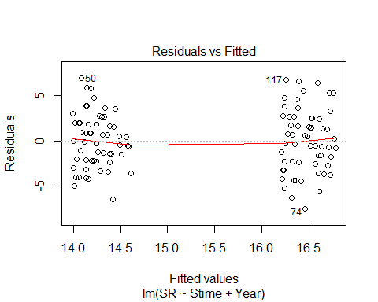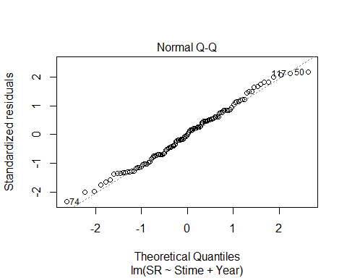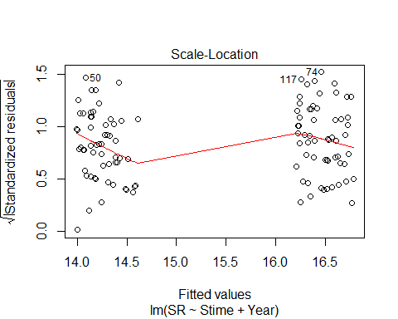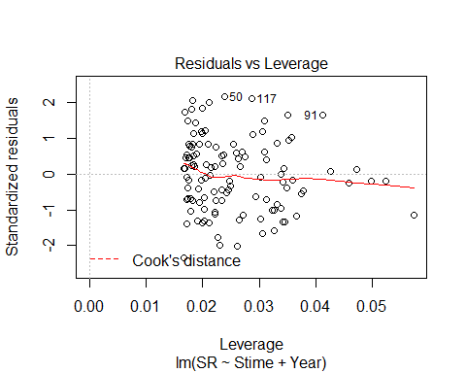

evaluationYV3B<-lm(SR ~ Stime*Year, methodYSR1) #non-sig int term  
summary(evaluationYV3B)

##   
## Call:  
## lm(formula = SR ~ Stime * Year, data = methodYSR1)  
##   
## Residuals:  
## Min 1Q Median 3Q Max   
## -7.4640 -2.2770 -0.1044 1.8700 6.9877   
##   
## Coefficients:  
## Estimate Std. Error t value Pr(>|t|)   
## (Intercept) 14.714004 3.038989 4.842 4.08e-06 ***  
## Stime -0.001056 0.006721 -0.157 0.875   
## YearB -0.872079 4.155155 -0.210 0.834   
## Stime:YearB 0.006922 0.009187 0.753 0.453   
## ---  
## Signif. codes: 0 '***' 0.001 '**' 0.01 '*' 0.05 '.' 0.1 ' ' 1  
##   
## Residual standard error: 3.234 on 114 degrees of freedom  
## Multiple R-squared: 0.1154, Adjusted R-squared: 0.09209   
## F-statistic: 4.956 on 3 and 114 DF, p-value: 0.002858

confint(evaluationYV3B, level=0.95)

## 2.5 % 97.5 %  
## (Intercept) 8.69379066 20.73421658  
## Stime -0.01436942 0.01225827  
## YearB -9.10341011 7.35925137  
## Stime:YearB -0.01127829 0.02512144

anova(evaluationYV3B)

## Analysis of Variance Table  
##   
## Response: SR  
## Df Sum Sq Mean Sq F value Pr(>F)   
## Stime 1 3.39 3.393 0.3244 0.5700687   
## Year 1 146.14 146.140 13.9750 0.0002913 ***  
## Stime:Year 1 5.94 5.935 0.5676 0.4527689   
## Residuals 114 1192.13 10.457   
## ---  
## Signif. codes: 0 '***' 0.001 '**' 0.01 '*' 0.05 '.' 0.1 ' ' 1

plot(evaluationYV3B)

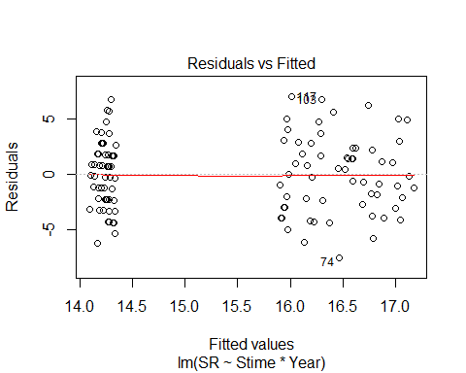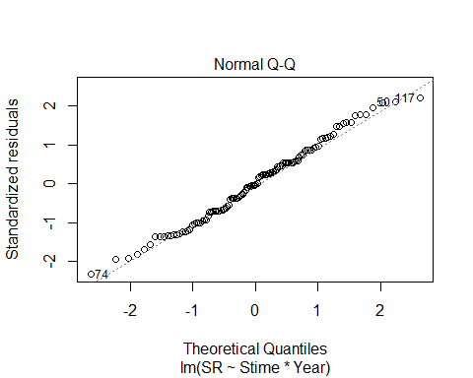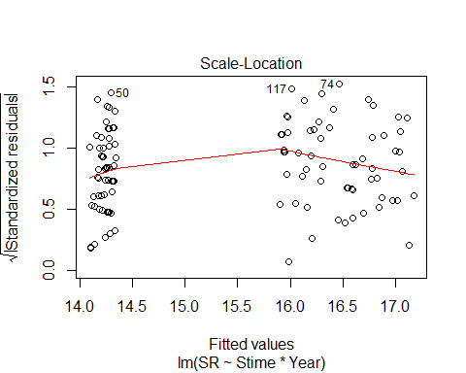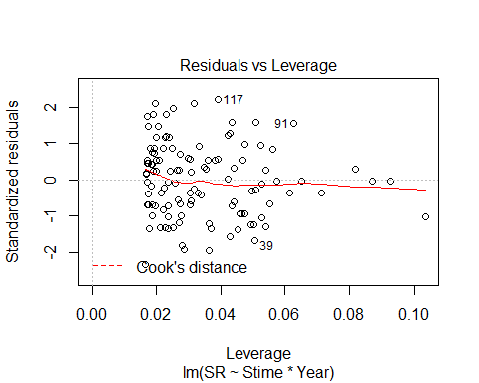

evaluationYV3C<-lm(SR ~ Year + Stime + I(Stime^2), methodYSR1) #year effect but time non-sig  
summary(evaluationYV3C)

##   
## Call:  
## lm(formula = SR ~ Year + Stime + I(Stime^2), data = methodYSR1)  
##   
## Residuals:  
## Min 1Q Median 3Q Max   
## -7.8884 -2.5048 0.2288 2.0846 7.0331   
##   
## Coefficients:  
## Estimate Std. Error t value Pr(>|t|)   
## (Intercept) -6.511e+00 1.537e+01 -0.424 0.672661   
## YearB 2.270e+00 5.936e-01 3.823 0.000215 ***  
## Stime 8.992e-02 6.808e-02 1.321 0.189204   
## I(Stime^2) -9.541e-05 7.426e-05 -1.285 0.201463   
## ---  
## Signif. codes: 0 '***' 0.001 '**' 0.01 '*' 0.05 '.' 0.1 ' ' 1  
##   
## Residual standard error: 3.219 on 114 degrees of freedom  
## Multiple R-squared: 0.1237, Adjusted R-squared: 0.1006   
## F-statistic: 5.362 on 3 and 114 DF, p-value: 0.001723

confint(evaluationYV3C, level=0.95)

## 2.5 % 97.5 %  
## (Intercept) -3.696178e+01 2.393939e+01  
## YearB 1.093570e+00 3.445575e+00  
## Stime -4.494324e-02 2.247842e-01  
## I(Stime^2) -2.425264e-04 5.170005e-05

anova(evaluationYV3C)

## Analysis of Variance Table  
##   
## Response: SR  
## Df Sum Sq Mean Sq F value Pr(>F)   
## Year 1 146.04 146.039 14.0974 0.0002749 ***  
## Stime 1 3.49 3.493 0.3372 0.5625835   
## I(Stime^2) 1 17.10 17.101 1.6507 0.2014626   
## Residuals 114 1180.96 10.359   
## ---  
## Signif. codes: 0 '***' 0.001 '**' 0.01 '*' 0.05 '.' 0.1 ' ' 1

plot(evaluationYV3C)

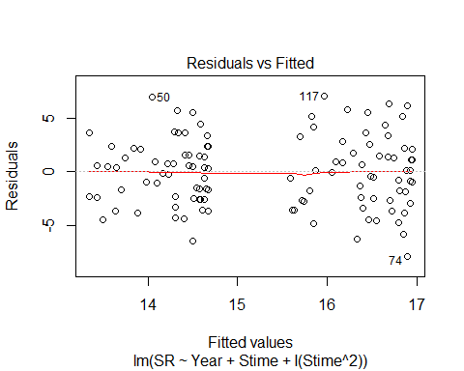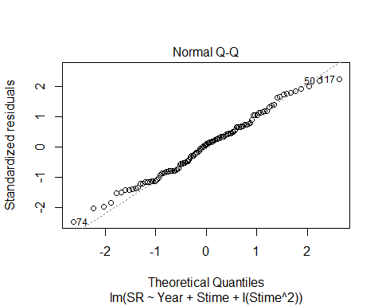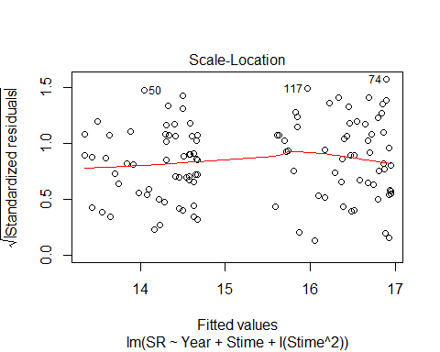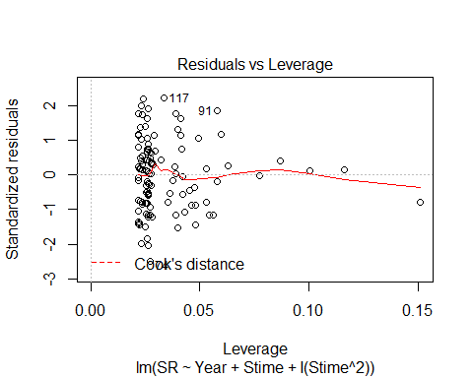

AIC(evaluationYV3, evaluationYV3B, evaluationYV3C) #first one so far where additive better fit, quadratic term for time is NOT better

## df AIC  
## evaluationYV3 4 616.3669  
## evaluationYV3B 5 617.7809  
## evaluationYV3C 5 616.6705

matplot(residuals(evaluationYV3))

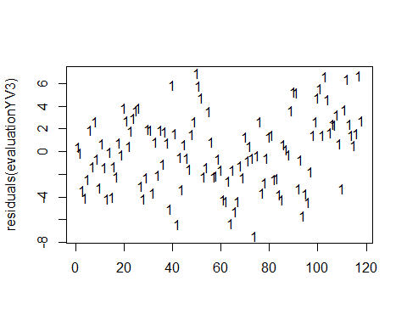

matplot(residuals(evaluationYV3C))

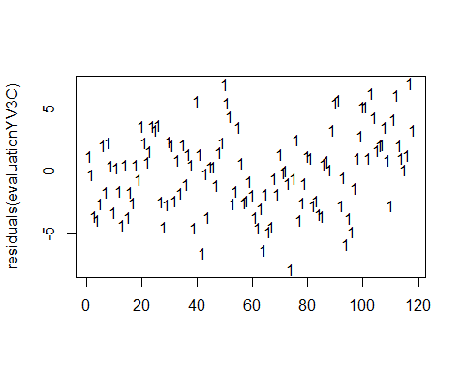

matplot(residuals(evaluationYV3B))

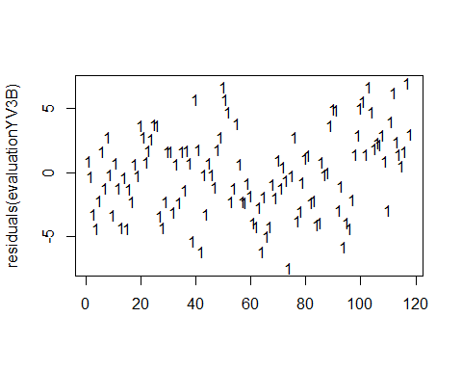

evaluationYV4<-lm(SR ~ Pdate+Year, methodYSR1) #neither sig, not even year  
summary(evaluationYV4)

##   
## Call:  
## lm(formula = SR ~ Pdate + Year, data = methodYSR1)  
##   
## Residuals:  
## Min 1Q Median 3Q Max   
## -5.781 -1.807 0.121 1.763 4.354   
##   
## Coefficients:  
## Estimate Std. Error t value Pr(>|t|)  
## (Intercept) 2024.75006 3447.56779 0.587 0.559  
## Pdate -0.04656 0.07982 -0.583 0.562  
## YearB 6.81504 10.32435 0.660 0.512  
##   
## Residual standard error: 2.58 on 56 degrees of freedom  
## (59 observations deleted due to missingness)  
## Multiple R-squared: 0.03078, Adjusted R-squared: -0.00384   
## F-statistic: 0.8891 on 2 and 56 DF, p-value: 0.4168

confint(evaluationYV4, level=0.95)

## 2.5 % 97.5 %  
## (Intercept) -4881.5581126 8931.0582364  
## Pdate -0.2064695 0.1133477  
## YearB -13.8671219 27.4972091

anova(evaluationYV4)

## Analysis of Variance Table  
##   
## Response: SR  
## Df Sum Sq Mean Sq F value Pr(>F)  
## Pdate 1 8.94 8.9375 1.3424 0.2515  
## Year 1 2.90 2.9010 0.4357 0.5119  
## Residuals 56 372.84 6.6578

plot(evaluationYV4)

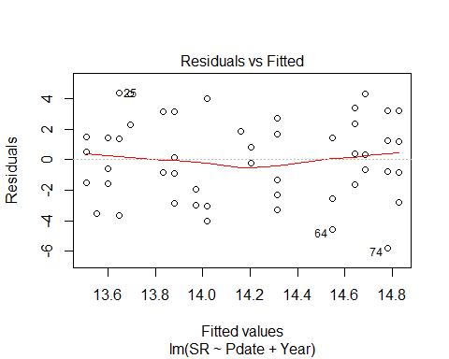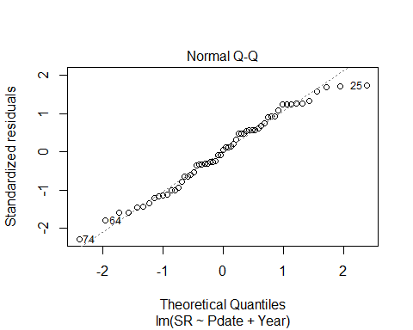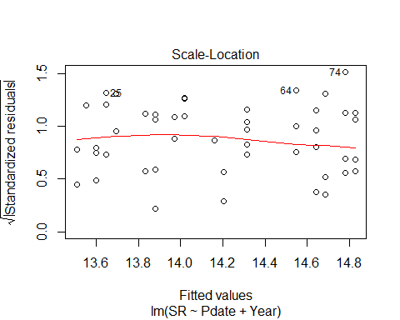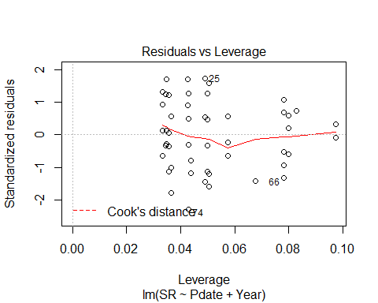

evaluationYV4B<-lm(SR ~ Pdate*Year, methodYSR1) #nothing sig  
summary(evaluationYV4B)

##   
## Call:  
## lm(formula = SR ~ Pdate * Year, data = methodYSR1)  
##   
## Residuals:  
## Min 1Q Median 3Q Max   
## -6.0524 -1.8324 0.2123 2.1838 4.2123   
##   
## Coefficients:  
## Estimate Std. Error t value Pr(>|t|)  
## (Intercept) -2.196e+02 4.381e+03 -0.050 0.960  
## Pdate 5.405e-03 1.014e-01 0.053 0.958  
## YearB 5.967e+03 7.146e+03 0.835 0.407  
## Pdate:YearB -1.378e-01 1.651e-01 -0.834 0.408  
##   
## Residual standard error: 2.587 on 55 degrees of freedom  
## (59 observations deleted due to missingness)  
## Multiple R-squared: 0.04288, Adjusted R-squared: -0.009322   
## F-statistic: 0.8214 on 3 and 55 DF, p-value: 0.4876

confint(evaluationYV4B, level=0.95)

## 2.5 % 97.5 %  
## (Intercept) -8998.6118459 8.559358e+03  
## Pdate -0.1978631 2.086739e-01  
## YearB -8352.6412116 2.028720e+04  
## Pdate:YearB -0.4686991 1.931949e-01

anova(evaluationYV4B)

## Analysis of Variance Table  
##   
## Response: SR  
## Df Sum Sq Mean Sq F value Pr(>F)  
## Pdate 1 8.94 8.9375 1.3351 0.2529  
## Year 1 2.90 2.9010 0.4334 0.5131  
## Pdate:Year 1 4.66 4.6579 0.6958 0.4078  
## Residuals 55 368.18 6.6942

plot(evaluationYV4B)

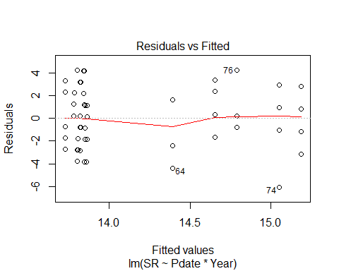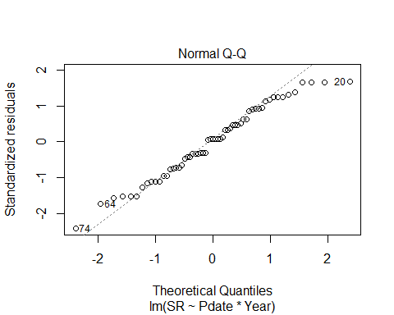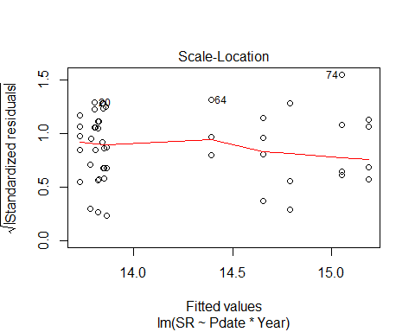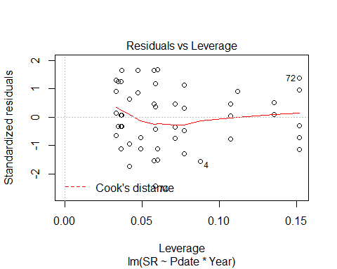

evaluationYV4C<-lm(SR ~ Pdate+I(Pdate^2)+Year, methodYSR1) #neither sig, not even year  
summary(evaluationYV4C)

##   
## Call:  
## lm(formula = SR ~ Pdate + I(Pdate^2) + Year, data = methodYSR1)  
##   
## Residuals:  
## Min 1Q Median 3Q Max   
## -6.0520 -1.8347 0.2068 2.1877 4.2068   
##   
## Coefficients:  
## Estimate Std. Error t value Pr(>|t|)  
## (Intercept) -9.915e+05 1.179e+06 -0.841 0.404  
## Pdate 4.591e+01 5.453e+01 0.842 0.403  
## I(Pdate^2) -5.314e-04 6.306e-04 -0.843 0.403  
## YearB 8.946e+00 1.066e+01 0.840 0.405  
##   
## Residual standard error: 2.587 on 55 degrees of freedom  
## (59 observations deleted due to missingness)  
## Multiple R-squared: 0.04313, Adjusted R-squared: -0.00906   
## F-statistic: 0.8264 on 3 and 55 DF, p-value: 0.485

confint(evaluationYV4C, level=0.95)

## 2.5 % 97.5 %  
## (Intercept) -3.354017e+06 1.370975e+06  
## Pdate -6.336780e+01 1.551888e+02  
## I(Pdate^2) -1.795123e-03 7.322382e-04  
## YearB -1.240802e+01 3.030026e+01

anova(evaluationYV4C)

## Analysis of Variance Table  
##   
## Response: SR  
## Df Sum Sq Mean Sq F value Pr(>F)  
## Pdate 1 8.94 8.9375 1.3355 0.2528  
## I(Pdate^2) 1 2.94 2.9373 0.4389 0.5104  
## Year 1 4.72 4.7174 0.7049 0.4048  
## Residuals 55 368.09 6.6925

plot(evaluationYV4C)

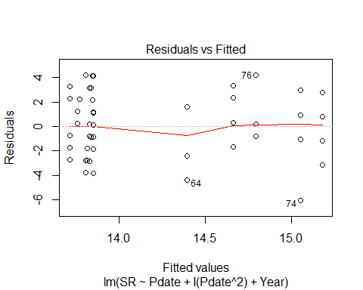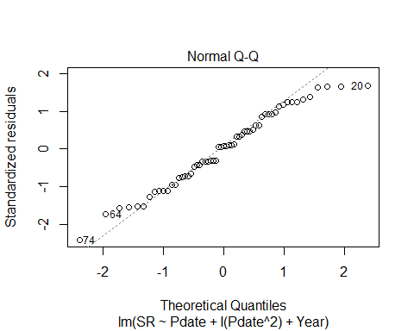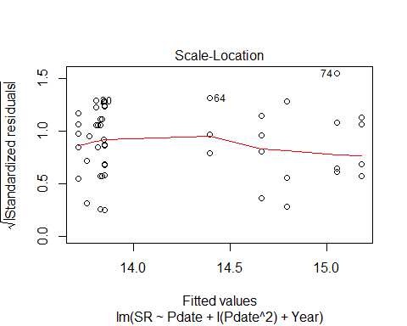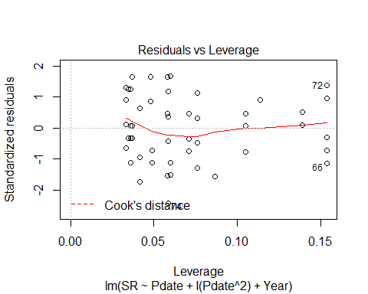

evaluationYV4D<-lm(SR ~ Pdate+I(Pdate^2)+I(Pdate^3)+Year, methodYSR1) #neither sig, not even year  
summary(evaluationYV4D)

##   
## Call:  
## lm(formula = SR ~ Pdate + I(Pdate^2) + I(Pdate^3) + Year, data = methodYSR1)  
##   
## Residuals:  
## Min 1Q Median 3Q Max   
## -6.0520 -1.8347 0.2068 2.1877 4.2068   
##   
## Coefficients: (1 not defined because of singularities)  
## Estimate Std. Error t value Pr(>|t|)  
## (Intercept) -9.915e+05 1.179e+06 -0.841 0.404  
## Pdate 4.591e+01 5.453e+01 0.842 0.403  
## I(Pdate^2) -5.314e-04 6.306e-04 -0.843 0.403  
## I(Pdate^3) NA NA NA NA  
## YearB 8.946e+00 1.066e+01 0.840 0.405  
##   
## Residual standard error: 2.587 on 55 degrees of freedom  
## (59 observations deleted due to missingness)  
## Multiple R-squared: 0.04313, Adjusted R-squared: -0.00906   
## F-statistic: 0.8264 on 3 and 55 DF, p-value: 0.485

confint(evaluationYV4D, level=0.95)

## 2.5 % 97.5 %  
## (Intercept) -3.354017e+06 1.370975e+06  
## Pdate -6.336780e+01 1.551888e+02  
## I(Pdate^2) -1.795123e-03 7.322382e-04  
## I(Pdate^3) NA NA  
## YearB -1.240802e+01 3.030026e+01

anova(evaluationYV4D)

## Analysis of Variance Table  
##   
## Response: SR  
## Df Sum Sq Mean Sq F value Pr(>F)  
## Pdate 1 8.94 8.9375 1.3355 0.2528  
## I(Pdate^2) 1 2.94 2.9373 0.4389 0.5104  
## Year 1 4.72 4.7174 0.7049 0.4048  
## Residuals 55 368.09 6.6925

plot(evaluationYV4D)

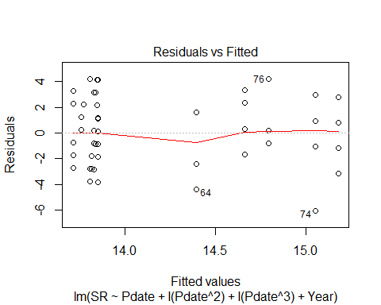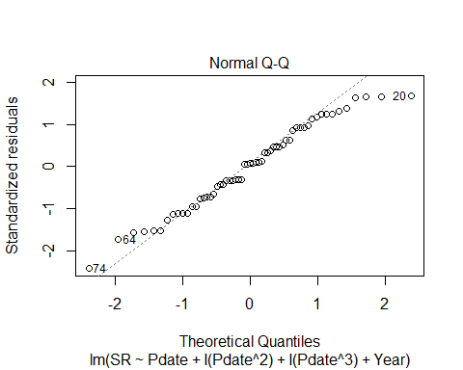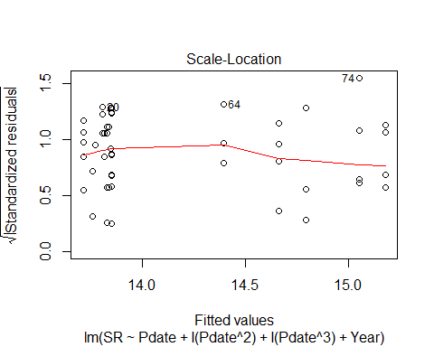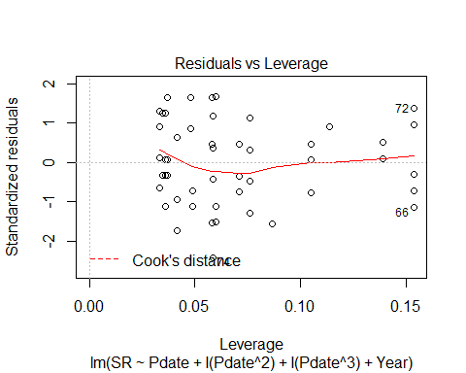

AIC(evaluationYV4,evaluationYV4B) #additive actually better

## df AIC  
## evaluationYV4 4 284.2078  
## evaluationYV4B 5 285.4660

AIC(evaluationYV4,evaluationYV4B, evaluationYV4C, evaluationYV4D) #nonlinear

## df AIC  
## evaluationYV4 4 284.2078  
## evaluationYV4B 5 285.4660  
## evaluationYV4C 5 285.4507  
## evaluationYV4D 5 285.4507

evaluationYV5<-lm(SR ~ Pmin + Year, methodYSR1) #both sig (Pmin is +)  
summary(evaluationYV5)

##   
## Call:  
## lm(formula = SR ~ Pmin + Year, data = methodYSR1)  
##   
## Residuals:  
## Min 1Q Median 3Q Max   
## -5.6013 -1.7700 0.2386 1.6729 4.5358   
##   
## Coefficients:  
## Estimate Std. Error t value Pr(>|t|)   
## (Intercept) 10.33368 1.09864 9.406 4.01e-13 ***  
## Pmin 0.13711 0.03957 3.465 0.00102 **   
## YearB 2.34814 0.75645 3.104 0.00299 **   
## ---  
## Signif. codes: 0 '***' 0.001 '**' 0.01 '*' 0.05 '.' 0.1 ' ' 1  
##   
## Residual standard error: 2.349 on 56 degrees of freedom  
## (59 observations deleted due to missingness)  
## Multiple R-squared: 0.197, Adjusted R-squared: 0.1684   
## F-statistic: 6.871 on 2 and 56 DF, p-value: 0.002146

confint(evaluationYV5, level=0.95)

## 2.5 % 97.5 %  
## (Intercept) 8.13284559 12.534507  
## Pmin 0.05783957 0.216378  
## YearB 0.83279539 3.863489

anova(evaluationYV5)

## Analysis of Variance Table  
##   
## Response: SR  
## Df Sum Sq Mean Sq F value Pr(>F)   
## Pmin 1 22.645 22.645 4.1055 0.047518 *   
## Year 1 53.149 53.149 9.6359 0.002991 **  
## Residuals 56 308.884 5.516   
## ---  
## Signif. codes: 0 '***' 0.001 '**' 0.01 '*' 0.05 '.' 0.1 ' ' 1

evaluationYV5B<-lm(SR ~ Pmin * Year, methodYSR1) #p min & year are sig; int term not  
summary(evaluationYV5B)

##   
## Call:  
## lm(formula = SR ~ Pmin * Year, data = methodYSR1)  
##   
## Residuals:  
## Min 1Q Median 3Q Max   
## -5.6238 -1.6388 0.2438 1.4918 4.4171   
##   
## Coefficients:  
## Estimate Std. Error t value Pr(>|t|)   
## (Intercept) 10.17878 1.13390 8.977 2.3e-12 ***  
## Pmin 0.14319 0.04103 3.490 0.000961 ***  
## YearB 3.87217 2.62101 1.477 0.145283   
## Pmin:YearB -0.10227 0.16831 -0.608 0.545939   
## ---  
## Signif. codes: 0 '***' 0.001 '**' 0.01 '*' 0.05 '.' 0.1 ' ' 1  
##   
## Residual standard error: 2.362 on 55 degrees of freedom  
## (59 observations deleted due to missingness)  
## Multiple R-squared: 0.2024, Adjusted R-squared: 0.1589   
## F-statistic: 4.652 on 3 and 55 DF, p-value: 0.005725

confint(evaluationYV5B, level=0.95)

## 2.5 % 97.5 %  
## (Intercept) 7.90638982 12.4511723  
## Pmin 0.06095457 0.2254199  
## YearB -1.38045140 9.1247839  
## Pmin:YearB -0.43957506 0.2350347

anova(evaluationYV5B)

## Analysis of Variance Table  
##   
## Response: SR  
## Df Sum Sq Mean Sq F value Pr(>F)   
## Pmin 1 22.645 22.645 4.0592 0.048830 *   
## Year 1 53.149 53.149 9.5273 0.003168 **  
## Pmin:Year 1 2.060 2.060 0.3692 0.545939   
## Residuals 55 306.824 5.579   
## ---  
## Signif. codes: 0 '***' 0.001 '**' 0.01 '*' 0.05 '.' 0.1 ' ' 1

evaluationYV5C<-lm(SR ~ Pmin + I(Pmin^2) + Year, methodYSR1)  
summary(evaluationYV5C)

##   
## Call:  
## lm(formula = SR ~ Pmin + I(Pmin^2) + Year, data = methodYSR1)  
##   
## Residuals:  
## Min 1Q Median 3Q Max   
## -5.5999 -1.7613 0.2401 1.7248 4.5641   
##   
## Coefficients:  
## Estimate Std. Error t value Pr(>|t|)   
## (Intercept) 9.6976103 2.1597630 4.490 3.69e-05 ***  
## Pmin 0.1822509 0.1375097 1.325 0.19053   
## I(Pmin^2) -0.0006735 0.0019633 -0.343 0.73288   
## YearB 2.4828230 0.8576269 2.895 0.00543 **   
## ---  
## Signif. codes: 0 '***' 0.001 '**' 0.01 '*' 0.05 '.' 0.1 ' ' 1  
##   
## Residual standard error: 2.367 on 55 degrees of freedom  
## (59 observations deleted due to missingness)  
## Multiple R-squared: 0.1987, Adjusted R-squared: 0.155   
## F-statistic: 4.548 on 3 and 55 DF, p-value: 0.006439

confint(evaluationYV5C, level=0.95)

## 2.5 % 97.5 %  
## (Intercept) 5.369348521 14.025872136  
## Pmin -0.093324582 0.457826442  
## I(Pmin^2) -0.004608041 0.003261088  
## YearB 0.764100257 4.201545722

anova(evaluationYV5C)

## Analysis of Variance Table  
##   
## Response: SR  
## Df Sum Sq Mean Sq F value Pr(>F)   
## Pmin 1 22.645 22.645 4.0408 0.049328 *   
## I(Pmin^2) 1 6.841 6.841 1.2207 0.274025   
## Year 1 46.968 46.968 8.3810 0.005428 **  
## Residuals 55 308.224 5.604   
## ---  
## Signif. codes: 0 '***' 0.001 '**' 0.01 '*' 0.05 '.' 0.1 ' ' 1

evaluationYV5D<-lm(SR ~ Pmin + I(Pmin^2) + I(Pmin^3) + Year, methodYSR1)  
summary(evaluationYV5D)

##   
## Call:  
## lm(formula = SR ~ Pmin + I(Pmin^2) + I(Pmin^3) + Year, data = methodYSR1)  
##   
## Residuals:  
## Min 1Q Median 3Q Max   
## -5.5622 -1.5728 0.4169 1.4307 4.4454   
##   
## Coefficients:  
## Estimate Std. Error t value Pr(>|t|)   
## (Intercept) 14.5943974 5.1012018 2.861 0.0060 **  
## Pmin -0.3815855 0.5496981 -0.694 0.4905   
## I(Pmin^2) 0.0179104 0.0176524 1.015 0.3148   
## I(Pmin^3) -0.0001726 0.0001629 -1.059 0.2942   
## YearB 2.2730384 0.8792679 2.585 0.0125 *   
## ---  
## Signif. codes: 0 '***' 0.001 '**' 0.01 '*' 0.05 '.' 0.1 ' ' 1  
##   
## Residual standard error: 2.365 on 54 degrees of freedom  
## (59 observations deleted due to missingness)  
## Multiple R-squared: 0.2151, Adjusted R-squared: 0.1569   
## F-statistic: 3.699 on 4 and 54 DF, p-value: 0.009852

confint(evaluationYV5D, level=0.95)

## 2.5 % 97.5 %  
## (Intercept) 4.367103618 2.482169e+01  
## Pmin -1.483663793 7.204928e-01  
## I(Pmin^2) -0.017480558 5.330136e-02  
## I(Pmin^3) -0.000499136 1.540238e-04  
## YearB 0.510212389 4.035864e+00

anova(evaluationYV5D)

## Analysis of Variance Table  
##   
## Response: SR  
## Df Sum Sq Mean Sq F value Pr(>F)   
## Pmin 1 22.645 22.645 4.0498 0.04918 *  
## I(Pmin^2) 1 6.841 6.841 1.2235 0.27359   
## I(Pmin^3) 1 15.873 15.873 2.8388 0.09779 .  
## Year 1 37.369 37.369 6.6830 0.01247 *  
## Residuals 54 301.950 5.592   
## ---  
## Signif. codes: 0 '***' 0.001 '**' 0.01 '*' 0.05 '.' 0.1 ' ' 1

evaluationYVa5<-lm(SR ~ Pmin, methodYSR1)  
#summary(methodYSR1$Pmin) #min 12, max 65  
summary(evaluationYVa5)

##   
## Call:  
## lm(formula = SR ~ Pmin, data = methodYSR1)  
##   
## Residuals:  
## Min 1Q Median 3Q Max   
## -4.8637 -1.8313 0.0991 1.9556 5.2011   
##   
## Coefficients:  
## Estimate Std. Error t value Pr(>|t|)   
## (Intercept) 12.95617 0.75366 17.191 <2e-16 ***  
## Pmin 0.06483 0.03433 1.888 0.0641 .   
## ---  
## Signif. codes: 0 '***' 0.001 '**' 0.01 '*' 0.05 '.' 0.1 ' ' 1  
##   
## Residual standard error: 2.52 on 57 degrees of freedom  
## (59 observations deleted due to missingness)  
## Multiple R-squared: 0.05887, Adjusted R-squared: 0.04236   
## F-statistic: 3.565 on 1 and 57 DF, p-value: 0.06409

confint(evaluationYVa5, level=0.95)

## 2.5 % 97.5 %  
## (Intercept) 11.446996148 14.4653373  
## Pmin -0.003922906 0.1335733

anova(evaluationYVa5)

## Analysis of Variance Table  
##   
## Response: SR  
## Df Sum Sq Mean Sq F value Pr(>F)   
## Pmin 1 22.64 22.6449 3.5653 0.06409 .  
## Residuals 57 362.03 6.3515   
## ---  
## Signif. codes: 0 '***' 0.001 '**' 0.01 '*' 0.05 '.' 0.1 ' ' 1

plot(SR ~ Pmin, methodYSR1, pch=16, axes=F, xlab="", ylab="")  
axis(1,cex.axis=0.8)  
mtext(text="Time Spent Processing Surveys (minutes)", side = 1, line = 3)  
axis(2,las=1)  
mtext(text="Species Richness by Site", side = 2, line = 3)  
box(bty="l")  
x<-seq(12,65,l=1000)  
points(x, predict(evaluationYVa5, data.frame(Pmin=x)),type="l")

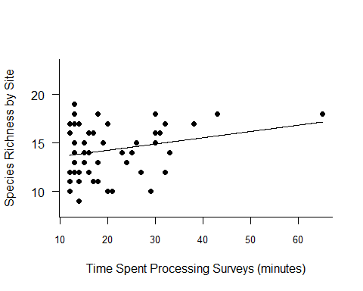

AIC(evaluationYV5,evaluationYV5B) #ADDITIVE better

## df AIC  
## evaluationYV5 4 273.1050  
## evaluationYV5B 5 274.7102

AIC(evaluationYV5, evaluationYV5B, evaluationYV5C, evaluationYV5D, evaluationYVa5) #nonlinear best

## df AIC  
## evaluationYV5 4 273.1050  
## evaluationYV5B 5 274.7102  
## evaluationYV5C 5 274.9789  
## evaluationYV5D 6 275.7654  
## evaluationYVa5 3 280.4724

evaluationYV5<-lm(SR ~ Pmin + Year, methodYSR1)  
plot_model(evaluationYV5, type="pred",terms=c("Pmin", "Year"))

## Argument `include.non.labelled` is deprecated. Please use `non.labelled` instead.

## Argument `include.values` is deprecated. Please use `values` instead.

## Argument `include.non.labelled` is deprecated. Please use `non.labelled` instead.

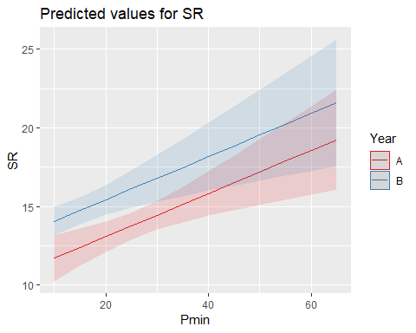

evaluationYV6<-lm(SR ~ Peffort + Year, methodYSR1) #sig  
summary(evaluationYV6)

##   
## Call:  
## lm(formula = SR ~ Peffort + Year, data = methodYSR1)  
##   
## Residuals:  
## Min 1Q Median 3Q Max   
## -5.8150 -1.6886 0.2664 1.7300 4.8114   
##   
## Coefficients:  
## Estimate Std. Error t value Pr(>|t|)   
## (Intercept) 12.0987 0.8231 14.700 <2e-16 ***  
## Peffort 0.5450 0.2161 2.522 0.0145 *   
## YearB 1.6263 0.7168 2.269 0.0271 *   
## ---  
## Signif. codes: 0 '***' 0.001 '**' 0.01 '*' 0.05 '.' 0.1 ' ' 1  
##   
## Residual standard error: 2.453 on 56 degrees of freedom  
## (59 observations deleted due to missingness)  
## Multiple R-squared: 0.1243, Adjusted R-squared: 0.09306   
## F-statistic: 3.976 on 2 and 56 DF, p-value: 0.02429

confint(evaluationYV6, level=0.95)

## 2.5 % 97.5 %  
## (Intercept) 10.4499212 13.7474731  
## Peffort 0.1120719 0.9778799  
## YearB 0.1904129 3.0622732

anova(evaluationYV6)

## Analysis of Variance Table  
##   
## Response: SR  
## Df Sum Sq Mean Sq F value Pr(>F)   
## Peffort 1 16.86 16.8631 2.8034 0.09964 .  
## Year 1 30.97 30.9651 5.1478 0.02715 *  
## Residuals 56 336.85 6.0152   
## ---  
## Signif. codes: 0 '***' 0.001 '**' 0.01 '*' 0.05 '.' 0.1 ' ' 1

evaluationYV6B<-lm(SR ~ Peffort * Year, methodYSR1) #int term non-sig  
summary(evaluationYV6B)

##   
## Call:  
## lm(formula = SR ~ Peffort * Year, data = methodYSR1)  
##   
## Residuals:  
## Min 1Q Median 3Q Max   
## -5.5895 -1.6021 0.2789 1.6012 4.8979   
##   
## Coefficients:  
## Estimate Std. Error t value Pr(>|t|)   
## (Intercept) 11.8646 0.8531 13.908 < 2e-16 ***  
## Peffort 0.6188 0.2274 2.721 0.00871 **   
## YearB 2.9880 1.4985 1.994 0.05112 .   
## Peffort:YearB -0.7503 0.7253 -1.035 0.30540   
## ---  
## Signif. codes: 0 '***' 0.001 '**' 0.01 '*' 0.05 '.' 0.1 ' ' 1  
##   
## Residual standard error: 2.451 on 55 degrees of freedom  
## (59 observations deleted due to missingness)  
## Multiple R-squared: 0.141, Adjusted R-squared: 0.0942   
## F-statistic: 3.011 on 3 and 55 DF, p-value: 0.0378

confint(evaluationYV6B, level=0.95)

## 2.5 % 97.5 %  
## (Intercept) 10.15497464 13.5742415  
## Peffort 0.16296736 1.0745623  
## YearB -0.01502387 5.9910709  
## Peffort:YearB -2.20381500 0.7031274

anova(evaluationYV6B)

## Analysis of Variance Table  
##   
## Response: SR  
## Df Sum Sq Mean Sq F value Pr(>F)   
## Peffort 1 16.86 16.8631 2.8069 0.09953 .  
## Year 1 30.97 30.9651 5.1543 0.02713 *  
## Peffort:Year 1 6.43 6.4302 1.0703 0.30540   
## Residuals 55 330.42 6.0076   
## ---  
## Signif. codes: 0 '***' 0.001 '**' 0.01 '*' 0.05 '.' 0.1 ' ' 1

# absolutely no reason to believe Peffort would be quadratic - not going to do it automatically.

evaluationYVa6<-lm(SR ~ Peffort, methodYSR1) #nonsig  
#summary(methodYSR1$Peffort) #min 1, max 8  
summary(evaluationYVa6)

##   
## Call:  
## lm(formula = SR ~ Peffort, data = methodYSR1)  
##   
## Residuals:  
## Min 1Q Median 3Q Max   
## -5.1061 -1.9449 -0.1061 1.8939 5.2163   
##   
## Coefficients:  
## Estimate Std. Error t value Pr(>|t|)   
## (Intercept) 13.4613 0.5829 23.094 <2e-16 ***  
## Peffort 0.3224 0.1994 1.617 0.111   
## ---  
## Signif. codes: 0 '***' 0.001 '**' 0.01 '*' 0.05 '.' 0.1 ' ' 1  
##   
## Residual standard error: 2.54 on 57 degrees of freedom  
## (59 observations deleted due to missingness)  
## Multiple R-squared: 0.04384, Adjusted R-squared: 0.02706   
## F-statistic: 2.613 on 1 and 57 DF, p-value: 0.1115

confint(evaluationYVa6, level=0.95)

## 2.5 % 97.5 %  
## (Intercept) 12.2941163 14.6285749  
## Peffort -0.0769635 0.7217608

anova(evaluationYVa6)

## Analysis of Variance Table  
##   
## Response: SR  
## Df Sum Sq Mean Sq F value Pr(>F)  
## Peffort 1 16.86 16.8631 2.6133 0.1115  
## Residuals 57 367.81 6.4529

plot(SR ~ Peffort, methodYSR1, pch=16, axes=F, xlab="", ylab="")  
axis(1,cex.axis=0.8)  
mtext(text="Number of Repeated Listens", side = 1, line = 3)  
axis(2,las=1)  
mtext(text="Species Richness by Site", side = 2, line = 3)  
box(bty="l")  
x<-seq(1,8,l=1000)  
points(x, predict(evaluationYVa6, data.frame(Peffort=x)),type="l")

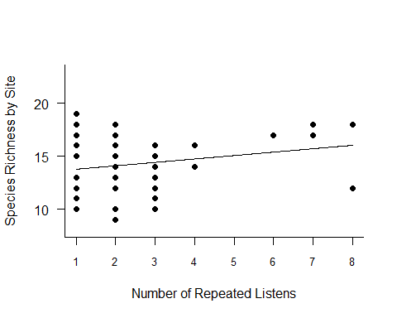

AIC(evaluationYV6,evaluationYV6B, evaluationYVa6) #ADDITIVE IS BETTER

## df AIC  
## evaluationYV6 4 278.2186  
## evaluationYV6B 5 279.0815  
## evaluationYVa6 3 281.4072

evaluationYV6<-lm(SR ~ Peffort + Year, methodYSR1)  
plot_model(evaluationYV6, type="pred",terms=c("Peffort", "Year"))

## Argument `include.non.labelled` is deprecated. Please use `non.labelled` instead.

## Argument `include.values` is deprecated. Please use `values` instead.

## Argument `include.non.labelled` is deprecated. Please use `non.labelled` instead.

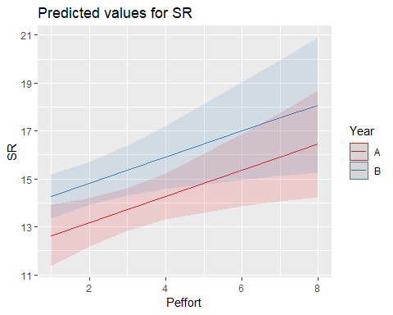

ALL SIG VISIT 1 VARIABLES:

plot(SR ~ Year, methodYSR1)

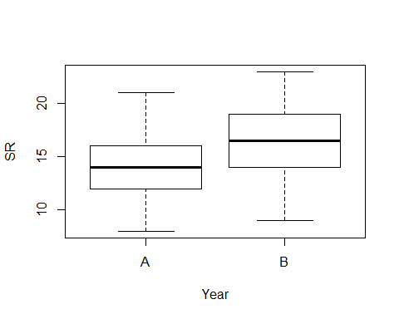

plot(SR ~ Type, methodYSR1)



plot(SR ~ Sdate, methodYSR1)



plot(SR ~ Pmin, methodYSR1)



plot(SR ~ Peffort, methodYSR1)



# Visit 2 - all variables

methodYSR2 <-read.csv("17_18_2by2_ACPC_SR.csv") #SR by count #2 each - Site Type SR  
#summary(methodYSR2)  
str(methodYSR2)

## 'data.frame': 118 obs. of 9 variables:  
## $ SiteName: Factor w/ 32 levels "Abercrombie_0B_E_AB",..: 4 5 6 8 9 15 16 17 18 19 ...  
## $ Type : Factor w/ 2 levels "AC","PC": 1 1 1 1 1 1 1 1 1 1 ...  
## $ SR : int 17 15 12 9 9 16 13 11 17 13 ...  
## $ Sdate : int 2 17 28 36 22 25 35 28 9 22 ...  
## $ Stime : int 426 353 553 355 354 558 386 425 521 514 ...  
## $ Pdate : int 43201 43201 43203 43209 43210 43202 43205 43205 43206 43205 ...  
## $ Pmin : int 39 25 37 14 15 15 18 22 15 21 ...  
## $ Peffort : int 4 3 7 1 1 2 2 2 2 2 ...  
## $ Year : Factor w/ 2 levels "A","B": 1 1 1 1 1 1 1 1 1 1 ...

#test for distribution - gaussian is best so can continue with lm  
test1<-lm(SR ~ Pmin, methodYSR2)  
test2<-glm(SR ~ Pmin, family=gaussian(), data=methodYSR2)  
test3<-glm(SR ~ Pmin, family=poisson(), data=methodYSR2)  
AIC(test1, test2,test3)

## df AIC  
## test1 3 317.7409  
## test2 3 317.7409  
## test3 2 318.3716

plot(methodYSR2$SR ~ methodYSR2$Type)



#plot(SR ~ Type, data=methodSR) #same as above

evaluationYV7A<-lm(SR ~ Year, methodYSR2) #sig year effect  
summary(evaluationYV7A)

##   
## Call:  
## lm(formula = SR ~ Year, data = methodYSR2)  
##   
## Residuals:  
## Min 1Q Median 3Q Max   
## -8.2333 -2.0931 -0.2333 2.7667 5.7667   
##   
## Coefficients:  
## Estimate Std. Error t value Pr(>|t|)   
## (Intercept) 13.6724 0.3983 34.324 < 2e-16 ***  
## YearB 1.5609 0.5586 2.794 0.00609 **   
## ---  
## Signif. codes: 0 '***' 0.001 '**' 0.01 '*' 0.05 '.' 0.1 ' ' 1  
##   
## Residual standard error: 3.034 on 116 degrees of freedom  
## Multiple R-squared: 0.06307, Adjusted R-squared: 0.05499   
## F-statistic: 7.808 on 1 and 116 DF, p-value: 0.006088

confint(evaluationYV7A, level=0.95)

## 2.5 % 97.5 %  
## (Intercept) 12.8834714 14.461356  
## YearB 0.4545233 2.667316

anova(evaluationYV7A)

## Analysis of Variance Table  
##   
## Response: SR  
## Df Sum Sq Mean Sq F value Pr(>F)   
## Year 1 71.86 71.855 7.8081 0.006088 **  
## Residuals 116 1067.51 9.203   
## ---  
## Signif. codes: 0 '***' 0.001 '**' 0.01 '*' 0.05 '.' 0.1 ' ' 1

evaluationYV7<-lm(SR ~ Type + Year, methodYSR2) #only year is sig  
summary(evaluationYV7)

##   
## Call:  
## lm(formula = SR ~ Type + Year, data = methodYSR2)  
##   
## Residuals:  
## Min 1Q Median 3Q Max   
## -8.1232 -2.0380 -0.1232 2.6565 5.8768   
##   
## Coefficients:  
## Estimate Std. Error t value Pr(>|t|)   
## (Intercept) 13.5622 0.4883 27.777 < 2e-16 ***  
## TypePC 0.2203 0.5606 0.393 0.69500   
## YearB 1.5609 0.5607 2.784 0.00628 **   
## ---  
## Signif. codes: 0 '***' 0.001 '**' 0.01 '*' 0.05 '.' 0.1 ' ' 1  
##   
## Residual standard error: 3.045 on 115 degrees of freedom  
## Multiple R-squared: 0.06432, Adjusted R-squared: 0.04805   
## F-statistic: 3.953 on 2 and 115 DF, p-value: 0.02186

confint(evaluationYV7, level=0.95)

## 2.5 % 97.5 %  
## (Intercept) 12.5951051 14.529383  
## TypePC -0.8900538 1.330732  
## YearB 0.4503672 2.671472

anova(evaluationYV7)

## Analysis of Variance Table  
##   
## Response: SR  
## Df Sum Sq Mean Sq F value Pr(>F)   
## Type 1 1.43 1.432 0.1545 0.695004   
## Year 1 71.86 71.855 7.7512 0.006278 **  
## Residuals 115 1066.08 9.270   
## ---  
## Signif. codes: 0 '***' 0.001 '**' 0.01 '*' 0.05 '.' 0.1 ' ' 1

evaluationYV7B<-lm(SR ~ Type * Year, methodYSR2) #only year is sig  
summary(evaluationYV7B)

##   
## Call:  
## lm(formula = SR ~ Type * Year, data = methodYSR2)  
##   
## Residuals:  
## Min 1Q Median 3Q Max   
## -8.3000 -2.1164 -0.1667 2.7000 5.7000   
##   
## Coefficients:  
## Estimate Std. Error t value Pr(>|t|)   
## (Intercept) 13.3793 0.5668 23.603 <2e-16 ***  
## TypePC 0.5862 0.8016 0.731 0.4661   
## YearB 1.9207 0.7949 2.416 0.0173 *   
## TypePC:YearB -0.7195 1.1242 -0.640 0.5234   
## ---  
## Signif. codes: 0 '***' 0.001 '**' 0.01 '*' 0.05 '.' 0.1 ' ' 1  
##   
## Residual standard error: 3.053 on 114 degrees of freedom  
## Multiple R-squared: 0.06767, Adjusted R-squared: 0.04314   
## F-statistic: 2.758 on 3 and 114 DF, p-value: 0.04554

confint(evaluationYV7B, level=0.95)

## 2.5 % 97.5 %  
## (Intercept) 12.2563957 14.502225  
## TypePC -1.0018342 2.174248  
## YearB 0.3459379 3.495441  
## TypePC:YearB -2.9465756 1.507495

anova(evaluationYV7B)

## Analysis of Variance Table  
##   
## Response: SR  
## Df Sum Sq Mean Sq F value Pr(>F)   
## Type 1 1.43 1.432 0.1537 0.695755   
## Year 1 71.86 71.855 7.7114 0.006417 **  
## Type:Year 1 3.82 3.817 0.4097 0.523427   
## Residuals 114 1062.26 9.318   
## ---  
## Signif. codes: 0 '***' 0.001 '**' 0.01 '*' 0.05 '.' 0.1 ' ' 1

evaluationYV7C<-lm(SR ~ Type, methodYSR2)  
summary(evaluationYV7C)

##   
## Call:  
## lm(formula = SR ~ Type, data = methodYSR2)  
##   
## Residuals:  
## Min 1Q Median 3Q Max   
## -7.3559 -2.3559 0.0339 2.6441 6.6441   
##   
## Coefficients:  
## Estimate Std. Error t value Pr(>|t|)   
## (Intercept) 14.3559 0.4078 35.207 <2e-16 ***  
## TypePC 0.2203 0.5767 0.382 0.703   
## ---  
## Signif. codes: 0 '***' 0.001 '**' 0.01 '*' 0.05 '.' 0.1 ' ' 1  
##   
## Residual standard error: 3.132 on 116 degrees of freedom  
## Multiple R-squared: 0.001257, Adjusted R-squared: -0.007353   
## F-statistic: 0.146 on 1 and 116 DF, p-value: 0.7031

confint(evaluationYV7C, level=0.95)

## 2.5 % 97.5 %  
## (Intercept) 13.5483148 15.163550  
## TypePC -0.9218045 1.362482

anova(evaluationYV7C)

## Analysis of Variance Table  
##   
## Response: SR  
## Df Sum Sq Mean Sq F value Pr(>F)  
## Type 1 1.43 1.4322 0.146 0.7031  
## Residuals 116 1137.93 9.8098

AIC(evaluationYV7,evaluationYV7B, evaluationYV7C)

## df AIC  
## evaluationYV7 4 602.5941  
## evaluationYV7B 5 604.1709  
## evaluationYV7C 3 608.2909

#year+type better than year*type (mostly bc type not significant here!)

evaluationYV8<-lm(SR ~ Sdate + Year, methodYSR2) #non-sig  
summary(evaluationYV8)

##   
## Call:  
## lm(formula = SR ~ Sdate + Year, data = methodYSR2)  
##   
## Residuals:  
## Min 1Q Median 3Q Max   
## -7.5924 -1.9709 -0.1346 2.7686 5.7492   
##   
## Coefficients:  
## Estimate Std. Error t value Pr(>|t|)   
## (Intercept) 12.84779 0.79933 16.073 < 2e-16 ***  
## Sdate 0.03873 0.03257 1.189 0.23680   
## YearB 1.47352 0.56244 2.620 0.00998 **   
## ---  
## Signif. codes: 0 '***' 0.001 '**' 0.01 '*' 0.05 '.' 0.1 ' ' 1  
##   
## Residual standard error: 3.028 on 115 degrees of freedom  
## Multiple R-squared: 0.07445, Adjusted R-squared: 0.05835   
## F-statistic: 4.625 on 2 and 115 DF, p-value: 0.0117

confint(evaluationYV8, level=0.95)

## 2.5 % 97.5 %  
## (Intercept) 11.26447765 14.4311053  
## Sdate -0.02577813 0.1032325  
## YearB 0.35943620 2.5875963

anova(evaluationYV8)

## Analysis of Variance Table  
##   
## Response: SR  
## Df Sum Sq Mean Sq F value Pr(>F)   
## Sdate 1 21.88 21.884 2.3865 0.125138   
## Year 1 62.94 62.940 6.8638 0.009983 **  
## Residuals 115 1054.54 9.170   
## ---  
## Signif. codes: 0 '***' 0.001 '**' 0.01 '*' 0.05 '.' 0.1 ' ' 1

evaluationYV8B<-lm(SR ~ Sdate * Year, methodYSR2) #non-sig  
summary(evaluationYV8B)

##   
## Call:  
## lm(formula = SR ~ Sdate * Year, data = methodYSR2)  
##   
## Residuals:  
## Min 1Q Median 3Q Max   
## -7.595 -1.972 -0.135 2.769 5.749   
##   
## Coefficients:  
## Estimate Std. Error t value Pr(>|t|)   
## (Intercept) 12.8455570 0.9939957 12.923 <2e-16 ***  
## Sdate 0.0388321 0.0427482 0.908 0.366   
## YearB 1.4792404 1.6041501 0.922 0.358   
## Sdate:YearB -0.0002531 0.0663913 -0.004 0.997   
## ---  
## Signif. codes: 0 '***' 0.001 '**' 0.01 '*' 0.05 '.' 0.1 ' ' 1  
##   
## Residual standard error: 3.041 on 114 degrees of freedom  
## Multiple R-squared: 0.07445, Adjusted R-squared: 0.05009   
## F-statistic: 3.057 on 3 and 114 DF, p-value: 0.03124

confint(evaluationYV8B, level=0.95)

## 2.5 % 97.5 %  
## (Intercept) 10.87645917 14.8146548  
## Sdate -0.04585163 0.1235159  
## YearB -1.69856866 4.6570495  
## Sdate:YearB -0.13177381 0.1312676

anova(evaluationYV8B)

## Analysis of Variance Table  
##   
## Response: SR  
## Df Sum Sq Mean Sq F value Pr(>F)   
## Sdate 1 21.88 21.884 2.3657 0.12680   
## Year 1 62.94 62.940 6.8041 0.01031 *  
## Sdate:Year 1 0.00 0.000 0.0000 0.99696   
## Residuals 114 1054.54 9.250   
## ---  
## Signif. codes: 0 '***' 0.001 '**' 0.01 '*' 0.05 '.' 0.1 ' ' 1

evaluationYV8C<-lm(SR ~ Year + Sdate + I(Sdate^2), methodYSR2) #non-sig  
summary(evaluationYV8C)

##   
## Call:  
## lm(formula = SR ~ Year + Sdate + I(Sdate^2), data = methodYSR2)  
##   
## Residuals:  
## Min 1Q Median 3Q Max   
## -7.453 -2.009 -0.175 2.729 5.707   
##   
## Coefficients:  
## Estimate Std. Error t value Pr(>|t|)   
## (Intercept) 12.5343834 1.2327286 10.168 <2e-16 ***  
## YearB 1.4520477 0.5682483 2.555 0.0119 *   
## Sdate 0.0716711 0.1036570 0.691 0.4907   
## I(Sdate^2) -0.0007178 0.0021431 -0.335 0.7383   
## ---  
## Signif. codes: 0 '***' 0.001 '**' 0.01 '*' 0.05 '.' 0.1 ' ' 1  
##   
## Residual standard error: 3.04 on 114 degrees of freedom  
## Multiple R-squared: 0.07536, Adjusted R-squared: 0.05103   
## F-statistic: 3.097 on 3 and 114 DF, p-value: 0.02969

confint(evaluationYV8C, level=0.95)

## 2.5 % 97.5 %  
## (Intercept) 10.092357537 14.976409320  
## YearB 0.326352206 2.577743124  
## Sdate -0.133672588 0.277014794  
## I(Sdate^2) -0.004963285 0.003527777

anova(evaluationYV8C)

## Analysis of Variance Table  
##   
## Response: SR  
## Df Sum Sq Mean Sq F value Pr(>F)   
## Year 1 71.86 71.855 7.7755 0.006208 **  
## Sdate 1 12.97 12.969 1.4033 0.238631   
## I(Sdate^2) 1 1.04 1.037 0.1122 0.738309   
## Residuals 114 1053.50 9.241   
## ---  
## Signif. codes: 0 '***' 0.001 '**' 0.01 '*' 0.05 '.' 0.1 ' ' 1

plot(evaluationYV8C)

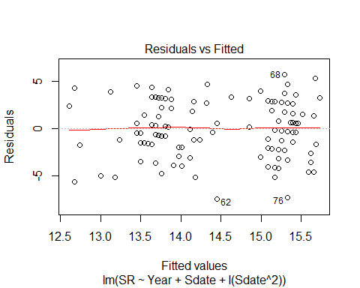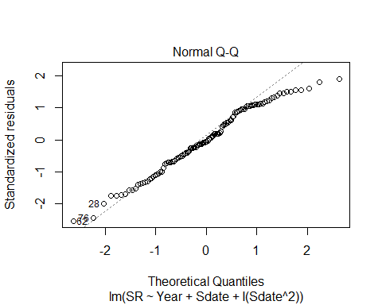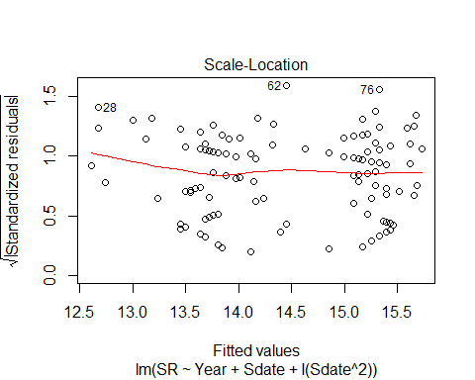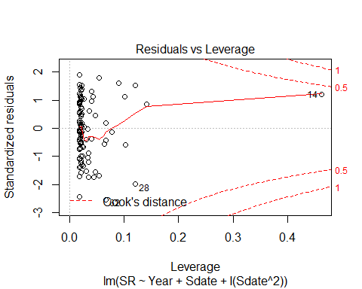

AIC(evaluationYV8, evaluationYV8B) #additive better

## df AIC  
## evaluationYV8 4 601.3103  
## evaluationYV8B 5 603.3102

AIC(evaluationYV8, evaluationYV8B, evaluationYV8C) #quad not better

## df AIC  
## evaluationYV8 4 601.3103  
## evaluationYV8B 5 603.3102  
## evaluationYV8C 5 603.1942

evaluationYV9<-lm(SR ~ Stime + Year, methodYSR2) #sig  
summary(evaluationYV9)

##   
## Call:  
## lm(formula = SR ~ Stime + Year, data = methodYSR2)  
##   
## Residuals:  
## Min 1Q Median 3Q Max   
## -8.0124 -1.9288 0.3428 2.3907 5.5818   
##   
## Coefficients:  
## Estimate Std. Error t value Pr(>|t|)   
## (Intercept) 9.513935 1.944729 4.892 3.27e-06 ***  
## Stime 0.009513 0.004357 2.183 0.03106 *   
## YearB 1.528302 0.549959 2.779 0.00637 **   
## ---  
## Signif. codes: 0 '***' 0.001 '**' 0.01 '*' 0.05 '.' 0.1 ' ' 1  
##   
## Residual standard error: 2.986 on 115 degrees of freedom  
## Multiple R-squared: 0.1004, Adjusted R-squared: 0.08471   
## F-statistic: 6.414 on 2 and 115 DF, p-value: 0.002287

confint(evaluationYV9, level=0.95)

## 2.5 % 97.5 %  
## (Intercept) 5.6618023569 13.36606827  
## Stime 0.0008816927 0.01814424  
## YearB 0.4389387183 2.61766547

anova(evaluationYV9)

## Analysis of Variance Table  
##   
## Response: SR  
## Df Sum Sq Mean Sq F value Pr(>F)   
## Stime 1 45.50 45.504 5.1052 0.025737 *   
## Year 1 68.83 68.833 7.7225 0.006372 **  
## Residuals 115 1025.03 8.913   
## ---  
## Signif. codes: 0 '***' 0.001 '**' 0.01 '*' 0.05 '.' 0.1 ' ' 1

evaluationYV9B<-lm(SR ~ Stime * Year, methodYSR2) #sig  
summary(evaluationYV9B)

##   
## Call:  
## lm(formula = SR ~ Stime * Year, data = methodYSR2)  
##   
## Residuals:  
## Min 1Q Median 3Q Max   
## -6.9175 -1.7266 -0.0573 2.1878 5.4427   
##   
## Coefficients:  
## Estimate Std. Error t value Pr(>|t|)   
## (Intercept) 12.911893 2.674780 4.827 4.33e-06 ***  
## Stime 0.001740 0.006054 0.287 0.7744   
## YearB -5.401046 3.825702 -1.412 0.1607   
## Stime:YearB 0.015789 0.008628 1.830 0.0699 .   
## ---  
## Signif. codes: 0 '***' 0.001 '**' 0.01 '*' 0.05 '.' 0.1 ' ' 1  
##   
## Residual standard error: 2.955 on 114 degrees of freedom  
## Multiple R-squared: 0.126, Adjusted R-squared: 0.103   
## F-statistic: 5.479 on 3 and 114 DF, p-value: 0.001489

confint(evaluationYV9B, level=0.95)

## 2.5 % 97.5 %  
## (Intercept) 7.613175594 18.2106108  
## Stime -0.010253357 0.0137329  
## YearB -12.979731851 2.1776394  
## Stime:YearB -0.001303788 0.0328813

anova(evaluationYV9B)

## Analysis of Variance Table  
##   
## Response: SR  
## Df Sum Sq Mean Sq F value Pr(>F)   
## Stime 1 45.50 45.504 5.2095 0.02432 *   
## Year 1 68.83 68.833 7.8802 0.00588 **  
## Stime:Year 1 29.25 29.249 3.3485 0.06988 .   
## Residuals 114 995.78 8.735   
## ---  
## Signif. codes: 0 '***' 0.001 '**' 0.01 '*' 0.05 '.' 0.1 ' ' 1

evaluationYV9C<-lm(SR ~ Stime + I(Stime^2) + Year, methodYSR2) #sig  
summary(evaluationYV9C)

##   
## Call:  
## lm(formula = SR ~ Stime + I(Stime^2) + Year, data = methodYSR2)  
##   
## Residuals:  
## Min 1Q Median 3Q Max   
## -6.7388 -1.9907 0.0965 2.3183 6.0627   
##   
## Coefficients:  
## Estimate Std. Error t value Pr(>|t|)   
## (Intercept) -2.981e+01 1.392e+01 -2.142 0.03433 *   
## Stime 1.873e-01 6.247e-02 2.998 0.00334 **  
## I(Stime^2) -1.966e-04 6.894e-05 -2.852 0.00516 **  
## YearB 1.460e+00 5.342e-01 2.733 0.00728 **  
## ---  
## Signif. codes: 0 '***' 0.001 '**' 0.01 '*' 0.05 '.' 0.1 ' ' 1  
##   
## Residual standard error: 2.897 on 114 degrees of freedom  
## Multiple R-squared: 0.1603, Adjusted R-squared: 0.1382   
## F-statistic: 7.252 on 3 and 114 DF, p-value: 0.00017

confint(evaluationYV9C, level=0.95)

## 2.5 % 97.5 %  
## (Intercept) -5.738715e+01 -2.239980e+00  
## Stime 6.350484e-02 3.110235e-01  
## I(Stime^2) -3.331539e-04 -6.002836e-05  
## YearB 4.016874e-01 2.518168e+00

anova(evaluationYV9C)

## Analysis of Variance Table  
##   
## Response: SR  
## Df Sum Sq Mean Sq F value Pr(>F)   
## Stime 1 45.50 45.504 5.4219 0.021649 *   
## I(Stime^2) 1 74.40 74.402 8.8651 0.003551 **  
## Year 1 62.68 62.685 7.4690 0.007278 **  
## Residuals 114 956.77 8.393   
## ---  
## Signif. codes: 0 '***' 0.001 '**' 0.01 '*' 0.05 '.' 0.1 ' ' 1

evaluationYV9D<-lm(SR ~ Stime + I(Stime^2) + I(Stime^3) + Year, methodYSR2) #sig  
summary(evaluationYV9D)

##   
## Call:  
## lm(formula = SR ~ Stime + I(Stime^2) + I(Stime^3) + Year, data = methodYSR2)  
##   
## Residuals:  
## Min 1Q Median 3Q Max   
## -6.6334 -2.0860 0.0818 2.2539 6.3079   
##   
## Coefficients:  
## Estimate Std. Error t value Pr(>|t|)   
## (Intercept) -1.283e+02 1.148e+02 -1.118 0.2659   
## Stime 8.523e-01 7.717e-01 1.105 0.2717   
## I(Stime^2) -1.674e-03 1.710e-03 -0.979 0.3297   
## I(Stime^3) 1.080e-06 1.249e-06 0.865 0.3890   
## YearB 1.443e+00 5.352e-01 2.696 0.0081 **  
## ---  
## Signif. codes: 0 '***' 0.001 '**' 0.01 '*' 0.05 '.' 0.1 ' ' 1  
##   
## Residual standard error: 2.9 on 113 degrees of freedom  
## Multiple R-squared: 0.1658, Adjusted R-squared: 0.1362   
## F-statistic: 5.614 on 4 and 113 DF, p-value: 0.0003699

confint(evaluationYV9D, level=0.95)

## 2.5 % 97.5 %  
## (Intercept) -3.556820e+02 9.904818e+01  
## Stime -6.764689e-01 2.381167e+00  
## I(Stime^2) -5.061598e-03 1.713647e-03  
## I(Stime^3) -1.394357e-06 3.554277e-06  
## YearB 3.824162e-01 2.502919e+00

anova(evaluationYV9D)

## Analysis of Variance Table  
##   
## Response: SR  
## Df Sum Sq Mean Sq F value Pr(>F)   
## Stime 1 45.50 45.504 5.4099 0.021807 *   
## I(Stime^2) 1 74.40 74.402 8.8455 0.003593 **  
## I(Stime^3) 1 7.85 7.848 0.9330 0.336137   
## Year 1 61.13 61.126 7.2671 0.008096 **  
## Residuals 113 950.48 8.411   
## ---  
## Signif. codes: 0 '***' 0.001 '**' 0.01 '*' 0.05 '.' 0.1 ' ' 1

evaluationYV9C2<-lm(SR ~ Stime + I(Stime^2) + Stime*Year, methodYSR2) #sig  
summary(evaluationYV9C2)

##   
## Call:  
## lm(formula = SR ~ Stime + I(Stime^2) + Stime * Year, data = methodYSR2)  
##   
## Residuals:  
## Min 1Q Median 3Q Max   
## -6.309 -1.894 0.022 2.487 5.419   
##   
## Coefficients:  
## Estimate Std. Error t value Pr(>|t|)   
## (Intercept) -2.733e+01 1.379e+01 -1.982 0.04996 *   
## Stime 1.841e-01 6.167e-02 2.985 0.00347 **  
## I(Stime^2) -2.023e-04 6.809e-05 -2.970 0.00363 **  
## YearB -5.922e+00 3.705e+00 -1.598 0.11276   
## Stime:YearB 1.682e-02 8.354e-03 2.013 0.04651 *   
## ---  
## Signif. codes: 0 '***' 0.001 '**' 0.01 '*' 0.05 '.' 0.1 ' ' 1  
##   
## Residual standard error: 2.859 on 113 degrees of freedom  
## Multiple R-squared: 0.1893, Adjusted R-squared: 0.1606   
## F-statistic: 6.597 on 4 and 113 DF, p-value: 8.278e-05

confint(evaluationYV9C2, level=0.95)

## 2.5 % 97.5 %  
## (Intercept) -5.465276e+01 -4.697566e-03  
## Stime 6.192471e-02 3.062976e-01  
## I(Stime^2) -3.371589e-04 -6.736074e-05  
## YearB -1.326204e+01 1.418383e+00  
## Stime:YearB 2.647700e-04 3.336541e-02

anova(evaluationYV9C2)

## Analysis of Variance Table  
##   
## Response: SR  
## Df Sum Sq Mean Sq F value Pr(>F)   
## Stime 1 45.50 45.504 5.5670 0.020018 *   
## I(Stime^2) 1 74.40 74.402 9.1024 0.003154 **  
## Year 1 62.68 62.685 7.6689 0.006569 **  
## Stime:Year 1 33.12 33.118 4.0517 0.046505 *   
## Residuals 113 923.65 8.174   
## ---  
## Signif. codes: 0 '***' 0.001 '**' 0.01 '*' 0.05 '.' 0.1 ' ' 1

AIC(evaluationYV9, evaluationYV9B) #interaction model slightly better

## df AIC  
## evaluationYV9 4 597.9607  
## evaluationYV9B 5 596.5447

AIC(evaluationYV9, evaluationYV9B, evaluationYV9C, evaluationYV9D, evaluationYV9C2) #however, quadratic model*interaction is the best overall.

## df AIC  
## evaluationYV9 4 597.9607  
## evaluationYV9B 5 596.5447  
## evaluationYV9C 5 591.8295  
## evaluationYV9D 6 593.0512  
## evaluationYV9C2 6 589.6726

evaluationYVa9C2<-lm(SR ~ Stime, methodYSR2)  
#summary(methodYSR2$Stime) #min 353, max 578  
#summary(evaluationYVa9C2)  
#confint(evaluationYVa9C2, level=0.95)  
#anova(evaluationYVa6)  
plot(SR ~ Stime, methodYSR2, pch=16, axes=F, xlab="", ylab="")  
axis(1,cex.axis=0.8)  
mtext(text="Survey Start Time", side = 1, line = 3)  
axis(2,las=1)  
mtext(text="Species Richness by Site", side = 2, line = 3)  
box(bty="l")

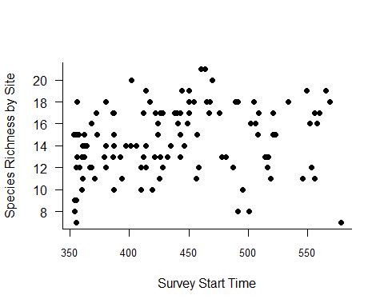

x<-seq(353,578,l=1000)  
#points(x, predict(SR ~ Stime, data.frame(Stime=x)),type="l")

plot_model(evaluationYV9C2, type="pred", terms=c("Stime","Year"))

## Argument `include.non.labelled` is deprecated. Please use `non.labelled` instead.

## Argument `include.values` is deprecated. Please use `values` instead.

## Argument `include.non.labelled` is deprecated. Please use `non.labelled` instead.

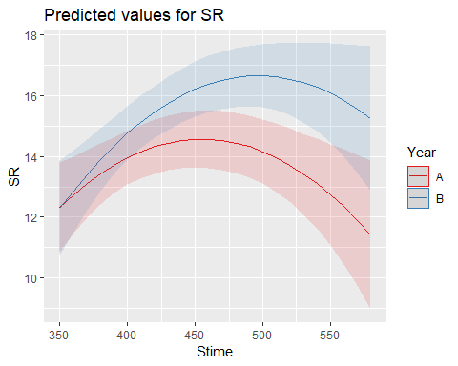

plot(SR ~ Stime, methodYSR2)

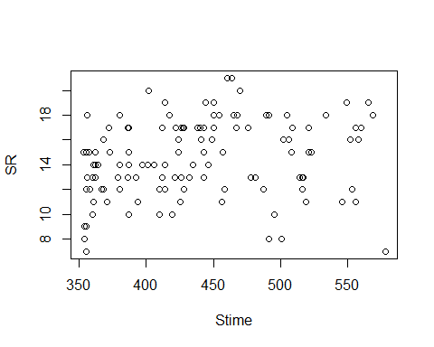

plot(evaluationYV9B)

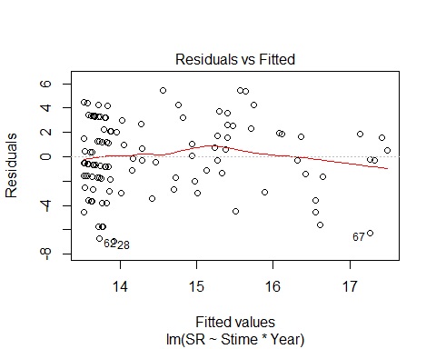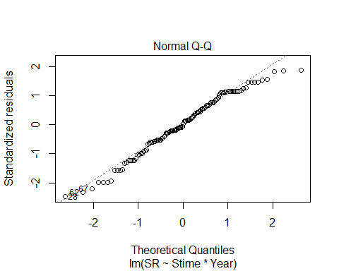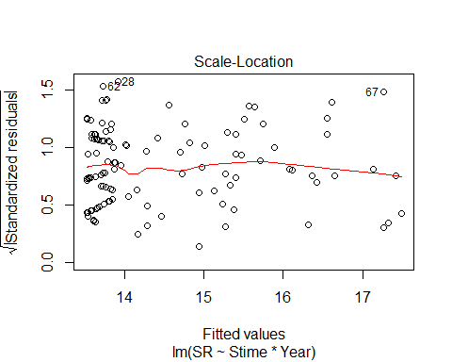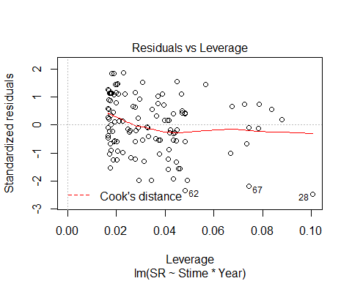

matplot(residuals(evaluationYV9))

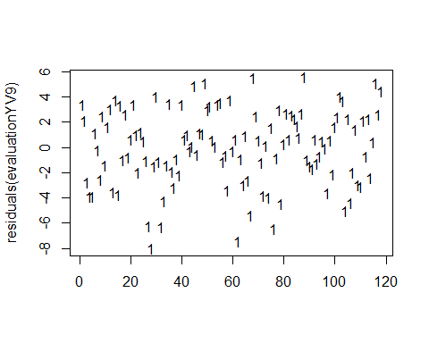

matplot(residuals(evaluationYV9B))

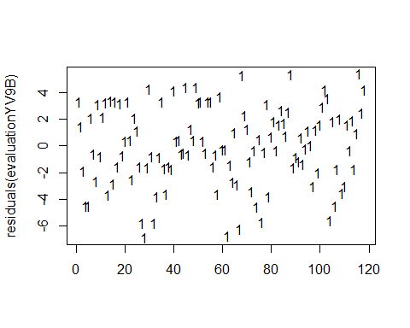

evaluationYV10<-lm(SR ~ Pdate + Year, methodYSR2) #pdate only  
summary(evaluationYV10)

##   
## Call:  
## lm(formula = SR ~ Pdate + Year, data = methodYSR2)  
##   
## Residuals:  
## Min 1Q Median 3Q Max   
## -8.0396 -2.4096 0.1998 2.8139 5.7651   
##   
## Coefficients:  
## Estimate Std. Error t value Pr(>|t|)  
## (Intercept) -4.206e+03 7.478e+03 -0.562 0.576  
## Pdate 9.766e-02 1.731e-01 0.564 0.575  
## YearB -1.009e+01 2.130e+01 -0.474 0.638  
##   
## Residual standard error: 3.342 on 56 degrees of freedom  
## (59 observations deleted due to missingness)  
## Multiple R-squared: 0.08479, Adjusted R-squared: 0.0521   
## F-statistic: 2.594 on 2 and 56 DF, p-value: 0.08368

confint(evaluationYV10, level=0.95)

## 2.5 % 97.5 %  
## (Intercept) -1.918686e+04 1.077493e+04  
## Pdate -2.490771e-01 4.443915e-01  
## YearB -5.276488e+01 3.258708e+01

anova(evaluationYV10)

## Analysis of Variance Table  
##   
## Response: SR  
## Df Sum Sq Mean Sq F value Pr(>F)   
## Pdate 1 55.45 55.449 4.9636 0.02992 *  
## Year 1 2.51 2.505 0.2243 0.63764   
## Residuals 56 625.57 11.171   
## ---  
## Signif. codes: 0 '***' 0.001 '**' 0.01 '*' 0.05 '.' 0.1 ' ' 1

evaluationYV10B<-lm(SR ~ Pdate*Year, methodYSR2) #pdate only; not int term; and no year effect  
summary(evaluationYV10B)

##   
## Call:  
## lm(formula = SR ~ Pdate * Year, data = methodYSR2)  
##   
## Residuals:  
## Min 1Q Median 3Q Max   
## -8.4371 -2.1969 0.2315 2.6400 5.7686   
##   
## Coefficients:  
## Estimate Std. Error t value Pr(>|t|)  
## (Intercept) -7139.1104 9075.8794 -0.787 0.435  
## Pdate 0.1655 0.2101 0.788 0.434  
## YearB 9382.7418 16257.1733 0.577 0.566  
## Pdate:YearB -0.2170 0.3755 -0.578 0.566  
##   
## Residual standard error: 3.362 on 55 degrees of freedom  
## (59 observations deleted due to missingness)  
## Multiple R-squared: 0.09031, Adjusted R-squared: 0.04069   
## F-statistic: 1.82 on 3 and 55 DF, p-value: 0.1542

confint(evaluationYV10B, level=0.95)

## 2.5 % 97.5 %  
## (Intercept) -2.532758e+04 1.104936e+04  
## Pdate -2.554288e-01 5.865190e-01  
## YearB -2.319736e+04 4.196285e+04  
## Pdate:YearB -9.695709e-01 5.356235e-01

anova(evaluationYV10B)

## Analysis of Variance Table  
##   
## Response: SR  
## Df Sum Sq Mean Sq F value Pr(>F)   
## Pdate 1 55.45 55.449 4.9046 0.03095 *  
## Year 1 2.51 2.505 0.2216 0.63968   
## Pdate:Year 1 3.77 3.774 0.3338 0.56578   
## Residuals 55 621.80 11.305   
## ---  
## Signif. codes: 0 '***' 0.001 '**' 0.01 '*' 0.05 '.' 0.1 ' ' 1

evaluationYV10C<-lm(SR ~ Pdate + I(Pdate^2) + Year, methodYSR2)   
summary(evaluationYV10C)

##   
## Call:  
## lm(formula = SR ~ Pdate + I(Pdate^2) + Year, data = methodYSR2)  
##   
## Residuals:  
## Min 1Q Median 3Q Max   
## -8.4461 -2.1893 0.2432 2.6327 5.7726   
##   
## Coefficients:  
## Estimate Std. Error t value Pr(>|t|)  
## (Intercept) -1.703e+06 2.843e+06 -0.599 0.552  
## Pdate 7.866e+01 1.315e+02 0.598 0.552  
## I(Pdate^2) -9.084e-04 1.520e-03 -0.598 0.553  
## YearB -4.949e+00 2.309e+01 -0.214 0.831  
##   
## Residual standard error: 3.362 on 55 degrees of freedom  
## (59 observations deleted due to missingness)  
## Multiple R-squared: 0.09069, Adjusted R-squared: 0.04109   
## F-statistic: 1.829 on 3 and 55 DF, p-value: 0.1527

confint(evaluationYV10C, level=0.95)

## 2.5 % 97.5 %  
## (Intercept) -7.399551e+06 3.993669e+06  
## Pdate -1.847996e+02 3.421248e+02  
## I(Pdate^2) -3.954602e-03 2.137827e-03  
## YearB -5.121941e+01 4.132073e+01

anova(evaluationYV10C)

## Analysis of Variance Table  
##   
## Response: SR  
## Df Sum Sq Mean Sq F value Pr(>F)   
## Pdate 1 55.45 55.449 4.9067 0.03091 *  
## I(Pdate^2) 1 6.02 6.022 0.5329 0.46849   
## Year 1 0.52 0.519 0.0460 0.83105   
## Residuals 55 621.54 11.301   
## ---  
## Signif. codes: 0 '***' 0.001 '**' 0.01 '*' 0.05 '.' 0.1 ' ' 1

evaluationYV10D<-lm(SR ~ Pdate + I(Pdate^2) + I(Pdate^3) + Year, methodYSR2)  
summary(evaluationYV10D)

##   
## Call:  
## lm(formula = SR ~ Pdate + I(Pdate^2) + I(Pdate^3) + Year, data = methodYSR2)  
##   
## Residuals:  
## Min 1Q Median 3Q Max   
## -8.4461 -2.1893 0.2432 2.6327 5.7726   
##   
## Coefficients: (1 not defined because of singularities)  
## Estimate Std. Error t value Pr(>|t|)  
## (Intercept) -1.703e+06 2.843e+06 -0.599 0.552  
## Pdate 7.866e+01 1.315e+02 0.598 0.552  
## I(Pdate^2) -9.084e-04 1.520e-03 -0.598 0.553  
## I(Pdate^3) NA NA NA NA  
## YearB -4.949e+00 2.309e+01 -0.214 0.831  
##   
## Residual standard error: 3.362 on 55 degrees of freedom  
## (59 observations deleted due to missingness)  
## Multiple R-squared: 0.09069, Adjusted R-squared: 0.04109   
## F-statistic: 1.829 on 3 and 55 DF, p-value: 0.1527

confint(evaluationYV10D, level=0.95)

## 2.5 % 97.5 %  
## (Intercept) -7.399551e+06 3.993669e+06  
## Pdate -1.847996e+02 3.421248e+02  
## I(Pdate^2) -3.954602e-03 2.137827e-03  
## I(Pdate^3) NA NA  
## YearB -5.121941e+01 4.132073e+01

anova(evaluationYV10D)

## Analysis of Variance Table  
##   
## Response: SR  
## Df Sum Sq Mean Sq F value Pr(>F)   
## Pdate 1 55.45 55.449 4.9067 0.03091 *  
## I(Pdate^2) 1 6.02 6.022 0.5329 0.46849   
## Year 1 0.52 0.519 0.0460 0.83105   
## Residuals 55 621.54 11.301   
## ---  
## Signif. codes: 0 '***' 0.001 '**' 0.01 '*' 0.05 '.' 0.1 ' ' 1

plot(SR ~ Pdate, methodYSR2)

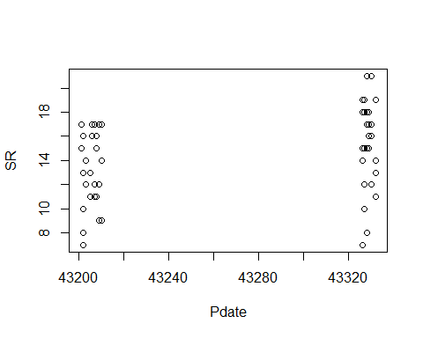

plot(evaluationYV10)

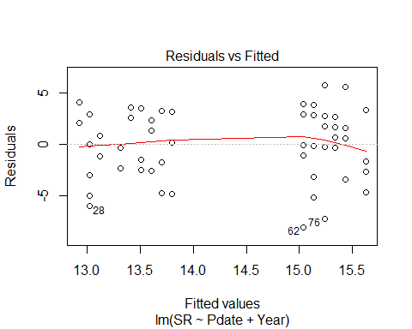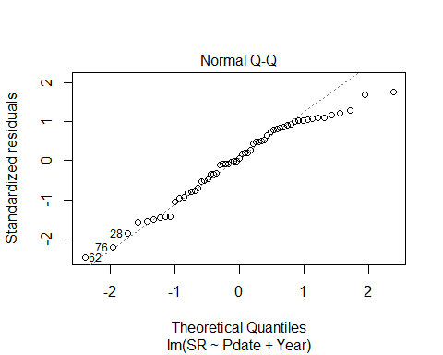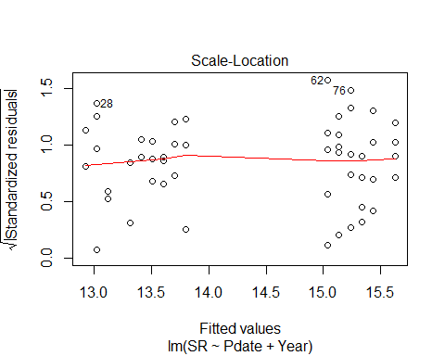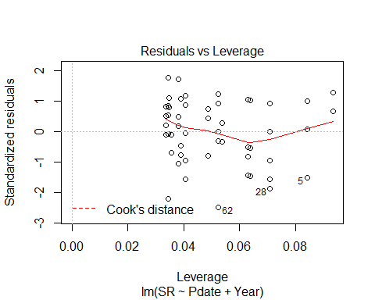

evaluationYVa10<-lm(SR ~ Pdate, methodYSR2)  
#summary(methodYSR1$Peffort) #min 1, max 8  
summary(evaluationYVa10)

##   
## Call:  
## lm(formula = SR ~ Pdate, data = methodYSR2)  
##   
## Residuals:  
## Min 1Q Median 3Q Max   
## -8.2663 -2.3603 0.5613 2.6948 5.7022   
##   
## Coefficients:  
## Estimate Std. Error t value Pr(>|t|)   
## (Intercept) -6.673e+02 3.039e+02 -2.196 0.0322 *  
## Pdate 1.576e-02 7.023e-03 2.243 0.0288 *  
## ---  
## Signif. codes: 0 '***' 0.001 '**' 0.01 '*' 0.05 '.' 0.1 ' ' 1  
##   
## Residual standard error: 3.319 on 57 degrees of freedom  
## (59 observations deleted due to missingness)  
## Multiple R-squared: 0.08112, Adjusted R-squared: 0.065   
## F-statistic: 5.032 on 1 and 57 DF, p-value: 0.02878

confint(evaluationYVa10, level=0.95)

## 2.5 % 97.5 %  
## (Intercept) -1.275876e+03 -58.81299735  
## Pdate 1.691069e-03 0.02981938

anova(evaluationYVa10)

## Analysis of Variance Table  
##   
## Response: SR  
## Df Sum Sq Mean Sq F value Pr(>F)   
## Pdate 1 55.45 55.449 5.0321 0.02878 *  
## Residuals 57 628.08 11.019   
## ---  
## Signif. codes: 0 '***' 0.001 '**' 0.01 '*' 0.05 '.' 0.1 ' ' 1

plot(SR ~ Pdate, methodYSR2, pch=16, axes=F, xlab="", ylab="")  
axis(1,cex.axis=0.8)  
mtext(text="Processing Date", side = 1, line = 3)  
axis(2,las=1)  
mtext(text="Species Richness by Site", side = 2, line = 3)  
box(bty="l")  
x<-seq(1,8,l=1000)  
points(x, predict(evaluationYVa10, data.frame(Pdate=x)),type="l")

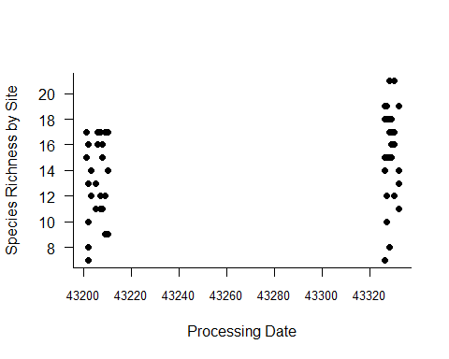

AIC(evaluationYV10,evaluationYV10B) #additive better ranked

## df AIC  
## evaluationYV10 4 314.7413  
## evaluationYV10B 5 316.3843

AIC(evaluationYV10, evaluationYV10B, evaluationYV10C, evaluationYV10D, evaluationYVa10) #single, no year best.

## df AIC  
## evaluationYV10 4 314.7413  
## evaluationYV10B 5 316.3843  
## evaluationYV10C 5 316.3594  
## evaluationYV10D 5 316.3594  
## evaluationYVa10 3 312.9771

plot_model(evaluationYVa10, type="pred", terms=c("Pdate"))

## Argument `include.non.labelled` is deprecated. Please use `non.labelled` instead.

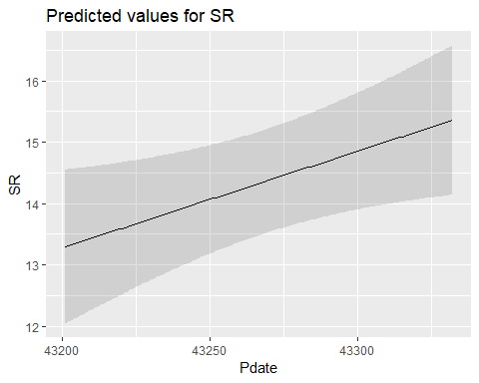

evaluationYV11<-lm(SR ~ Pmin + Year, methodYSR2) #non-sig, just year effect  
summary(evaluationYV11)

##   
## Call:  
## lm(formula = SR ~ Pmin + Year, data = methodYSR2)  
##   
## Residuals:  
## Min 1Q Median 3Q Max   
## -8.3248 -2.2467 -0.1597 2.7165 5.6752   
##   
## Coefficients:  
## Estimate Std. Error t value Pr(>|t|)   
## (Intercept) 11.68277 1.77037 6.599 1.59e-08 ***  
## Pmin 0.08255 0.08075 1.022 0.311   
## YearB 2.56885 1.07232 2.396 0.020 *   
## ---  
## Signif. codes: 0 '***' 0.001 '**' 0.01 '*' 0.05 '.' 0.1 ' ' 1  
##   
## Residual standard error: 3.321 on 56 degrees of freedom  
## (59 observations deleted due to missingness)  
## Multiple R-squared: 0.09645, Adjusted R-squared: 0.06418   
## F-statistic: 2.989 on 2 and 56 DF, p-value: 0.05844

confint(evaluationYV11, level=0.95)

## 2.5 % 97.5 %  
## (Intercept) 8.13628385 15.2292475  
## Pmin -0.07920611 0.2443061  
## YearB 0.42072702 4.7169718

anova(evaluationYV11)

## Analysis of Variance Table  
##   
## Response: SR  
## Df Sum Sq Mean Sq F value Pr(>F)   
## Pmin 1 2.63 2.633 0.2387 0.62703   
## Year 1 63.29 63.292 5.7389 0.01996 *  
## Residuals 56 617.60 11.029   
## ---  
## Signif. codes: 0 '***' 0.001 '**' 0.01 '*' 0.05 '.' 0.1 ' ' 1

plot(evaluationYV11)

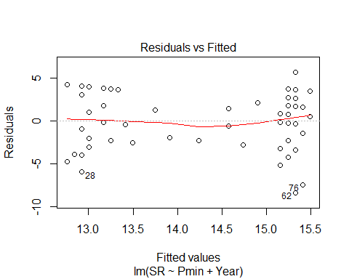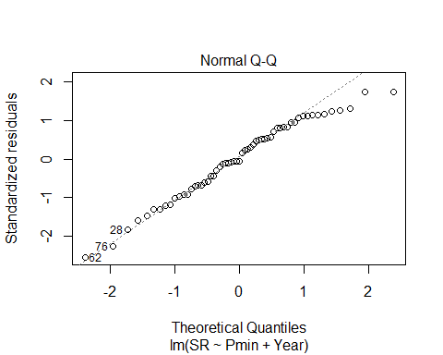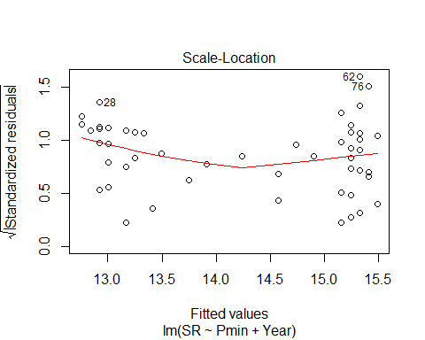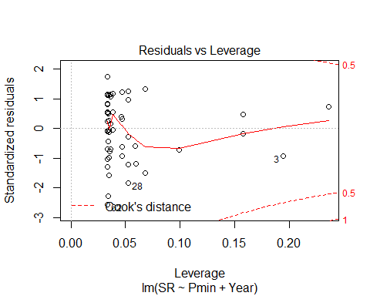

evaluationYV11B<-lm(SR ~ Pmin*Year, methodYSR2) #year effect only; int term non-sig  
summary(evaluationYV11B)

##   
## Call:  
## lm(formula = SR ~ Pmin * Year, data = methodYSR2)  
##   
## Residuals:  
## Min 1Q Median 3Q Max   
## -8.4461 -2.2093 0.0408 2.5671 5.5539   
##   
## Coefficients:  
## Estimate Std. Error t value Pr(>|t|)   
## (Intercept) 11.85476 1.79419 6.607 1.66e-08 ***  
## Pmin 0.07418 0.08193 0.905 0.369   
## YearB -2.73814 7.47687 -0.366 0.716   
## Pmin:YearB 0.41270 0.57538 0.717 0.476   
## ---  
## Signif. codes: 0 '***' 0.001 '**' 0.01 '*' 0.05 '.' 0.1 ' ' 1  
##   
## Residual standard error: 3.335 on 55 degrees of freedom  
## (59 observations deleted due to missingness)  
## Multiple R-squared: 0.1048, Adjusted R-squared: 0.05599   
## F-statistic: 2.147 on 3 and 55 DF, p-value: 0.1048

confint(evaluationYV11B, level=0.95)

## 2.5 % 97.5 %  
## (Intercept) 8.2591156 15.4504020  
## Pmin -0.0900193 0.2383817  
## YearB -17.7221285 12.2458470  
## Pmin:YearB -0.7403819 1.5657804

anova(evaluationYV11B)

## Analysis of Variance Table  
##   
## Response: SR  
## Df Sum Sq Mean Sq F value Pr(>F)   
## Pmin 1 2.63 2.633 0.2367 0.62856   
## Year 1 63.29 63.292 5.6891 0.02054 *  
## Pmin:Year 1 5.72 5.724 0.5145 0.47624   
## Residuals 55 611.88 11.125   
## ---  
## Signif. codes: 0 '***' 0.001 '**' 0.01 '*' 0.05 '.' 0.1 ' ' 1

plot(evaluationYV11B)

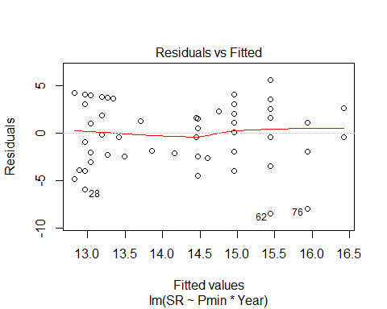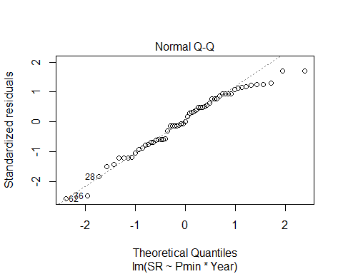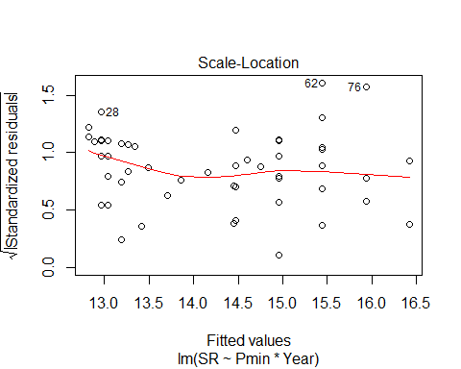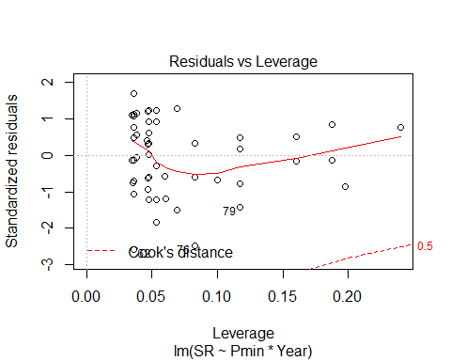

evaluationYV11C<-lm(SR ~ Pmin + I(Pmin^2) + Year, methodYSR2) #non-sig, just year effect  
summary(evaluationYV11C)

##   
## Call:  
## lm(formula = SR ~ Pmin + I(Pmin^2) + Year, data = methodYSR2)  
##   
## Residuals:  
## Min 1Q Median 3Q Max   
## -8.3802 -2.4524 0.1267 2.8667 5.6198   
##   
## Coefficients:  
## Estimate Std. Error t value Pr(>|t|)   
## (Intercept) 8.081072 6.549910 1.234 0.2225   
## Pmin 0.410913 0.580361 0.708 0.4819   
## I(Pmin^2) -0.006562 0.011484 -0.571 0.5700   
## YearB 3.066267 1.386234 2.212 0.0311 *  
## ---  
## Signif. codes: 0 '***' 0.001 '**' 0.01 '*' 0.05 '.' 0.1 ' ' 1  
##   
## Residual standard error: 3.341 on 55 degrees of freedom  
## (59 observations deleted due to missingness)  
## Multiple R-squared: 0.1018, Adjusted R-squared: 0.05279   
## F-statistic: 2.077 on 3 and 55 DF, p-value: 0.1137

confint(evaluationYV11C, level=0.95)

## 2.5 % 97.5 %  
## (Intercept) -5.04524170 21.20738562  
## Pmin -0.75215589 1.57398205  
## I(Pmin^2) -0.02957724 0.01645265  
## YearB 0.28819292 5.84434204

anova(evaluationYV11C)

## Analysis of Variance Table  
##   
## Response: SR  
## Df Sum Sq Mean Sq F value Pr(>F)   
## Pmin 1 2.63 2.633 0.2359 0.62914   
## I(Pmin^2) 1 12.32 12.320 1.1037 0.29806   
## Year 1 54.62 54.616 4.8927 0.03114 *  
## Residuals 55 613.96 11.163   
## ---  
## Signif. codes: 0 '***' 0.001 '**' 0.01 '*' 0.05 '.' 0.1 ' ' 1

plot(evaluationYV11C)

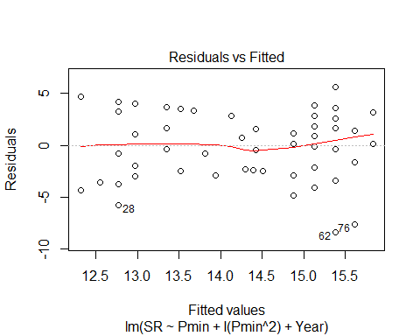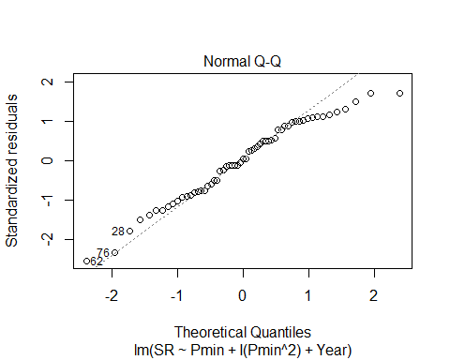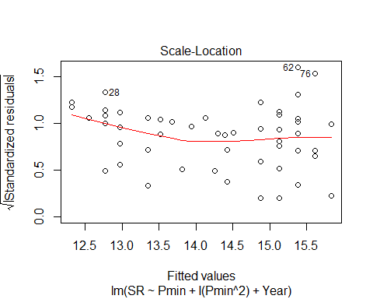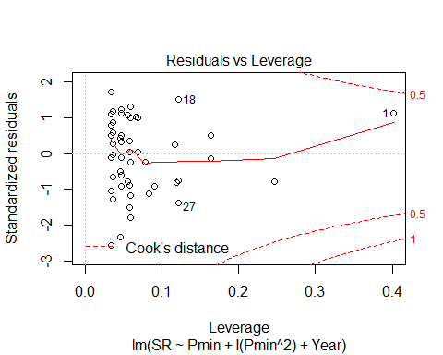

evaluationYV11D<-lm(SR ~ Pmin + I(Pmin^2) + I(Pmin^3) + Year, methodYSR2) #non-sig, just year effect  
summary(evaluationYV11D)

##   
## Call:  
## lm(formula = SR ~ Pmin + I(Pmin^2) + I(Pmin^3) + Year, data = methodYSR2)  
##   
## Residuals:  
## Min 1Q Median 3Q Max   
## -8.5768 -2.2167 0.3254 2.4232 5.4232   
##   
## Coefficients:  
## Estimate Std. Error t value Pr(>|t|)   
## (Intercept) -11.548567 16.399248 -0.704 0.4843   
## Pmin 3.252563 2.254051 1.443 0.1548   
## I(Pmin^2) -0.134972 0.099126 -1.362 0.1790   
## I(Pmin^3) 0.001789 0.001372 1.304 0.1977   
## YearB 3.720802 1.466078 2.538 0.0141 *  
## ---  
## Signif. codes: 0 '***' 0.001 '**' 0.01 '*' 0.05 '.' 0.1 ' ' 1  
##   
## Residual standard error: 3.32 on 54 degrees of freedom  
## (59 observations deleted due to missingness)  
## Multiple R-squared: 0.1292, Adjusted R-squared: 0.0647   
## F-statistic: 2.003 on 4 and 54 DF, p-value: 0.1071

confint(evaluationYV11D, level=0.95)

## 2.5 % 97.5 %  
## (Intercept) -4.442708e+01 21.329945900  
## Pmin -1.266538e+00 7.771663434  
## I(Pmin^2) -3.337068e-01 0.063763449  
## I(Pmin^3) -9.616251e-04 0.004540578  
## YearB 7.814925e-01 6.660110677

anova(evaluationYV11D)

## Analysis of Variance Table  
##   
## Response: SR  
## Df Sum Sq Mean Sq F value Pr(>F)   
## Pmin 1 2.63 2.633 0.2389 0.62701   
## I(Pmin^2) 1 12.32 12.320 1.1177 0.29511   
## I(Pmin^3) 1 2.37 2.365 0.2146 0.64506   
## Year 1 71.00 70.996 6.4411 0.01407 *  
## Residuals 54 595.21 11.022   
## ---  
## Signif. codes: 0 '***' 0.001 '**' 0.01 '*' 0.05 '.' 0.1 ' ' 1

plot(evaluationYV11D)

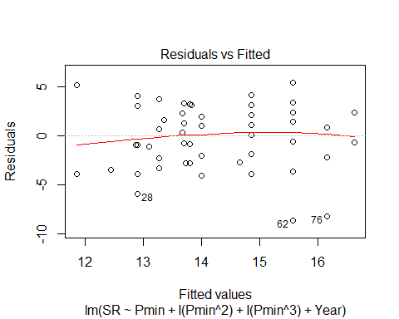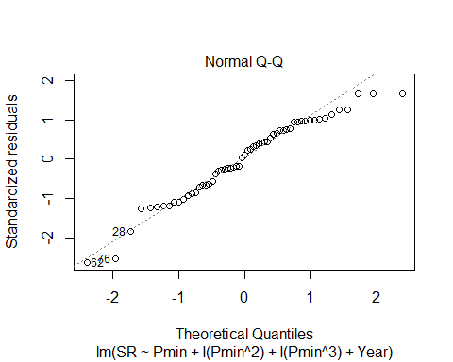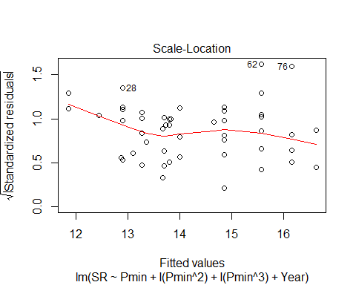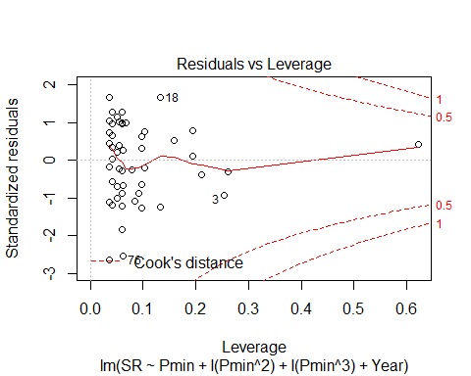

AIC(evaluationYV11,evaluationYV11B) #additive better

## df AIC  
## evaluationYV11 4 313.9848  
## evaluationYV11B 5 315.4354

AIC(evaluationYV11,evaluationYV11B,evaluationYV11C,evaluationYV11D) #not better

## df AIC  
## evaluationYV11 4 313.9848  
## evaluationYV11B 5 315.4354  
## evaluationYV11C 5 315.6355  
## evaluationYV11D 6 315.8061

evaluationYV12<-lm(SR ~ Peffort+Year, methodYSR2) #non-sig, year effect only  
summary(evaluationYV12)

##   
## Call:  
## lm(formula = SR ~ Peffort + Year, data = methodYSR2)  
##   
## Residuals:  
## Min 1Q Median 3Q Max   
## -8.3595 -2.2099 -0.1363 2.7901 5.8637   
##   
## Coefficients:  
## Estimate Std. Error t value Pr(>|t|)   
## (Intercept) 12.7634 1.0404 12.268 <2e-16 ***  
## Peffort 0.2233 0.3030 0.737 0.4643   
## YearB 2.1496 0.9225 2.330 0.0234 *   
## ---  
## Signif. codes: 0 '***' 0.001 '**' 0.01 '*' 0.05 '.' 0.1 ' ' 1  
##   
## Residual standard error: 3.336 on 56 degrees of freedom  
## (59 observations deleted due to missingness)  
## Multiple R-squared: 0.08842, Adjusted R-squared: 0.05587   
## F-statistic: 2.716 on 2 and 56 DF, p-value: 0.07486

confint(evaluationYV12, level=0.95)

## 2.5 % 97.5 %  
## (Intercept) 10.6792255 14.8475615  
## Peffort -0.3837506 0.8302903  
## YearB 0.3015330 3.9976778

anova(evaluationYV12)

## Analysis of Variance Table  
##   
## Response: SR  
## Df Sum Sq Mean Sq F value Pr(>F)   
## Peffort 1 0.03 0.029 0.0026 0.95962   
## Year 1 60.41 60.410 5.4293 0.02343 *  
## Residuals 56 623.09 11.127   
## ---  
## Signif. codes: 0 '***' 0.001 '**' 0.01 '*' 0.05 '.' 0.1 ' ' 1

plot(evaluationYV12)

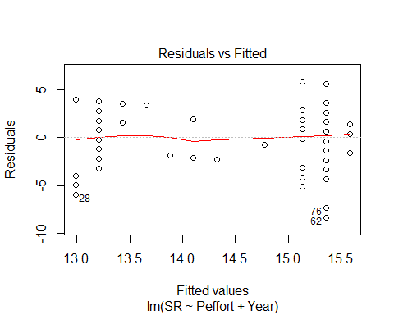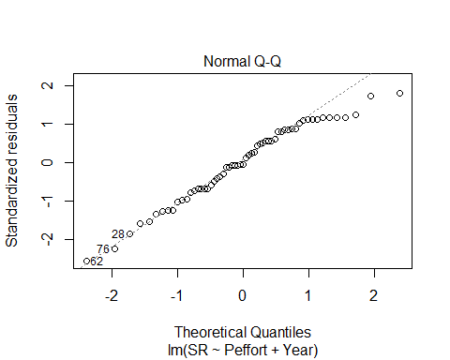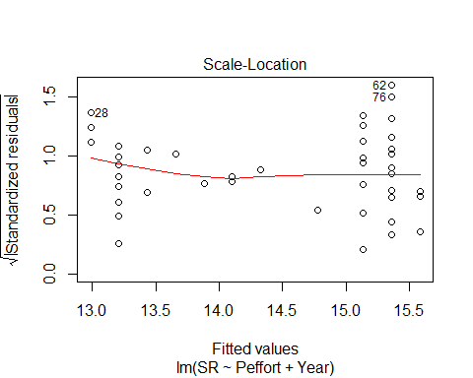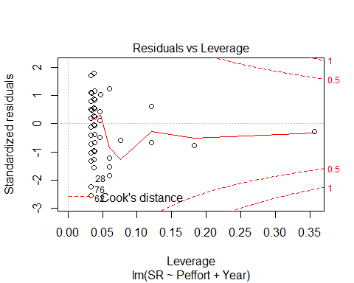

evaluationYV12B<-lm(SR ~ Peffort*Year, methodYSR2) #int term non-sig; only year  
summary(evaluationYV12B)

##   
## Call:  
## lm(formula = SR ~ Peffort * Year, data = methodYSR2)  
##   
## Residuals:  
## Min 1Q Median 3Q Max   
## -8.2865 -2.1934 -0.1874 2.7135 5.7135   
##   
## Coefficients:  
## Estimate Std. Error t value Pr(>|t|)   
## (Intercept) 12.6814 1.0851 11.687 <2e-16 ***  
## Peffort 0.2530 0.3217 0.786 0.435   
## YearB 2.7063 2.1020 1.287 0.203   
## Peffort:YearB -0.3036 1.0279 -0.295 0.769   
## ---  
## Signif. codes: 0 '***' 0.001 '**' 0.01 '*' 0.05 '.' 0.1 ' ' 1  
##   
## Residual standard error: 3.363 on 55 degrees of freedom  
## (59 observations deleted due to missingness)  
## Multiple R-squared: 0.08986, Adjusted R-squared: 0.04022   
## F-statistic: 1.81 on 3 and 55 DF, p-value: 0.156

confint(evaluationYV12B, level=0.95)

## 2.5 % 97.5 %  
## (Intercept) 10.5067663 14.8560097  
## Peffort -0.3916558 0.8976495  
## YearB -1.5061746 6.9186795  
## Peffort:YearB -2.3635789 1.7564616

anova(evaluationYV12B)

## Analysis of Variance Table  
##   
## Response: SR  
## Df Sum Sq Mean Sq F value Pr(>F)   
## Peffort 1 0.03 0.029 0.0025 0.95996   
## Year 1 60.41 60.410 5.3408 0.02461 *  
## Peffort:Year 1 0.99 0.986 0.0872 0.76887   
## Residuals 55 622.10 11.311   
## ---  
## Signif. codes: 0 '***' 0.001 '**' 0.01 '*' 0.05 '.' 0.1 ' ' 1

plot(evaluationYV12B)

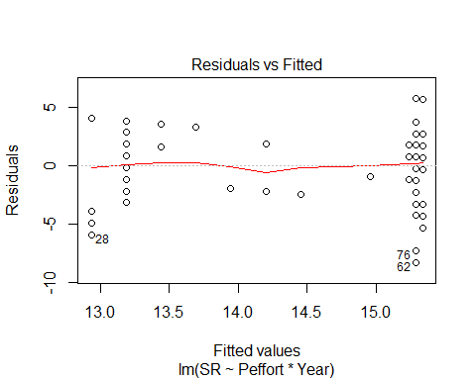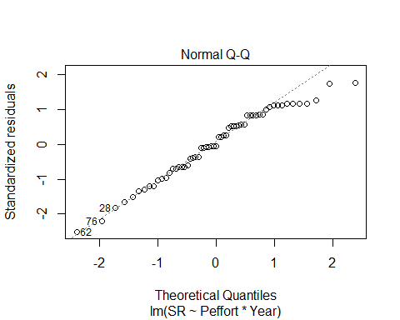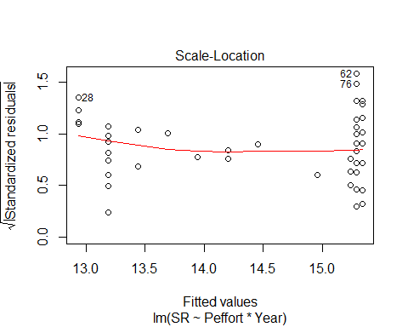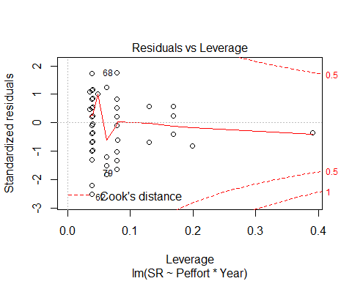

AIC(evaluationYV12,evaluationYV12B) #additive better

## df AIC  
## evaluationYV12 4 314.5065  
## evaluationYV12B 5 316.4130

no reason to thing Peffort would be quadratic.

ALL SIG VISIT 2 VARIABLES:

plot(SR ~ Year, methodYSR2)

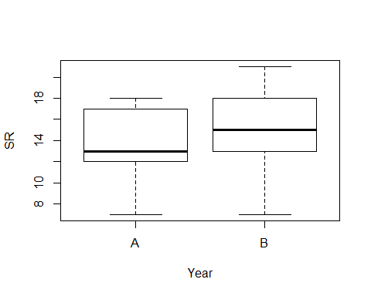

plot(SR ~ Stime, methodYSR2)



plot(SR ~ Pdate, methodYSR2)



# Visit 3 - all variables

#File read-in  
methodYSR3 <-read.csv("17_18_3by3_ACPC_SR.csv") #SR by count #3 each - Site Type SR  
#summary(methodYSR3)  
str(methodYSR3)

## 'data.frame': 118 obs. of 9 variables:  
## $ SiteName: Factor w/ 32 levels "Abercrombie_0B_E_AB",..: 4 5 6 8 9 15 16 17 18 19 ...  
## $ Type : Factor w/ 2 levels "AC","PC": 1 1 1 1 1 1 1 1 1 1 ...  
## $ SR : int 10 16 11 16 16 16 14 14 15 14 ...  
## $ Sdate : int 15 18 47 33 22 33 34 29 10 20 ...  
## $ Stime : int 363 500 380 513 559 507 526 359 395 566 ...  
## $ Pdate : int 43214 43214 43216 43219 43220 43215 43216 43216 43217 43216 ...  
## $ Pmin : int 18 15 14 27 12 26 14 19 24 19 ...  
## $ Peffort : int 1 2 2 7 2 8 2 4 5 5 ...  
## $ Year : Factor w/ 2 levels "A","B": 1 1 1 1 1 1 1 1 1 1 ...

#testing distribution - gaussian best fit for all  
test2<-glm(SR ~ Peffort, family=gaussian(), data=methodYSR3)  
test3<-glm(SR ~ Peffort, family=poisson(), data=methodYSR3)  
AIC(test2,test3)

## df AIC  
## test2 3 292.6134  
## test3 2 301.4951

evaluationYV333<-lm(SR ~ Year, methodYSR3) #no year effect OR year*type effect  
summary(evaluationYV333)

##   
## Call:  
## lm(formula = SR ~ Year, data = methodYSR3)  
##   
## Residuals:  
## Min 1Q Median 3Q Max   
## -7.6667 -1.6667 0.1724 1.3333 6.3333   
##   
## Coefficients:  
## Estimate Std. Error t value Pr(>|t|)   
## (Intercept) 14.8276 0.3524 42.074 <2e-16 ***  
## YearB -0.1609 0.4942 -0.326 0.745   
## ---  
## Signif. codes: 0 '***' 0.001 '**' 0.01 '*' 0.05 '.' 0.1 ' ' 1  
##   
## Residual standard error: 2.684 on 116 degrees of freedom  
## Multiple R-squared: 0.0009131, Adjusted R-squared: -0.0077   
## F-statistic: 0.106 on 1 and 116 DF, p-value: 0.7453

confint(evaluationYV333, level=0.95)

## 2.5 % 97.5 %  
## (Intercept) 14.129577 15.5255953  
## YearB -1.139793 0.8179537

anova(evaluationYV333)

## Analysis of Variance Table  
##   
## Response: SR  
## Df Sum Sq Mean Sq F value Pr(>F)  
## Year 1 0.76 0.7637 0.106 0.7453  
## Residuals 116 835.61 7.2035

plot(methodYSR3$SR ~ methodYSR3$Type) #



#plot(SR ~ Type, data=methodSR) #same as above

evaluationYV13<-lm(SR ~ Type, methodYSR3) #NOTE, now on border of 0.05  
summary(evaluationYV13)

##   
## Call:  
## lm(formula = SR ~ Type, data = methodYSR3)  
##   
## Residuals:  
## Min 1Q Median 3Q Max   
## -7.2712 -1.2712 -0.2203 1.7288 6.7288   
##   
## Coefficients:  
## Estimate Std. Error t value Pr(>|t|)   
## (Intercept) 14.2712 0.3440 41.488 <2e-16 ***  
## TypePC 0.9492 0.4865 1.951 0.0535 .   
## ---  
## Signif. codes: 0 '***' 0.001 '**' 0.01 '*' 0.05 '.' 0.1 ' ' 1  
##   
## Residual standard error: 2.642 on 116 degrees of freedom  
## Multiple R-squared: 0.03178, Adjusted R-squared: 0.02343   
## F-statistic: 3.807 on 1 and 116 DF, p-value: 0.05345

confint(evaluationYV13, level=0.95)

## 2.5 % 97.5 %  
## (Intercept) 13.58989105 14.95248  
## TypePC -0.01434464 1.91265

anova(evaluationYV13)

## Analysis of Variance Table  
##   
## Response: SR  
## Df Sum Sq Mean Sq F value Pr(>F)   
## Type 1 26.58 26.576 3.8069 0.05345 .  
## Residuals 116 809.80 6.981   
## ---  
## Signif. codes: 0 '***' 0.001 '**' 0.01 '*' 0.05 '.' 0.1 ' ' 1

plot(SR ~ Type, methodYSR3)

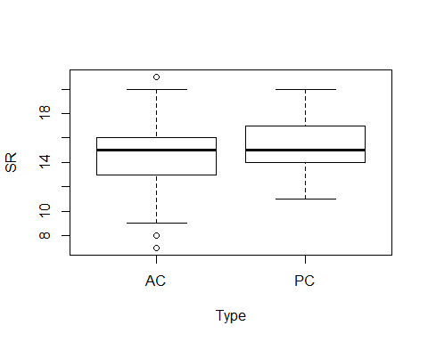

plot(evaluationYV13)

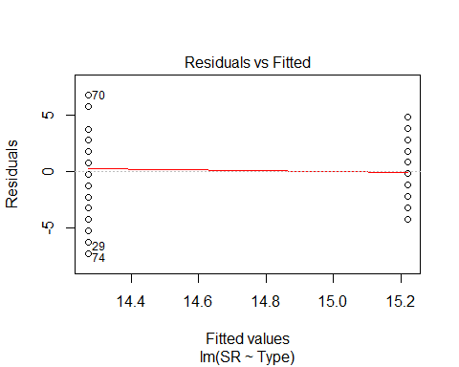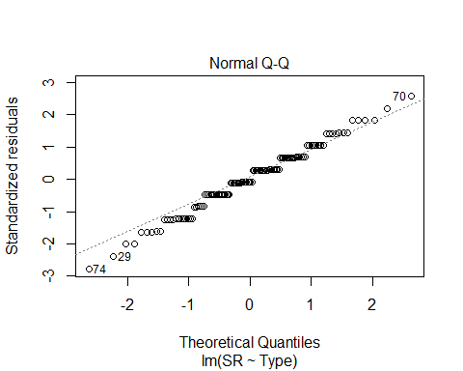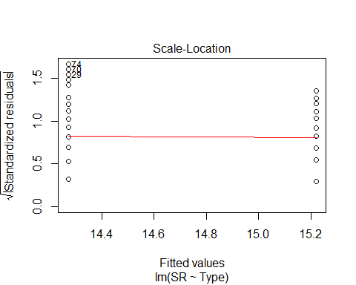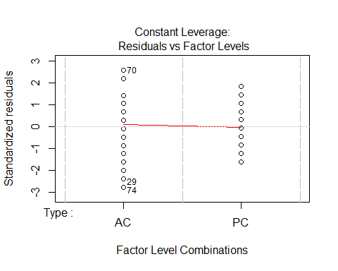

evaluationYV14<-lm(SR ~ Sdate, methodYSR3) #non-sig  
summary(evaluationYV14)

##   
## Call:  
## lm(formula = SR ~ Sdate, data = methodYSR3)  
##   
## Residuals:  
## Min 1Q Median 3Q Max   
## -7.7697 -1.7410 0.2472 1.2607 6.2472   
##   
## Coefficients:  
## Estimate Std. Error t value Pr(>|t|)   
## (Intercept) 14.801863 0.336647 43.969 <2e-16 ***  
## Sdate -0.001691 0.006890 -0.245 0.807   
## ---  
## Signif. codes: 0 '***' 0.001 '**' 0.01 '*' 0.05 '.' 0.1 ' ' 1  
##   
## Residual standard error: 2.684 on 116 degrees of freedom  
## Multiple R-squared: 0.0005189, Adjusted R-squared: -0.008097   
## F-statistic: 0.06022 on 1 and 116 DF, p-value: 0.8066

confint(evaluationYV14, level=0.95)

## 2.5 % 97.5 %  
## (Intercept) 14.13509176 15.46863368  
## Sdate -0.01533789 0.01195612

anova(evaluationYV14)

## Analysis of Variance Table  
##   
## Response: SR  
## Df Sum Sq Mean Sq F value Pr(>F)  
## Sdate 1 0.43 0.4340 0.0602 0.8066  
## Residuals 116 835.94 7.2064

plot(evaluationYV14)

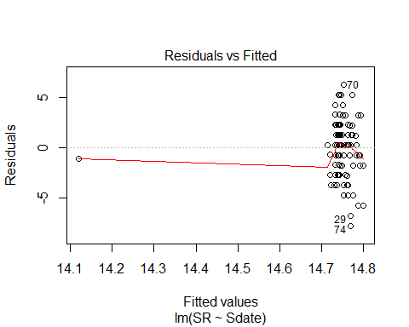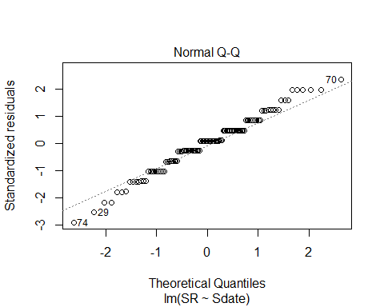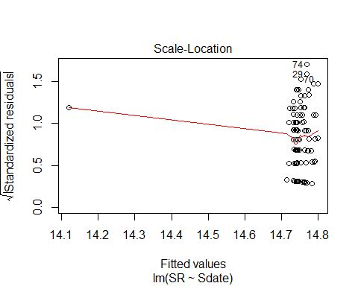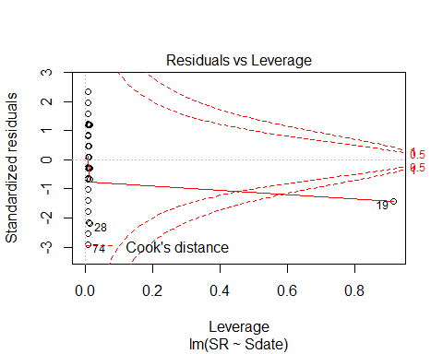

evaluationYV15<-lm(SR ~ Stime, methodYSR3) #sig but quadratic is better! see below & see F statistic & p value...  
summary(evaluationYV15)

##   
## Call:  
## lm(formula = SR ~ Stime, data = methodYSR3)  
##   
## Residuals:  
## Min 1Q Median 3Q Max   
## -6.6887 -1.5155 0.1473 1.4759 5.9203   
##   
## Coefficients:  
## Estimate Std. Error t value Pr(>|t|)   
## (Intercept) 8.344255 1.593613 5.236 7.40e-07 ***  
## Stime 0.014642 0.003606 4.060 8.95e-05 ***  
## ---  
## Signif. codes: 0 '***' 0.001 '**' 0.01 '*' 0.05 '.' 0.1 ' ' 1  
##   
## Residual standard error: 2.513 on 116 degrees of freedom  
## Multiple R-squared: 0.1244, Adjusted R-squared: 0.1169   
## F-statistic: 16.48 on 1 and 116 DF, p-value: 8.946e-05

confint(evaluationYV15, level=0.95)

## 2.5 % 97.5 %  
## (Intercept) 5.187903242 11.50060647  
## Stime 0.007499126 0.02178533

anova(evaluationYV15)

## Analysis of Variance Table  
##   
## Response: SR  
## Df Sum Sq Mean Sq F value Pr(>F)   
## Stime 1 104.06 104.060 16.483 8.946e-05 ***  
## Residuals 116 732.31 6.313   
## ---  
## Signif. codes: 0 '***' 0.001 '**' 0.01 '*' 0.05 '.' 0.1 ' ' 1

plot(SR ~ Stime, methodYSR3)

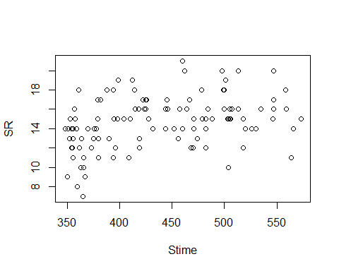

plot(evaluationYV15)

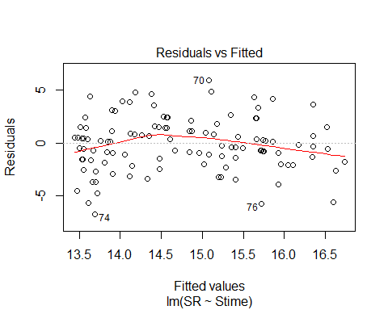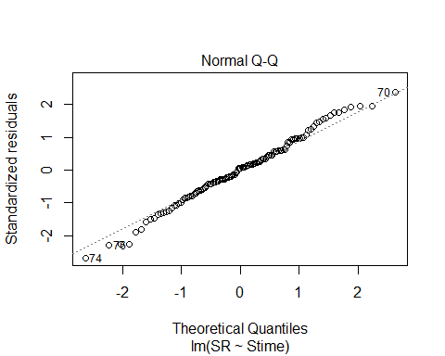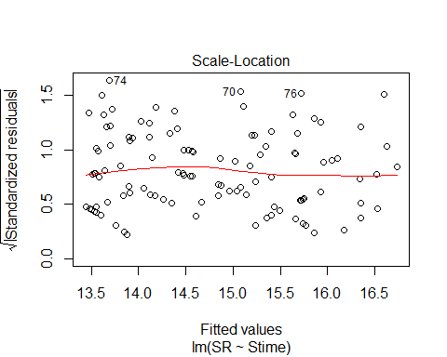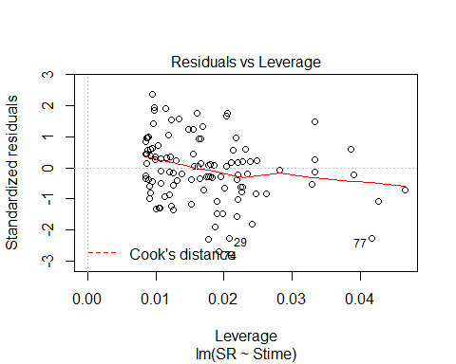

plot(SR ~ Stime, methodYSR3, pch=16, axes=F, xlab="", ylab="")  
axis(1,cex.axis=0.8)  
mtext(text="Survey Start Time", side = 1, line = 3)  
axis(2,las=1)  
mtext(text="Species Richness by Site", side = 2, line = 3)  
box(bty="l")

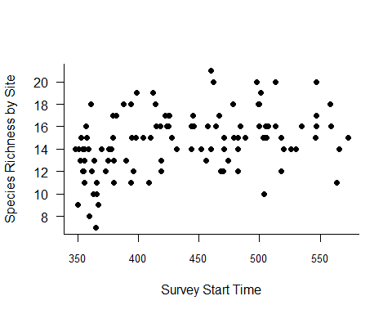

x<-seq(min(methodYSR3$Stime), max(methodYSR3$Stime),l=1000)  
#points(x, predict(evaluation15B, data.frame(Stime=x)),type="l")

#testing a quadratic # yes - Stime (-) for visit 3, quadratic IS better!  
evaluation15B<-lm(SR ~ Stime + I(Stime^2), methodYSR3)  
summary(evaluation15B)

##   
## Call:  
## lm(formula = SR ~ Stime + I(Stime^2), data = methodYSR3)  
##   
## Residuals:  
## Min 1Q Median 3Q Max   
## -6.2254 -1.5934 0.1552 1.4213 5.1698   
##   
## Coefficients:  
## Estimate Std. Error t value Pr(>|t|)   
## (Intercept) -2.803e+01 1.202e+01 -2.332 0.02145 *   
## Stime 1.810e-01 5.462e-02 3.313 0.00123 **  
## I(Stime^2) -1.861e-04 6.100e-05 -3.051 0.00283 **  
## ---  
## Signif. codes: 0 '***' 0.001 '**' 0.01 '*' 0.05 '.' 0.1 ' ' 1  
##   
## Residual standard error: 2.427 on 115 degrees of freedom  
## Multiple R-squared: 0.19, Adjusted R-squared: 0.1759   
## F-statistic: 13.49 on 2 and 115 DF, p-value: 5.473e-06

confint(evaluation15B, level=0.95)

## 2.5 % 97.5 %  
## (Intercept) -5.184249e+01 -4.220216e+00  
## Stime 7.276783e-02 2.891623e-01  
## I(Stime^2) -3.069447e-04 -6.528975e-05

anova(evaluation15B)

## Analysis of Variance Table  
##   
## Response: SR  
## Df Sum Sq Mean Sq F value Pr(>F)   
## Stime 1 104.06 104.060 17.6641 5.233e-05 ***  
## I(Stime^2) 1 54.84 54.843 9.3095 0.002831 **   
## Residuals 115 677.47 5.891   
## ---  
## Signif. codes: 0 '***' 0.001 '**' 0.01 '*' 0.05 '.' 0.1 ' ' 1

plot(evaluation15B)

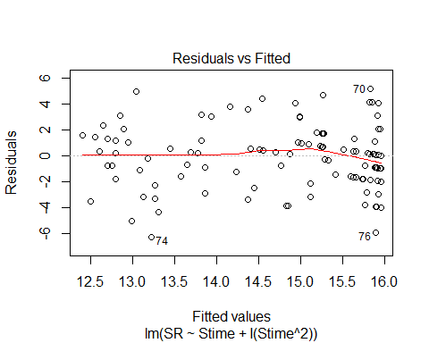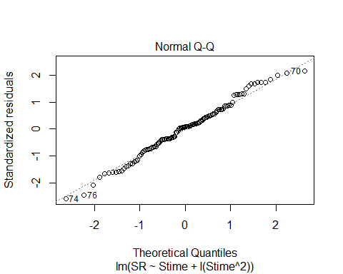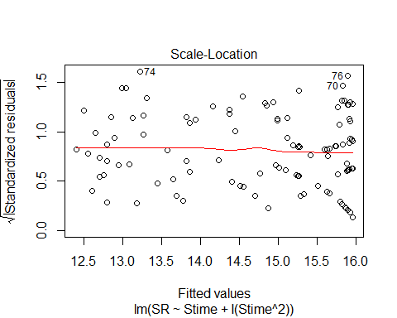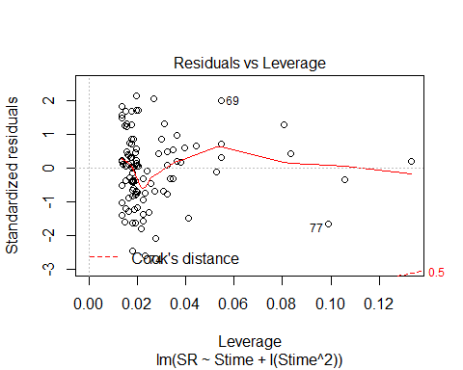

plot_model(evaluation15B, type="pred", terms=c("Stime"))

## Argument `include.non.labelled` is deprecated. Please use `non.labelled` instead.

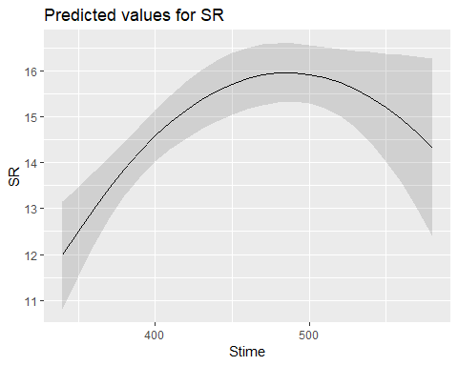

AIC(evaluationYV15, evaluation15B)

## df AIC  
## evaluationYV15 3 556.2812  
## evaluation15B 4 549.0958

evaluationYV16<-lm(SR ~ Pdate, methodYSR3) #non-sig  
summary(evaluationYV16)

##   
## Call:  
## lm(formula = SR ~ Pdate, data = methodYSR3)  
##   
## Residuals:  
## Min 1Q Median 3Q Max   
## -7.0953 -1.4595 0.5421 1.5467 6.9109   
##   
## Coefficients:  
## Estimate Std. Error t value Pr(>|t|)  
## (Intercept) 148.406076 270.348404 0.549 0.585  
## Pdate -0.003099 0.006247 -0.496 0.622  
##   
## Residual standard error: 2.852 on 57 degrees of freedom  
## (59 observations deleted due to missingness)  
## Multiple R-squared: 0.0043, Adjusted R-squared: -0.01317   
## F-statistic: 0.2462 on 1 and 57 DF, p-value: 0.6217

confint(evaluationYV16, level=0.95)

## 2.5 % 97.5 %  
## (Intercept) -392.95726437 6.897694e+02  
## Pdate -0.01560861 9.409745e-03

anova(evaluationYV16)

## Analysis of Variance Table  
##   
## Response: SR  
## Df Sum Sq Mean Sq F value Pr(>F)  
## Pdate 1 2.00 2.0024 0.2462 0.6217  
## Residuals 57 463.66 8.1344

plot(evaluationYV16)

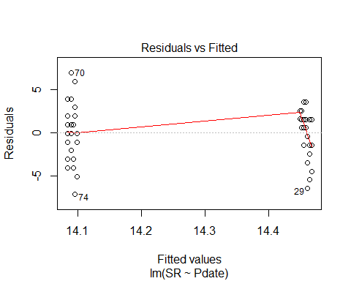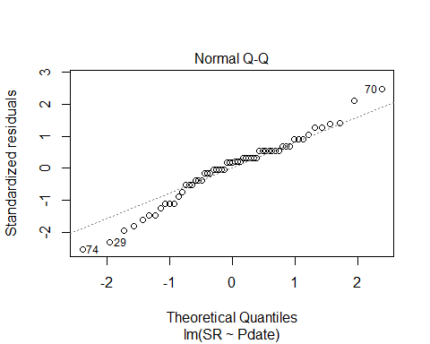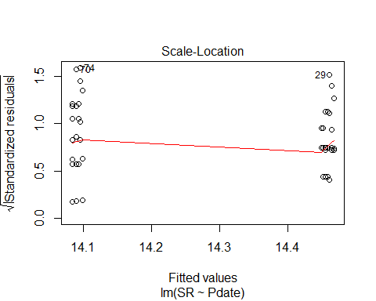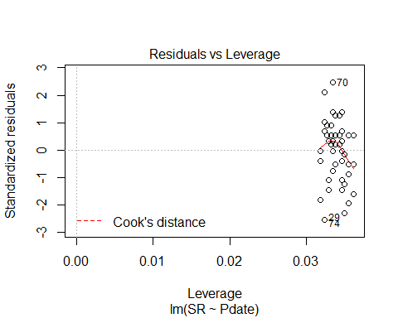

evaluationYV17<-lm(SR ~ Pmin, methodYSR3) #non-sig  
summary(evaluationYV17)

##   
## Call:  
## lm(formula = SR ~ Pmin, data = methodYSR3)  
##   
## Residuals:  
## Min 1Q Median 3Q Max   
## -7.1262 -1.3553 0.3391 1.7210 6.8738   
##   
## Coefficients:  
## Estimate Std. Error t value Pr(>|t|)   
## (Intercept) 13.20962 1.37821 9.585 1.74e-13 ***  
## Pmin 0.07638 0.09552 0.800 0.427   
## ---  
## Signif. codes: 0 '***' 0.001 '**' 0.01 '*' 0.05 '.' 0.1 ' ' 1  
##   
## Residual standard error: 2.842 on 57 degrees of freedom  
## (59 observations deleted due to missingness)  
## Multiple R-squared: 0.01109, Adjusted R-squared: -0.006257   
## F-statistic: 0.6394 on 1 and 57 DF, p-value: 0.4273

confint(evaluationYV17, level=0.95)

## 2.5 % 97.5 %  
## (Intercept) 10.4497921 15.9694430  
## Pmin -0.1149004 0.2676627

anova(evaluationYV17)

## Analysis of Variance Table  
##   
## Response: SR  
## Df Sum Sq Mean Sq F value Pr(>F)  
## Pmin 1 5.17 5.1654 0.6394 0.4273  
## Residuals 57 460.50 8.0789

plot(evaluationYV17)

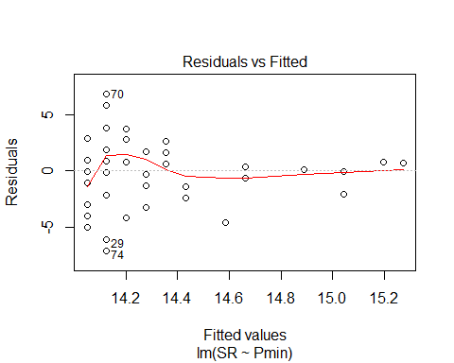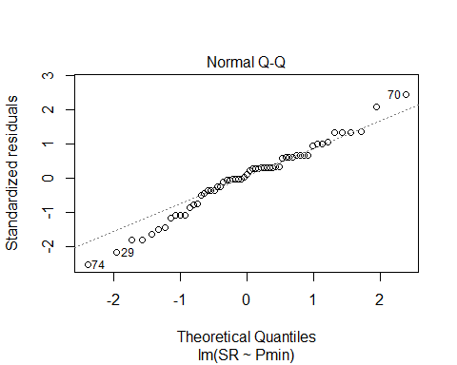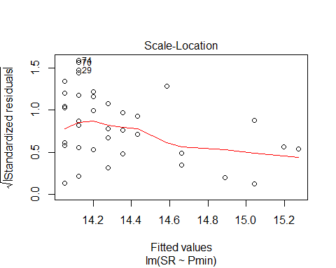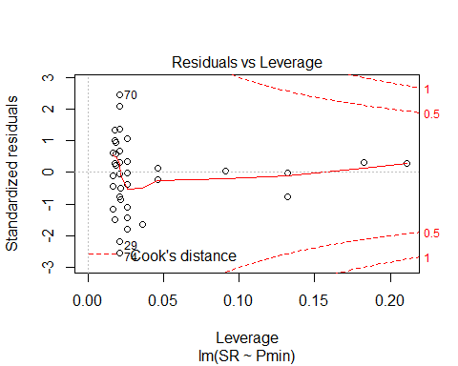

evaluationYV17B<-lm(SR ~ Pmin + I(Pmin^2), methodYSR3) #non-sig  
summary(evaluationYV17B)

##   
## Call:  
## lm(formula = SR ~ Pmin + I(Pmin^2), data = methodYSR3)  
##   
## Residuals:  
## Min 1Q Median 3Q Max   
## -7.0922 -1.6109 0.1334 1.5296 6.9078   
##   
## Coefficients:  
## Estimate Std. Error t value Pr(>|t|)  
## (Intercept) 9.78195 6.37214 1.535 0.130  
## Pmin 0.50497 0.78359 0.644 0.522  
## I(Pmin^2) -0.01215 0.02204 -0.551 0.584  
##   
## Residual standard error: 2.86 on 56 degrees of freedom  
## (59 observations deleted due to missingness)  
## Multiple R-squared: 0.01643, Adjusted R-squared: -0.0187   
## F-statistic: 0.4677 on 2 and 56 DF, p-value: 0.6289

confint(evaluationYV17B, level=0.95)

## 2.5 % 97.5 %  
## (Intercept) -2.98299308 22.54688538  
## Pmin -1.06473866 2.07468469  
## I(Pmin^2) -0.05630807 0.03201028

anova(evaluationYV17B)

## Analysis of Variance Table  
##   
## Response: SR  
## Df Sum Sq Mean Sq F value Pr(>F)  
## Pmin 1 5.17 5.1654 0.6316 0.4301  
## I(Pmin^2) 1 2.48 2.4842 0.3037 0.5837  
## Residuals 56 458.01 8.1788

plot(evaluationYV17B)

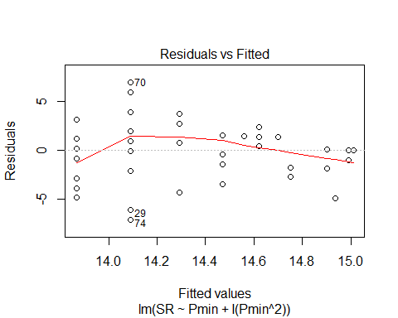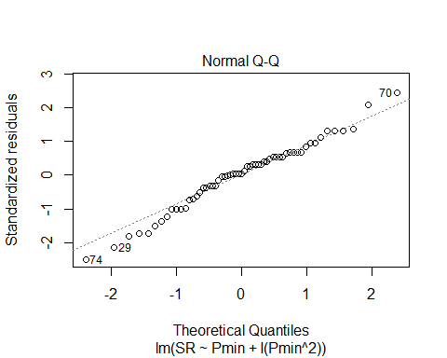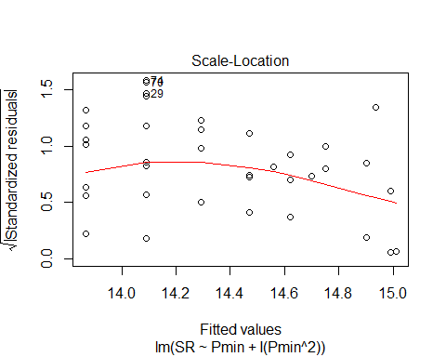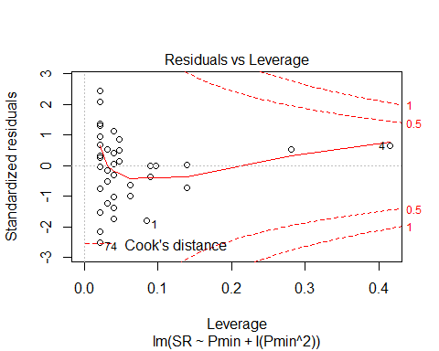

evaluationYV17C<-lm(SR ~ Pmin + I(Pmin^2) + I(Pmin^3), methodYSR3) #best but still not sig  
summary(evaluationYV17C)

##   
## Call:  
## lm(formula = SR ~ Pmin + I(Pmin^2) + I(Pmin^3), data = methodYSR3)  
##   
## Residuals:  
## Min 1Q Median 3Q Max   
## -7.2952 -1.7168 0.7048 1.7048 6.7048   
##   
## Coefficients:  
## Estimate Std. Error t value Pr(>|t|)   
## (Intercept) -46.543231 25.749328 -1.808 0.0761 .  
## Pmin 10.912694 4.681669 2.331 0.0234 *  
## I(Pmin^2) -0.623241 0.272106 -2.290 0.0259 *  
## I(Pmin^3) 0.011362 0.005044 2.253 0.0283 *  
## ---  
## Signif. codes: 0 '***' 0.001 '**' 0.01 '*' 0.05 '.' 0.1 ' ' 1  
##   
## Residual standard error: 2.761 on 55 degrees of freedom  
## (59 observations deleted due to missingness)  
## Multiple R-squared: 0.09951, Adjusted R-squared: 0.05039   
## F-statistic: 2.026 on 3 and 55 DF, p-value: 0.1209

confint(evaluationYV17C, level=0.95)

## 2.5 % 97.5 %  
## (Intercept) -98.14603753 5.05957579  
## Pmin 1.53041990 20.29496715  
## I(Pmin^2) -1.16855332 -0.07792801  
## I(Pmin^3) 0.00125404 0.02146907

anova(evaluationYV17C)

## Analysis of Variance Table  
##   
## Response: SR  
## Df Sum Sq Mean Sq F value Pr(>F)   
## Pmin 1 5.17 5.165 0.6775 0.41400   
## I(Pmin^2) 1 2.48 2.484 0.3258 0.57045   
## I(Pmin^3) 1 38.69 38.689 5.0746 0.02829 *  
## Residuals 55 419.32 7.624   
## ---  
## Signif. codes: 0 '***' 0.001 '**' 0.01 '*' 0.05 '.' 0.1 ' ' 1

plot(evaluationYV17C)

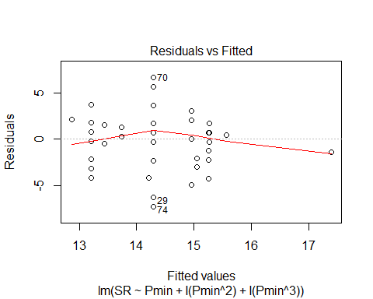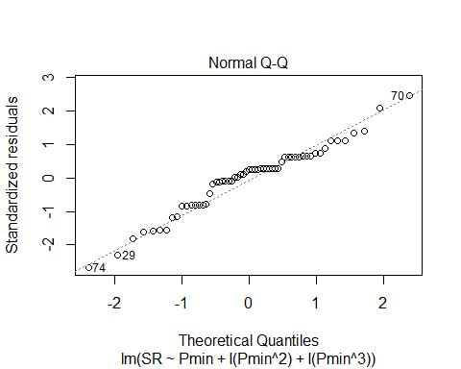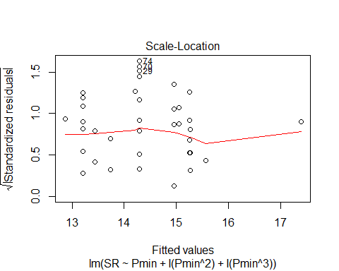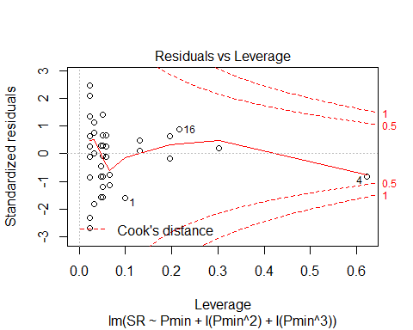

#Pmin3<-(methodYSR3$Pmin)^3  
#summary(Pmin3)

AIC(evaluationYV17, evaluationYV17B, evaluationYV17C) #cubic best but still not significant

## df AIC  
## evaluationYV17 3 294.6659  
## evaluationYV17B 4 296.3468  
## evaluationYV17C 5 293.1398

plot(SR ~ Pmin, methodYSR3, pch=16, axes=F, xlab="", ylab="")  
axis(1,cex.axis=0.8)  
mtext(text="Number of Minutes Processing Survey", side = 1, line = 3)  
axis(2,las=1)  
mtext(text="Species Richness by Site", side = 2, line = 3)  
box(bty="l")

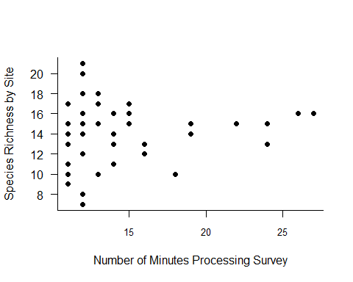

x<-seq(1331, 19683,l=1000)  
#points(x, predict(evaluationYV17C, data.frame(Pmin=x)),type="l")

plot_model(evaluationYV17C, type="pred", terms=c("Pmin"))

## Argument `include.non.labelled` is deprecated. Please use `non.labelled` instead.

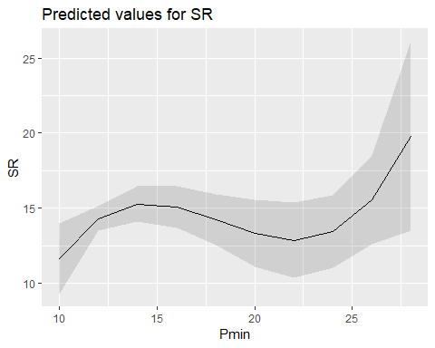

evaluationYV18<-lm(SR ~ Peffort, methodYSR3) #non-sig  
summary(evaluationYV18)

##   
## Call:  
## lm(formula = SR ~ Peffort, data = methodYSR3)  
##   
## Residuals:  
## Min 1Q Median 3Q Max   
## -6.8374 -1.2783 0.1626 1.7862 6.7862   
##   
## Coefficients:  
## Estimate Std. Error t value Pr(>|t|)   
## (Intercept) 13.4611 0.6141 21.919 <2e-16 ***  
## Peffort 0.3763 0.2299 1.637 0.107   
## ---  
## Signif. codes: 0 '***' 0.001 '**' 0.01 '*' 0.05 '.' 0.1 ' ' 1  
##   
## Residual standard error: 2.793 on 57 degrees of freedom  
## (59 observations deleted due to missingness)  
## Multiple R-squared: 0.0449, Adjusted R-squared: 0.02815   
## F-statistic: 2.68 on 1 and 57 DF, p-value: 0.1071

confint(evaluationYV18, level=0.95)

## 2.5 % 97.5 %  
## (Intercept) 12.23132535 14.6908331  
## Peffort -0.08401689 0.8367149

anova(evaluationYV18)

## Analysis of Variance Table  
##   
## Response: SR  
## Df Sum Sq Mean Sq F value Pr(>F)  
## Peffort 1 20.91 20.9097 2.6798 0.1071  
## Residuals 57 444.75 7.8027

plot(evaluationYV18)

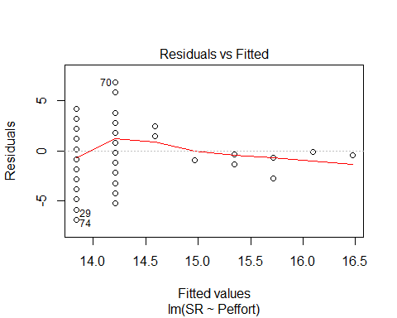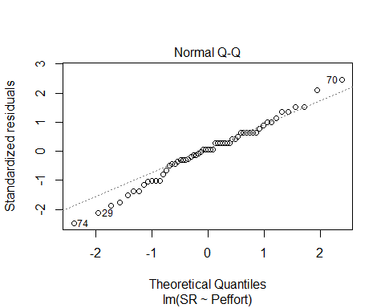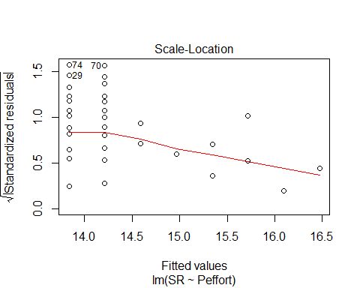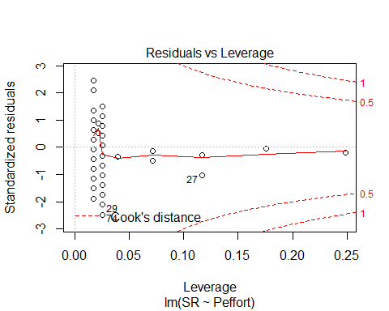

evaluationYV18B<-lm(SR ~ Peffort+ I(Peffort^2), methodYSR3) #non-sig  
summary(evaluationYV18B)

##   
## Call:  
## lm(formula = SR ~ Peffort + I(Peffort^2), data = methodYSR3)  
##   
## Residuals:  
## Min 1Q Median 3Q Max   
## -6.3209 -1.8117 0.3725 1.3725 6.3725   
##   
## Coefficients:  
## Estimate Std. Error t value Pr(>|t|)   
## (Intercept) 11.5993 1.2108 9.580 2.11e-13 ***  
## Peffort 1.9291 0.9043 2.133 0.0373 *   
## I(Peffort^2) -0.2075 0.1170 -1.773 0.0816 .   
## ---  
## Signif. codes: 0 '***' 0.001 '**' 0.01 '*' 0.05 '.' 0.1 ' ' 1  
##   
## Residual standard error: 2.742 on 56 degrees of freedom  
## (59 observations deleted due to missingness)  
## Multiple R-squared: 0.09568, Adjusted R-squared: 0.06338   
## F-statistic: 2.962 on 2 and 56 DF, p-value: 0.05985

confint(evaluationYV18B, level=0.95)

## 2.5 % 97.5 %  
## (Intercept) 9.1738576 14.02471146  
## Peffort 0.1175620 3.74060463  
## I(Peffort^2) -0.4418911 0.02692028

anova(evaluationYV18B)

## Analysis of Variance Table  
##   
## Response: SR  
## Df Sum Sq Mean Sq F value Pr(>F)   
## Peffort 1 20.91 20.9097 2.7806 0.10099   
## I(Peffort^2) 1 23.64 23.6434 3.1442 0.08164 .  
## Residuals 56 421.11 7.5198   
## ---  
## Signif. codes: 0 '***' 0.001 '**' 0.01 '*' 0.05 '.' 0.1 ' ' 1

plot(evaluationYV18B)

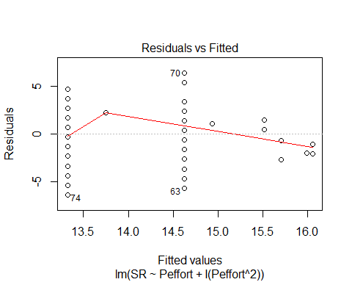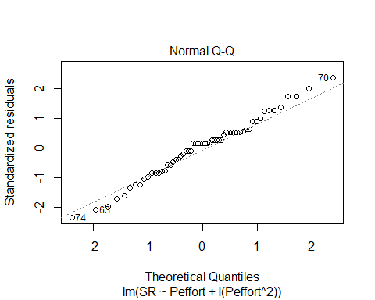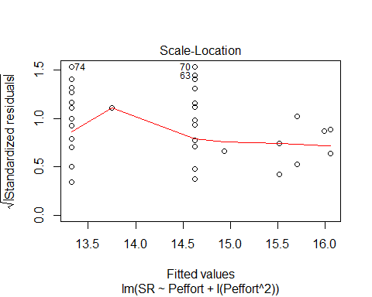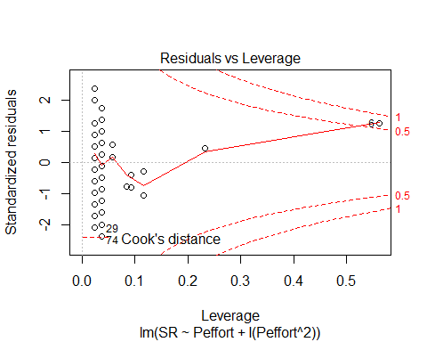

evaluationYV18C<-lm(SR ~ Peffort + I(Peffort^2) + I(Peffort^3), methodYSR3) #non-sig  
summary(evaluationYV18C)

##   
## Call:  
## lm(formula = SR ~ Peffort + I(Peffort^2) + I(Peffort^3), data = methodYSR3)  
##   
## Residuals:  
## Min 1Q Median 3Q Max   
## -6.1547 -1.3217 0.0766 1.0766 5.8453   
##   
## Coefficients:  
## Estimate Std. Error t value Pr(>|t|)   
## (Intercept) 8.45933 1.94299 4.354 5.87e-05 ***  
## Peffort 5.78836 2.09289 2.766 0.00772 **   
## I(Peffort^2) -1.42829 0.61137 -2.336 0.02315 *   
## I(Peffort^3) 0.10397 0.05116 2.032 0.04695 *   
## ---  
## Signif. codes: 0 '***' 0.001 '**' 0.01 '*' 0.05 '.' 0.1 ' ' 1  
##   
## Residual standard error: 2.669 on 55 degrees of freedom  
## (59 observations deleted due to missingness)  
## Multiple R-squared: 0.1588, Adjusted R-squared: 0.113   
## F-statistic: 3.462 on 3 and 55 DF, p-value: 0.0223

confint(evaluationYV18C, level=0.95)

## 2.5 % 97.5 %  
## (Intercept) 4.565498865 12.3531579  
## Peffort 1.594105150 9.9826141  
## I(Peffort^2) -2.653514968 -0.2030737  
## I(Peffort^3) 0.001450287 0.2064959

anova(evaluationYV18C)

## Analysis of Variance Table  
##   
## Response: SR  
## Df Sum Sq Mean Sq F value Pr(>F)   
## Peffort 1 20.91 20.9097 2.9361 0.09225 .  
## I(Peffort^2) 1 23.64 23.6434 3.3199 0.07388 .  
## I(Peffort^3) 1 29.42 29.4169 4.1306 0.04695 *  
## Residuals 55 391.69 7.1217   
## ---  
## Signif. codes: 0 '***' 0.001 '**' 0.01 '*' 0.05 '.' 0.1 ' ' 1

plot(evaluationYV18C)

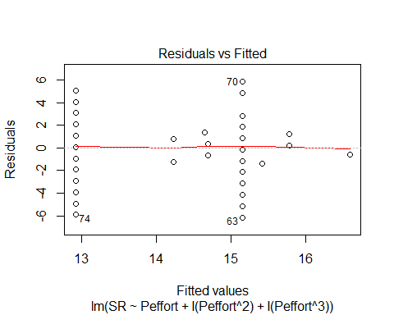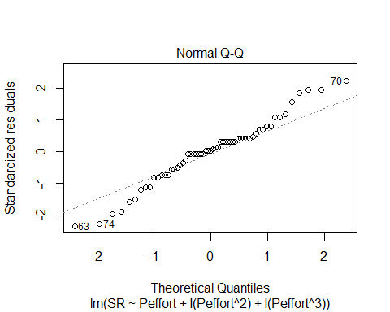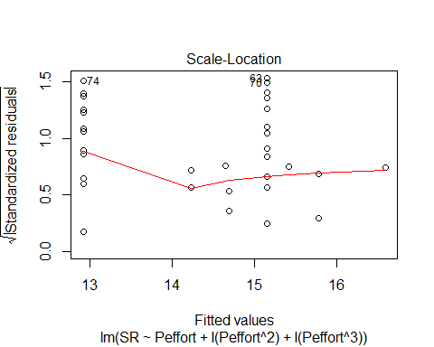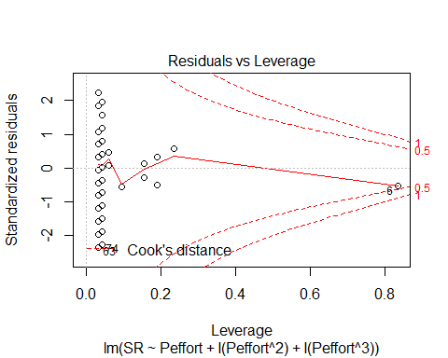

#Peffort3<-(methodYSR3$Peffort)^3  
#summary(Peffort3) #min 1 and max 512

AIC(evaluationYV18, evaluationYV18B, evaluationYV18C) #best with cubic!

## df AIC  
## evaluationYV18 3 292.6134  
## evaluationYV18B 4 291.3905  
## evaluationYV18C 5 289.1180

plot(SR ~ Peffort, methodYSR3, pch=16, axes=F, xlab="", ylab="")  
axis(1,cex.axis=0.8)  
mtext(text="Number of Repeated Listens", side = 1, line = 3)  
axis(2,las=1)  
mtext(text="Species Richness by Site", side = 2, line = 3)  
box(bty="l")  
x<-seq(1, 512,l=1000)  
points(x, predict(evaluationYV18C, data.frame(Peffort=x)),type="l")

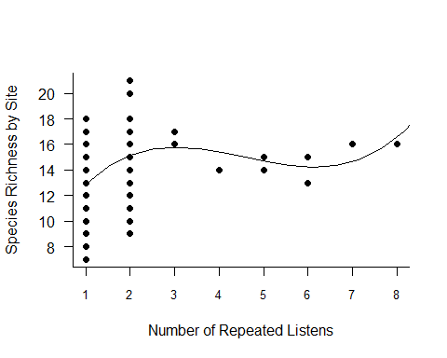

plot_model(evaluationYV18C, type="pred", terms=c("Peffort"))

## Argument `include.non.labelled` is deprecated. Please use `non.labelled` instead.

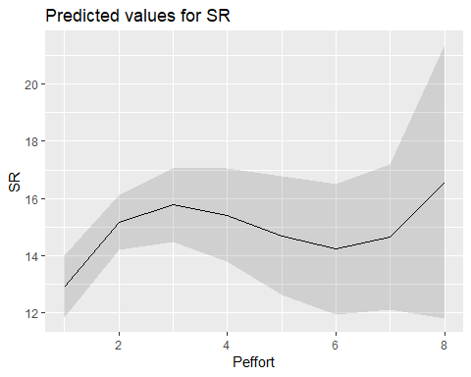

ALL SIG VISIT 3 VARIABLES:

plot(SR ~ Type, methodYSR3)



plot(SR ~ Stime, methodYSR3)



plot(SR ~ Pmin, methodYSR3)

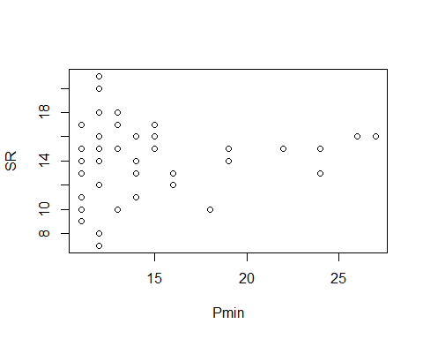

plot(SR ~ Peffort, methodYSR3)

